
CAN TIGERS (Panthera tigris) SURVIVE IN HUMAN-DOMINATED
LANDSCAPES OF INDIA? A CASE STUDY OF HUMAN-TIGER INTERACTION AROUND BHOPAL CITY, M.P.
Thesis submitted for the award of the degree of
DOCTOR OF PHILOSOPHY
IN
WILDLIFE SCIENCE

By
DURGA PRASAD SRIVASTAVA
to
Saurashtra University
Rajkot- 360005 (Gujarat)

Under the supervision of
Dr. Bhupendra Singh Adhikari
Scientist – G

June – 2026

Citation:
Durga Prasad Srivastava, and Bhupendra Singh Adhikari (2026). Can tigers survive in human-dominated landscapes? A case study of human-tiger interaction around Bhopal city, Madhya Pradesh. Ph.D. Thesis. Wildlife Institute of India, Dehradun, India and Saurashtra University, Rajkot, India.
DECLARATION
I, hereby, declare that the work conducted under this thesis titled “Can tigers survive in human-dominated landscapes? A case study of human-tiger interaction around Bhopal city, Madhya Pradesh” is original and independent research work done by me and subsequently submitted for the award of the degree of Doctor of Philosophy in Wildlife Science to the Saurashtra University, Rajkot (Gujarat). This research work has been carried out under the guidance and supervision of Dr. Bhupendra Singh Adhikari, Scientist-G, Wildlife Institute of India, Dehradun. The work has not formed the basis for the award of any other degree, diploma and any other qualification. I also declare that the thesis embodies my own work, analysis, observation, understanding and particulars given in it are true to the best of my knowledge.

Durga Prasad Srivastava
Place: Dehradun
Date:

Dr. B.S. Adhikari
(Supervisor)

Date:

CERTIFICATE
This is to certify that Mr. Durga Prasad Srivastava’s thesis “Can tigers survive in human-dominated landscapes? A case study of human-tiger interaction around Bhopal city, Madhya Pradesh” submitted for the degree of Doctor of Philosophy in Wildlife Science to the Saurashtra University, Rajkot (Gujarat) embodies original research work and carried under our guidance and supervision.
Mr. Durga Prasad Srivastava has researched for more than six terms under our supervision and guidance. The work presented in this thesis has not been submitted for any other degree. It meets all of the specifications stated forth in the ordinances of Saurashtra University in Rajkot, Gujarat, and the Wildlife Institute of India.

Forwarded by:

Dean
Faculty of Wildlife Science

Supervisor

Co-supervisor

Date:
Place: Dehradun
CERTIFICATE FOR PRE-PHD PRESENTATIONS

This is to certify that Mr. Durga Prasad Srivastava had made Pre PhD. Presentations as per UGC Guideline “University Grant Commission (Minimum Standard and Procedure for award of PhD Degree) Regulation – 2009” and Saurashtra University Ordinance for PhD. Programme (O.Ph.D. 6.2), on the Research work entitled “Can tigers survive in human-dominated landscapes? A case study of human-tiger interaction around Bhopal city, Madhya Pradesh” in the Department of Wildlife Sciences, Wildlife Institute of India, Dehradun, Research Centre of Saurashtra University, Rajkot on 2nd April 2026 before all the faculty members and students of the Department for getting feedback and comments.
I also certify that the research work was appreciated by all who remain present, and there were no comments made for this research work.
Signature of Department Head Signature of Guide

Dr. B.S. Adhikari
Dean, Faculty of Wildlife Sciences, Scientist G
Wildlife Institute of India Wildlife Institute of India

Place: Dehradun
Date:
CERTIFICATE OF PLAGIARISM CHECK

Acknowledgements
I express my deepest gratitude to my supervisor, Dr. Bhupendra Singh Adhikari, Scientist-G, Wildlife Institute of India, Dehradun, for his invaluable guidance, consistent encouragement, and insightful feedback, which kept me focused and motivated throughout this journey.
I am grateful to my co-supervisor, Dr. Shekhar Kolipaka, Sr. Landscape Developer, Commonland Foundation, the Netherlands, for his invaluable brainstorming on the research work and motivation amid the COVID and low phases.
I am sincerely thankful to Dr. Koustubh Sharma for mentoring, extending his support and motivation, and promoting my work across various platforms. I am thankful to Dr. Amit Kumar for his unwavering support during the initiation and execution of my fieldwork and intensive discussions. Their support proved crucial during various stages of my thesis work.
My heartfelt gratitude goes to PCCF-WL and CWLW Madhya Pradesh Forest Department for field permissions to conduct the field work, followed by their valuable support and cooperation through field staff. My special thanks to Mr. Alok Kumar, Mr. Suhas Kumar, Mr. Jasbir Singh Chauhan, Mr. Aseem Shrivastava, Mr. R.S. Murthy, Dr. Sanjay Shukla, Mr. Shubha Ranjan Sen, Mr. H.S. Negi and many other senior officials for their support and guidance.
I am also grateful to CCF Bhopal, DFOs, and their field staff for their cooperation during the field survey in the urban landscape of Bhopal, expanding over different territorial divisions. A few officers’ worth naming will be Mr. Ravindra Saxena, Mr. Vijay Kumar, Mr. Alok Pathak, Mr. Pradeep Tripathi, Mr. Sunil Bhardwaj, and Mr. R.S. Bhadouria.
I am grateful for visionary officers such as Mr. Suhas Kumar (retired APCCF) and Mr. L. Krishna Moorthy, APCCF-WL, who started the monitoring in Bhopal as DFO Bhopal in the early 2010s, and his consecutive successors for carrying out the trend enactment.
Special thanks to Mr. Rajnish Singh, currently posted as DFO Veeragana Durgavati Tiger Reserve, but an invisible support for me in the MP Forest Department for various discussions and support while dealing with the ground staff.
I extend my appreciation to Mr. Suman Raju, cinematographer and a great friend, documenting the research findings for the forest department and other platforms and extending his enduring support throughout this journey.
At this cherished moment, I would like to thank Mr. BMS Rathore (Retired IFS), Dr. Faiyaz Khudsar & Dr. Shah Hussain of CEMDE, Delhi University, and Dr. Edwait Edgaonkar & Dr. Yogesh Dubey of Indian Institute of Forest Management, for being well-wishers and consistent motivators.
I am thankful to Dr. Ankit Sinha, Dr. Gajendra Singh, Dr. Sameer Gautam, Mr. Anshuman Vashistha, Ms. Prerna Sharma, Mr. Akshat Srivastava, Ms. Nidhi Yadav, and Ms. Arpita Singh for their valuable suggestions, inputs, and support. I acknowledge the technical support provided by Ms. Anam Ahsan in various GIS and remote sensing-related works. I am thankful to Mr. Ramnesh Geer, Joint Director, CBI, Mr. Vaibhav Srivastava, SP, Cyber Crime, Mr. Vishal Khatri, Mr. Abhigyan, Dr. Shekhar, and Dr. Ritu Shekhar, for weekend breaks during the field surveys and as extended family in Bhopal.
A special thanks to Mr. Ravi Singh (WWF-India) and Mr. Ravi Chellam (Coexistence Consortium) and their team members for motivation and support to carry forward this work post PhD also.
A special thanks to Mr. Mehul Singh Tomar, Ms. Rakshita Shah, Ms. Shivangi Bendre, Mr. Gaurav Uppal, Mr. Shakti Kumar, Mr. Nishant Singh, Mr. Shaswatendu Chatterjee, Mr. Ayush Bisen, Mr. Ajinkya Bhatkar, and other team members for the field support as interns and volunteers. I acknowledge the vehicle support provided by Mr. Akshat Srivastava and, later multiple friends contributing to the Ketto Funding for the purchase of a field vehicle.
We acknowledge the local daily wages staff for their support in the field, as well as their kindness and hospitality after field work. Many of them are now extended family to me in the landscape.
I am indebted to the faculty of the Wildlife Institute of India, especially Dr. Ruchi Badola, Dean, Faculty of Wildlife Science, and Dr. Samrat Mondal, Scientist-F (NOEA), for their academic encouragement. I also thank former scientists of the institute Dr. V. P. Uniyal, Dr. Bitapi C. Sinha, Dr. Y. V. Jhala, Shri Qamar Qureshi, Dr. S. A. Hussain, for their lasting influence on the institution and its scholars.
I am deeply grateful to all the researcher friends and fellow researchers of WII, with the majority of whom I met in the field, for their unwavering support throughout my research career.
I also appreciate the support of financial support from the MP State Biodiversity Board, Rufford Foundation, Leo Foundation, Rainmatter Foundation to conduct field surveys. I am grateful to IDEAWILD, Sensing Clues, and Ecotone Telemetry for providing equipment and application-based support during the field survey. I am happy to acknowledge the support of Ms. Archana Sharma, of Aranyak, and Ms. Sunpreet Kaur, Inspire Network, for supporting the grant transaction.
I am especially indebted to Shri M. M. Uniyal for his continuous encouragement and support. I also thank Dr. Rahul Kumar, Dr. Bhawna Dhawan, Ms. Krishna Mishra, and Dr. Bableen for their assistance in all the administration office-related works in the institute while I was based in Bhopal. I acknowledge the long discussion call with Mr. Rajesh Gupta, APPCF, Rajasthan Forest Department, and Mr. Suvendu Das, Ms. Maumita, Ms. Sayli, fellow batchmate for submission-related calls and suggestions, as well as a lot of motivation in the last phase of my PhD journey.
I acknowledge the support of Dr. Vipin Vyas and Dr. Abhilasha Bhawasar, Department of Environmental Science and Limnology at Barkatullah University, and their research scholars in providing lab for our scat analysis. I am grateful to Mr. Guruvesh, Bharti Communication for supporting with all camera trap related works including safety boxes, repair etc.
Finally, I express my deepest thanks to my family and friends for their unwavering support, understanding, and patience. Their love and encouragement gave me the strength to persevere through challenges.
I dedicate this work to my father, the late Shri Rakesh Srivastava whom I lost in 2023 and the space cannot be filled.

Contents
Acknowledgements 8
List of Publications and Conferences 14
List of Figures 16
List of Tables 19
Executive Summary 20
CHAPTER 1 INTRODUCTION 26
1.1 Introduction 26
1.2 Scope of study 27
1.3. Research Objectives and the question of the study 28
CHAPTER 2 LITERATURE REVIEW: CARNIVORES IN URBAN LANDSCAPES 30
2.1 Urbanisation and its impact on biodiversity 30
2.2 Human-Carnivore Interactions 32
2.3 Status of tigers, conservation approaches, and underlying factors in conservation 33
2.4 Why the central Indian landscape? 36
CHAPTER 3 STUDY AREA 38
3.1 Bhopal City and Bhopal Forest Circle 38
3.2 Agro-climatic Region 39
3.3 Geology, Rock and Soil 39
3.4 Climate and Rainfall 40
3.5 Forest types and patches 40
3.6 Protected Areas 41
CHAPTER 4 LANDSCAPE CHARACTERISTICS WITH SPECIAL REFERENCE TO TIGER PRESENCE IN DYNAMIC URBAN LANDSCAPE OF BHOPAL 45
4.1 Introduction 45
4.2 Aim and Objective 47
4.3 Methodology 47
4.4 Results 63
4.5 Discussion 81
CHAPTER 5 PREY-BASE AVAILABILITY AND UTILISATION BY TIGERS IN URBAN LANDSCAPE OF BHOPAL 86
5.1 Introduction 86
5.2 Methodology 90
5.3 Results 93
5.4 Discussion 107
CHAPTER 6 PEOPLE’S KNOWLEDGE, ATTITUDE, AND PERCEPTION TOWARD SHARING SPACE WITH TIGERS IN THE URBAN LANDSCAPE OF BHOPAL 110
6.1 Introduction 110
6.2 Methodology 112
6.3 Results 117
6.4 Discussion 135
CHAPTER 7 SPATIO-TEMPORAL ADAPTATIONS OF TIGERS, AND ASSOCIATED SPECIES TO COEXIST IN BHOPAL-RATAPANI LANDSCAPE OF CENTRAL INDIA 140
7.1 Introduction 140
7.2 Methodology 141
7.3 Results and Discussions 145
7.4 Discussion 158
CHAPTER 8 CONCLUSION: HUMAN-TIGER COEXISTENCE IN URBAN LANDSCAPE OF BHOPAL 160
REFERENCE 168
ANNEXURE I 190
ANNEXURE II 197
ANNEXURE III 198

List of Publications and Conferences
Publications
- Srivastava, D. P., Bendre, S., Kolipaka, S., & Adhikari, B. S. (2025). Navigating the urban matrix: Spatio-temporal adaptations of tigers and associated species to coexist in the Bhopal-Ratapani landscape of central India. Indian Journal of Forestry, 48(2), 111-115.
- Survival in the Anthropocene: Prey dynamics and dietary shifts of tigers using urban landscape of Bhopal, central India. (in review, Mammalogy Notes)
- Assessing potential of tiger conservation using habitat suitability modelling at greater landscape of Bhopal Forest Circle, India (in submission)
- Assessing land-use land-cover with reference to urban green spaces and its implication on space-use by wild tigers (Panthera tigris) and their coexistence in Bhopal city, Madhya Pradesh (in submission)
Conference and Seminars
- Central Indian Landscape Symposium 5, which was held on January 2023 organized by Network for Conserving Central India (NCCI) at Kanha Tiger Reserve, MP (presented poster on “Understanding Tiger Survival in Urban Landscape: A case study from Bhopal city”)
- Central Indian Landscape Symposium 6, which was held on January 2025 organized by Network for Conserving Central India (NCCI) at Pench Tiger Reserve, Maharashtra (presented poster on “Prey selection (wild species or domestic species) by Tigers in Bhopal-Ratapani Landscape”)
- International Conference on Ecology and Transportation (ICOET) which was held in May 2025 organised in Denver, CO (presented talk on “Connectivity at a Crossroads: Evaluating Urban Green Spaces and Linear Infrastructure Effects on Tiger Conservation in Urban Landscape of Bhopal, MP, India”)
- Conservation Marketing Conference held online in December 2025 (presented talk on “Promoting Coexistence of Human-Tiger in urban landscape of Bhopal through community engagement, Central India”)
- Naturing Nature in Urban India organised by Azim Premji University, Bhopal held on 23-24 Feb 2026 (presented talk on “Survival in the Anthropocene: prey dynamics and dietary shifts of tigers using urban landscape of Bhopal, central India”)
- Conservation Asia Congress, Nepal, organised by the Society of Conservation Biology help during 3-5 June 2026 (presented talk on “Understanding Tiger survival in urban landscape of Bhopal, India”)

List of Figures

Figure 1: Bhopal Forest Circle (BFC) 42
Figure 2: Urban Landscape of Bhopal City (30 km of Bhopal Municipal Limit) 43
Figure 3: Classified proximity (Euclidean distance maps) generated in ArcMap for four different anthropogenic variables influencing tiger suitability 59
Figure 4: Classified proximity (Euclidean distance maps) generated in ArcMap for four different anthropogenic variables influencing tiger suitability (a) distance to waterbodies (b) distance to roads (c) distance to settlements and (d) distance to railways and three different classified topographical variables (e) Digital Elevation Model (DEM) (f) Slope and (g) aspect 59
Figure 5 Land use Land cover map (2022) of Bhopal Forest Circle 64
Figure 6: Spatial distribution of tiger habitat suitability across the study area 68
Figure 7: Spatial distribution of various tiger habitat suitability across five districts of Bhopal Forest Circle 69
Figure 8 The graph shows the relationship between observed and predicted values of the modeled variables, with the coefficient of determination(R2) indicating the goodness of fit. 70
Figure 9: Habitat suitability across different patches of BFC 72
Figure 10: Vertices and nodes Identified using Graph Theory in Bhopal Forest CIrcle 74
Figure 11: Potential habitats and habitat connections across Bhopal Forest Circle 75
Figure 12: Tiger presence in Urban landscape of Bhopal (Municipal limit & 30km buffer) 2019-22 76
Figure 13: Land use land cover map of Bhopal city 78
Figure 14: Mapped Blue-Green spaces of Bhopal city 79
Figure 15: Map showing distribution of Line transects utilised for prey-base estimation (2019-2021) 88
Figure 16: Map of Scat locations (n=227) utilized for estimating prey-preference for tigers in urban landscape of Bhopal 89
Figure 17: Individual rarefaction curve for Prey-base in the landscape and Bhopal city 94
Figure 18: Community structure of Prey base in Landscape and Bhopal city 95
Figure 19: Diversity and Species richness 96
Figure 20: Cluster analysis of availability of prey base tiger among sites at landscape level 100
Figure 21: Cluster analysis of availability of prey base tiger among selected sites in Bhopal city 101
Figure 22: Species diversity and richness of prey-base (n=227) 102
Figure 23: Species occurrence in the diet of tigers assessed through Scats (n=227) 103
Figure 24: Individual rarefaction curve at various gradients of landscape 103
Figure 25: PCA for correlation among landscape gradient for distribution 105
Figure 26: Framework of Theory of Reasoned Action and Planned behavior showing a particular behavior is governed by various Individual-social factors influencing attitude and intention toward an event or subject 116
Figure 27: Village-wise interviews and the number of respondents 118
Figure 28: Age of respondents 118
Figure 29: Gender of respondents 119
Figure 30: Duration of respondent's residence at current location 119
Figure 31: Religion of the respondents 120
Figure 32: Education level of respondents 120
Figure 33: Frequency of outdoor visits by respondents 122
Figure 34: Mood and personality of respondents 123
Figure 35: Awareness of tiger presence near their home and villages 123
Figure 36: Free-checklist of species observed by respondents during daily routine 124
Figure 37: Species identified by respondents using photo-cards 125
Figure 38: Perceptions of respondent toward wild animal population trends 126
Figure 39: Emotional response to tiger presence near the village 126
Figure 40: Value/Attitude of respondents toward wildlife 127
Figure 41: Response to wildlife acceptance 127
Figure 42: Source of knowledge on wildlife and dangers 128
Figure 43: Decision-making for routes and areas in the forest by respondents 129
Figure 44: Strategies to promote Human-wildlife coexistence 129
Figure 45: Response to tiger encounter in the wild 130
Figure 46: Field position of respondents from the forest 131
Figure 47: Field experience of respondents 131
Figure 48: Knowledge and understanding of tiger presence in the study area 132
Figure 49: Perception of respondents in managing tigers in the landscape 133
Figure 50: Reason behind the current actions to manage tigers in the landscape 134
Figure 51: Cattle walk maps (Nov 2020-May 2021) 135
Figure 52: Camera trap location in the Bhopal-Ratapani Connecting Forest 143
Figure 53: Camera trap locations and grids under AITE 2022 144
Figure 54: No. of photographs of focus groups in Bhopal-Ratapani Connecting Forest Patch 145
Figure 55: Temporal overlap among tigers, co-predators, prey base, and humans in the Bhopal-Ratapani Connecting Forest 146
Figure 56: Temporal space-use by focused groups in Bhopal-Ratapani Connecting Forest 147
Figure 57: Activity pattern of carnivores in the Bhopal-Ratapani Connecting Forest 148
Figure 58: Activity pattern of Prey-base in the Bhopal-Ratapani Connecting Forest 149
Figure 59: Activity pattern of domestic prey base in the Bhopal-Ratapani Connecting Forest 149
Figure 60: Non-MDS of temporal space-use 151
Figure 61: Share of photographs of tigers and co-predators in Bhopal-Ratapani Landscape 153
Figure 62: Temporal space-use by tigers and co-predators in Bhopal-Ratapani Landscape (AITE 2022) 154
Figure 63: Temporal space-use across a) Bhopal-Sehore Territorial b) Ratapani Core c) Obedullahganj Territorial Forest d) Obedullahganj division (Ratapani core+territorial forest) 155
Figure 64: Temporal adaptation of Tigers and co-predators in Bhopal-Ratapani Landscape (AITE 2022) 156

List of Tables
Table 1: Protected areas near study area 41
Table 2: Rank scale criteria for pairwise comparison matrix in AHP (Saaty, 1980, 1990) 53
Table 3: Weights of the criteria for each thematic layer used in Habitat suitability map 55
Table 4: Rank scale criteria for pairwise comparison matrix in AHP (Saaty, 1980, 1990) 56
Table 5: Pairwise comparison matrix for land use and density type map, which holds the preference, values for Tiger 57
Table 6: Pairwise comparison matrix for land use and density type map and anthropogenic layers 57
Table 7: Normalized pairwise comparison matrix for land use and density type map and Anthropogenic layers 58
Table 8: Area of land use and land cover (2022) 63
Table 9: Results of accuracy assessment for the land use and forest density classification map 65
Table 10: Habitat suitable areas in Bhopal Forest Circle 67
Table 11: Patch areas and details 71
Table 12: Results of the Land Use Land Cover Classified Map for 2022 77
Table 13: Tiger sign encounter rate with respect to survey efforts in Bhopal city 80
Table 14: Richness estimators for Bhopal city and Landscape 96
Table 15: ANOVA to determine spatial variation in the availability of prey base 98
Table 16: ANOVA to determine seasonal variation in the availability of prey base in city 98
Table 17: Richness Estimators for Prey-base occurrence in scat samples 104
Table 18: ANOVA to determine spatial variation in the dietary preferences 106
Table 19: Thematic analysis of behavioural response by respondents on encountering a tiger in the wild 130
Table 20:ANOVA table for Spatial & Temporal Variation among focal groups 152
Table 21: ANOVA table for Temporal Variation among tigers and co-predators 157
Table 22: ANOVA table for spatial Variation among tigers 157

Executive Summary

In India, wild tiger numbers have gone from 1411 (SE range 1,165 to 1,675) in 2006 to 3682 (SE 243) in 2022 (Status of Tigers in India, 2023). Tigers are known for their large home ranges and great dispersal distances, and the National Tiger Conservation Authority estimated that approximately 40% of all tigers in India live outside the reserves in unprotected lands. These unprotected lands are mosaics of multiple-use forests and agricultural fields surrounding villages, towns, and cities. With a growing human population and its need for expanding urbanization, agriculture and other land uses have implication on forest. The land-use change presents enormous problems to animal conservation, particularly for wide-ranging species like tigers (Panthera tigris), whose migration and habitat usage are being disturbed by developing urban infrastructure. One of the most significant difficulties is the fragmentation of ecosystems created by linear infrastructure such as roads, trains, and highways, which limit communication between important green spaces.
The study is focused on urban landscapes of Bhopal city, a city with 2.6 million people, placed at Vindhyan Hills and surrounded by the dry deciduous forest of Bhopal Forest Circle. The study area focuses on the urban-rural gradient, including the built-up area of Bhopal, peri-urban and rural/wilderness area of the territorial forest of Bhopal, Sehore, Obedullahganj, and Raisen. The study uses a bio-social approach to understand the tigers and prey surviving in these dynamic areas on one end and people’s attitudes and perceptions to understand social factors shaping coexistence in these landscapes. The basic questions of the study are what is the extend of green spaces available for tigers in this landscape? What is the available prey-base and how tigers are utilizing available prey base, how animals and people share spaces, and how people’s attitude and perception shape coexistence in these dynamic areas.
As the first part of the study, this study aims to evaluate habitat suitability and identify potential tiger habitats across five districts of central India (Sehore, Raisen, Bhopal, Rajgrah and Vidisha). We generated land use and forest density maps using LANDSAT 8 satellite imagery for 2022 by adopting the Maximum Likelihood Classification (MLC) method. Subsequently, we developed a Habitat Suitability Model (HSM) for tigers using Analytical Hierarchy Process (AHP) within a Multicriteria Decision Analysis (MCDA) framework. The model Integrated land use and forest density map, anthropogenic variables (proximity to water, roads, railways, and human settlements and three topographic variables: slope, Digital Elevation Model (DEM), and aspects. Each thematic layer was weighted based on ground data and secondary ecological reference data. The results of land use and forest density maps showed that the agriculture class dominates by covering (67.32 %; 21,097 km sq), high, moderate, and open dense forest covers (20.04 %; 6093.44 km sq), and settlement (5%;1614.66 km sq). The results of the accuracy evaluation showed a high-quality classification with an overall accuracy of 93.3% and a kappa coefficient (k) of 0.93, indicating strong agreement between the classified and reference data set. Habitat suitability analysis showed highly suitable class encompasses approximately 2,609.27 km sq, moderately suitable areas covered around 2909.09 km sq, and low suitability areas cover 4547.34 km sq. The overall result indicates that areas with high-density forest cover in Raisen and Sehore exhibited the highest habitat suitability across the study region.
For developing an understanding of city green spaces and tiger movement, we assessed land-use/land-cover (LULC) patterns and their implications for tiger space-use near city fringes adjacent to the Ratapani Tiger Reserve. Using Landsat-8 imagery (30m resolution, 2022), supervised maximum likelihood classification in ArcGIS 10.8 (Kappa=0.88) identified settlements (37%), agriculture (30%), urban green spaces (25%), and waterbodies (8%) across 414 km². Of 535 digitized green patches (65 cm Google Earth Pro), 248 exceeded 1 ha, forming connected networks via riparian and institutional areas. Tiger presence was evaluated via systematic sign surveys (Nov 2021–Jul 2022) across standardized trails (45.6 km total) in urban green spaces of Kaliasot-kerwa, supplemented by All India Tiger Estimation 2022 camera traps. Tigers occupied 19 grids in southern Bhopal (Kaliasot-Kerwa belt), with encounter rates of 0.88–1.82 signs/km (winter mean: 1.45 ±0.33; summer: 0.93 ±0.06), indicating territorial use influenced by prey, water, and human factors. Four individuals were photo-captured in sites like MANIT and WALMI.
As part of a broader effort to understand tiger survival in an urban landscape, we conducted extensive field surveys across Bhopal and a 30 km buffer zone to assess tiger presence, prey abundance, and human-wildlife interactions. Here, we present findings on the relationship between prey distribution, composition, and abundance and tiger diet across urban and peri-urban mosaics. Prey abundance was estimated using 40 and 12 line transects in the forest of Bhopal Forest Circle and Urban green spaces (2019- 2022), respectively. In the forest, 14 prey species were recorded, with wild pig (Sus scrofa, 83.33%) and peafowl (Pavo cristatus, 66.66%) being the most frequently encountered, whereas cattle (Bos taurus, 37.5%) and nilgai (Boselaphus tragocamelus, 30%) dominated urban areas. Mean prey abundance was highest for goats (Capra aegagrus hircus, 32 individuals per transect) and wild boar (Sus scrofa, 24.3) in the forest circle, whereas cattle, goats (14), and blackbuck (Antilope cervicapra, 10) were most prevalent in urban green spaces.
Tiger diet analysis, based on morphological identification of prey hair in 227 scat samples collected from Bhopal City, the Bhopal-Ratapani connecting forest, and Ratapani Tiger Reserve, revealed 19 prey species, with nilgai (17.62%), cattle (15.41%), and Chowsingha (Tetracerus quadricornis, 14.09%) being the most frequently consumed. While prey species were relatively evenly distributed, significant variation in dietary composition across landscapes underscores the adaptability of tigers to urban environments. Bhopal exemplifies how heterogeneous urban matrices sustain biodiversity connectivity. Protecting these corridors via integrated planning ensures human-wildlife harmony, ecosystem services, and Central India’s tiger landscape resilience.
To understand the human dimensions the study examines how people and tigers are sharing spaces. We investigated the spatial-temporal dynamics of tiger (Panthera tigris) coexistence within the human-modified landscape of the Bhopal-Ratapani Connecting Forest in Madhya Pradesh, India. Utilizing camera trap data collected in 2020, we examined the activity patterns of tigers, co-predators, prey species (wild and domestic), and humans to assess spatial-temporal overlap and segregation. Our results reveal significant temporal partitioning among these groups, with tigers exhibiting primarily nocturnal behaviour to minimize overlap with human activity. Prey species display diverse strategies, including diurnal, nocturnal, and crepuscular patterns. The same has also been depicted in the Non-metric Multidimensional Scaling plot. ANOVA analysis confirms significant Spatial variation (F=4.2, p<0.003) and temporal variation (F = 4.22, p<0.01) among the focal groups.
Even the study at Bhopal-Ratapani Landscape level states similar temporal adaptation of tigers and co-predators. However, the ANOVA results state clear temporal variation among Tigers and co-predators in space use but no significant difference in spatial context such as Bhopal-Sehore, Ratapani core and Obedullahganj territorial stating the homogenous landscape availability. These findings underscore the importance of temporal niche partitioning in facilitating tiger persistence in urban-influenced environments and inform targeted conservation strategies aimed at mitigating human- wildlife conflict and promoting coexistence.
The low conflict levels, timely compensatory practices, and non-retaliatory attitude of the local community are playing an important role in sharing space with tigers without any conflict. The absence of Human-tiger conflict is one of the important factors promoting acceptance within local communities.
These findings highlight the role of human-modified landscapes in shaping space availability, prey availability & utilization by large carnivores, and acceptance by local communities to share space with tigers, emphasizing the urgent need to reconsider the role of urban green spaces and consider wildlife as part of urban planning to mitigate human-wildlife conflicts and ensure long-term conservation.

CHAPTER 1
INTRODUCTION

CHAPTER 1
INTRODUCTION

1.1 Introduction
The All India Tiger Estimation carried out in 2022, estimated that nearly 3682 wild Bengal tigers (Panthera tigris) live in India (Status of tigers in India, 2023). These figures suggest a substantial increase from the 2006 census when tiger numbers decreased to 1411 (Status of tigers in India, 2018). Although the increase in tiger numbers may be partly credited to strengthened efforts to count tigers across India, improved protection of tigers in the nearly 50 tiger reserves that serve as key tiger source sites has been identified as a major contributing factor.
Tigers are nonetheless known to have wide-ranging habits and to move well beyond the tiger reserves. Approximately 30% of all tigers in India live outside the reserves in unprotected lands (GTF, 2014). These unprotected lands are mosaics of multiple-use forests and agricultural fields that surround villages, towns, and even cities.
Currently in India, the high economic growth is resulting in a rapid transformation of villages, towns, and cities. The natural landscapes in the proximity of these rapidly transforming human habitations are over-used, fragmented and disturbed (McKinney, 2002). As a result, several wildlife species live in small, disconnected and degraded natural areas in and around human habitations (Kong et al., 2010). The recent report “Nature in the Urban Century (2018)” points at the fact that current urban planning ignores ecosystems and biodiversity found in and around human habitation. And while integrated planning involving urban agencies, wildlife department personnel, NGO’s is also largely lacking, decision making and management processes are becoming more complicated. These management shortcomings have consequences for people and wildlife that live and share the same landscape.
Bhopal is a historic city and the capital of the Madhya Pradesh state of India. It has a population of over 2 million people (Census of India, 2011). Once a small city, Bhopal expanded rapidly in the last twenty years, and today the city limits stretch onto and around the Vindhyan hill ranges that were once far away on the outskirts of the city. With the hill ranges now integrated within Bhopal city, they continue to provide important living space to a variety of wildlife, including the tiger and the leopard. Despite the rapid urban expansion challenges, these wild cats apparently manage to survive in this city environment.
Reports from Mumbai, Delhi, and Visakhapatnam suggest that leopards have long been successful survivors in and around these big cities (Athreya et al., 2016; Surve et al., 2015) without much conflict with humans. In the city of Bhopal tigers, although a much larger cat than the leopard, are now seen roaming the streets and using the city spaces without any reported incidents of attacks on people. This raises two intriguing questions: How do tigers survive in this urban environment, and how are local people coping with the presence of these large cats?
Using a bio-social approach in this PhD research, we aim to understand tiger survival in a densely populated urban environment on the one hand and people’s coping mechanisms on the other. We started a survey from the outermost limits. These outermost areas include the Ratapani Tiger Reserve and territorial forest divisions of Bhopal, Raisen, and Sehore. Here, the areas are largely forest tracts with a relatively lower density of people (c. 200 people /sq. km). In 2021-22, the study was concentrated more inwards, closer to the city centre, where human density is more than 2500/sq. km.

1.2 Scope of study
Over the last decade, tigers are frequently reported and also sighted in the southern part of Bhopal city, the capital city of Madhya Pradesh state of India. The city that has expanded in the last two decades is located on the Vindhyan Plateau. These hills are connected to the Ratapani Tiger Reserve, which was a wildlife sanctuary till 2024, a source site for tigers. Ratapani is important as it is one of the tiger breeding populations, and tigers are moving in all directions, including toward Bhopal city.
Tiger presence in populated areas is weighed down with risks both to the tiger and the people who live in the area. It is often thought that the presence of the tiger will instill fear and trigger panic in people. The tiger attacks people and becomes a problem animal. And that people will retaliate and kill the tiger. But none of these happen in Bhopal, and tigers continue to somehow survive in the urban environment. As a conservation scientist, I am drawn by the ability of tigers and people to coexist and to understand the factors that foster such coexistence. I strongly feel that by studying human-tiger interactions, one can understand the ability of tigers and people to adapt to each other’s presence and activities. If left unaddressed, tigers will continue moving through their natural corridors that pass through urban landscapes like Bhopal, and people will continue their infrastructure developments, and tigers may eventually become vulnerable to human influences.

1.3. Research Objectives and the question of the study
The study aims to develop and evaluate a combination of qualitative and quantitative techniques that could be effective in managing the coexistence of wildlife, especially large carnivores, with human societies, especially in urban landscapes outside Protected Areas. The study reveals insights that allow planners to make an informed decision on whether to consider urban landscapes in the tiger conservation plans or to leave out urban spaces as undesirable for tiger conservation. This study also increases our understanding of human-tiger interactions, co-existence possibilities, and the potential of landscape-level conservation. The human-tiger interactions need both micro and macro level of analysis, including the individual factors affecting the behaviour of people or animals and landscape factors shaping the behaviour of the community and ecology.
Aim: To understand the prospects of tiger survival in urban spaces.
Objectives:
- To establish the presence and distribution of tigers in the green spaces across the urban landscape of Bhopal.
- To map the presence, distribution, and abundance of wild and domestic prey species in the green spaces of Bhopal.
- To understand human-tiger interactions and perceptions of people on tigers in Bhopal.
- To document baseline data and recommendations for the future development plan and improved management of Bhopal’s urban sprawl and its impacts on the potential tiger habitats.
Research Questions
- What is the extent of green spaces in Bhopal city and the occurrence of the tiger within these areas of Bhopal city?
- What is the diet of tigers in Bhopal?
- What is the abundance and distribution of domestic and wild prey in Bhopal?
- What are the perceptions and attitudes of urbanites about tigers moving in their city?

CHAPTER 2
LITERATURE REVIEW:
CARNIVORES IN URBAN LANDSCAPES

CHAPTER 2
LITERATURE REVIEW: CARNIVORES IN URBAN LANDSCAPES

Urbanization is a process of human-induced conversion of land into residential, commercial, and industrial uses, leading to diverse landscape-level changes altering the function and structure of ecosystems (Niemela 1999, Randa & Yunger, 2006). The urban areas are defined by a high-density core and outer areas with low-density population. Expansion of Urban areas into suburban and further suburban into rural is known as “urban sprawl”. These sprawls create a fragmented, new green habitat (managed & non-native species), etc. (Lindstrom and Bartling, 2003).
This urban–rural gradient has been studied in the West in the context of city biodiversity and impacts of urbanization (Nilon and Pais, 1997; Pickett et al., 2001). However, there are very limited studies in Asia, and particularly in India.

2.1 Urbanisation and its impact on biodiversity
In today’s world, the global landscape is increasingly human-dominated, with reports that every ecosystem on the Earth’s surface has now been subject to human activities due to expanding human populations (Vitousek et al., 1997). The impact of growing population is so high that around 40-50% of the earth’s surface is estimated to have been transformed by humans, often with marked ecological impacts: for instance, 10-15% of the global land surface is now covered by either agriculture or under transformation from rural to urban areas, while an additional 6-8% has undergone conversion to pasture leading to decrease of natural and semi-natural habitats (Vitousek et al., 1997, Srivastava, 2014).
The human population of the world is transforming to become a progressively urban place, with over 54% of the world’s population residing in urban areas in 2014, and over 66% of the world’s population is projected to be urban by the year 2025. In recent years, unplanned urbanization of cities has resulted in dwindling, fragmented patches of natural vegetation and altered ecosystem functionalities (Bateman et al., 2012). Fragmentation leads to vegetation loss, habitat conversion or destruction, an increase in patch distance, and an increase in the degree of isolation. This can affect the interactions of biotic communities and will have a cascading effect on the whole ecosystem. Despite the expansion in urban areas and increased awareness of urbanization's impacts on wildlife, urban wildlife studies have not been appraised systematically (Magle et al., 2012).
Urban areas are highly fragmented in terms of natural settings, with roads separating blocks of industrial properties (shops, factories, leisure facilities, schools, offices) or residential buildings which also contain natural, semi-natural or open habitats (woodlands, scrub, sports fields, golf courses, parks and road verges, railway embankments, churchyards, cemeteries, waterways) and deserted areas constituting the green spaces of complex urban ecosystems. Urban green spaces are an important component of the urban ecosystem, having significant ecological, social, and economic functions apart from acting as habitats and dispersal corridors for a wide range of species (Kong et al., 2010). But the ongoing trend in the urban sprawl is, in general, not positive for natural vegetation and faunal diversity, making it one of the most challenging environments for wild species to survive in urban landscapes. On a broader scale, urban habitats can be seen as disturbed and fragmented patches of natural habitat into more numerous and smaller remnant patches (McKinney, 2002).
In spite of expansion in urban areas and increased awareness of urbanization's impacts on wildlife, urban wildlife studies have not been appraised systematically (Magle et al., 2012). Urban ecology developed as a young discipline within natural science, and for a long time, it was thought that urban areas were not worth studying with regard to ecology, as cities were seen as anti-life. But recent developments show that the environment created by humans provides habitats for many species. However, wild animals have doubtless been entering human settlements for millennia, as raiders, scavengers, and nuisances or as predators, sometimes tolerated, sometimes retaliated against, or sometimes even removed legally.
Wild carnivores have doubtless been entering human settlements for millennia, as scavengers or as predators, but it has also been seen in many studies that many of the carnivores avoid urban spread (Witte et al., 1985). McKinney (2002) reviewed literatures and found many carnivore species actively avoid urban areas, rapidly disappearing from encroaching urban spread ‘urbanophobes’ (Witte et al., 1985) called ‘urban avoiders’, while several other species, maintaining varying levels of intimacy with humans, residing within cities and built-up areas across the globe, largely dependent on natural resources ‘urban adapters’, while many, fully dependent species ‘urban exploiters’ actively invade city environments, make use of anthropogenic food and shelter, and often attain population densities far above those found for rural habitats. These urban carnivores, vary from medium-sized carnivores such as the red fox, coyote, Eurasian badger and raccoon in Northern American & European Countries (Gehrt et al., 2010; Gehrt, 2011) to large-sized carnivores such as Wolves in Canada, Bears in Nevada (Beckmann & Lackey, 2008), Hyenas in Ethiopia (Yirga et al., 2015) and Leopards in India (Surve et al., 2015; Daily Mail News, 2016), which not only survive in cities but also have managed to maintain varying levels of intimacy with human societies and exploit anthropogenic food sources and shelter to their significant advantage (Radeloff et al., 2005; McKinney, 2006; Bateman P.W., 2012; Athreya et al., 2014; Surve et al., 2015). Little information is available about how carnivores co-exist with humans and the extent to which, if any, behavioral adjustments occur (Beckmann, 2003).

2.2 Human-Carnivore Interactions
Carnivores interact with humans in a variety of ways. Historically, many carnivore species were considered competitors for prey, a natural resource in the form of fur and food, or pests because of depredation on livestock (or humans), or as carriers of disease. As a consequence, many species are persecuted relentlessly, and their population and distribution are reduced dramatically. They have served as totems, icons, entertainments, political ‘footballs,’ and some have been domesticated and now number in the millions. More recently, the role that carnivores play in ecosystem processes and stability has been investigated and debated, giving them yet another, perhaps essential, perceived value. Thus, the need to conserve carnivores, even in the face of perpetual conflict with many, has led to a wide-ranging discussion of options and strategies for management (Sillero-Zubiri & Laurenson 2001). Human-wildlife interactions are pervasive and have been frequently in rural areas and have become common on the urban fringes. In spite of the diversity of situations and species involved in these interactions, the common thread: the thought and actions of humans are a key factor determining the course and resolution of the conflict (Manfredo & Dayer, 2004).
Three key variables are believed to affect a species’ adoption of new environments (Shea & Chesson, 2002). Cities may provide hospitable niches for carnivores due to reliable, non-seasonal food and water resources, reduced threat of natural enemies, and/or altered physical environment (e.g., temperature, providing shelter). The initial human impacts of suburban sprawl are sometimes relatively mild, with only a few housing subdivisions in a matrix of largely natural or agricultural habitat. The presence of natural vegetation within cities is important for supporting significant numbers of carnivores (Baker & Harris, 2007). Therefore, proximity to large expanses of connected habitat (‘green zones’) within cities would provide a refuge that may act as a resource for animals. The dispersal of food resources within a city is also likely to influence the utilization of these habitats by carnivores. Tolerance for humans is another additional factor, maybe an intrinsic trait, and the plasticity and adaptations of the trait define the survival probability of carnivores in urban landscapes (McKinney 2002). The importance of large carnivores as top predators maintaining ecosystem stability is being perceived by the significance of PAs (Protected Areas), different land cover-land use types, human densities, and human cultural tolerance to species distribution and occurrence is critical to improving large carnivore conservation in such landscapes (Cardillo et al., 2004; Cardillo et al., 2008; Karanth et al., 2009).
In a country like India, the co-existence of wildlife with human societies has existed for millennia. However, the level of co-existence and human-wildlife Interaction has varied with time, based on prior experiences and inherited predator-prey relationships (Kolipaka et al., 2015). Many such underlying factors contribute to the co-existence of carnivores in human-dominated landscapes and ensure the sustainability of these glorious species with humans. The recent development in tiger conservation approaches the co-existence of tigers in human-dominated landscapes as a major focus.

2.3 Status of tigers, conservation approaches, and underlying factors in conservation
The Bengal tiger (Panthera tigris) has represented the culture, history, and beauty of India. Tigers, being highly adaptable, exist in a wide range of forest types and climatic regimes and subsist on diverse prey (Schaller, 1967; Sunquist et al., 1999). Global tiger numbers are on the increase, and the recent All India Tiger Estimation (AITE) 2022 assessed 3682 tigers across the country, making India as the home for 70% of all wild tigers in the world (Qureshi et al., 2023). The increase in India can be attributed to the focused and sustained conservation efforts taking place in various tiger reserves. The tiger reserve concentrates efforts to allow tigers to successfully breed and raise young tigers in the relative safety of the reserve. With the increasing numbers, this wide-ranging carnivore requires new habitats to establish its territories, but unfortunately, the protected areas are at their carrying capacity (Sharma et al., 2013), and nearly 30% of all tigers in India continue to stay outside protected areas (GTF, 2014). The rapid economic development in tiger range countries and its impact on conservation is recognized as a serious global issue by the Convention on Biological Diversity (CBD).
Several factors are known to influence tiger use in areas outside PAs. Firstly, tigers have large home ranges, and sometimes their home ranges are larger than the size of the reserves. This mismatch in tiger home range sizes and PA size means that some tigers will invariably use areas outside the reserves too (Chundawat et al., 2016). Secondly, when tiger numbers increase in the reserves, some tigers disperse to other areas. Since reserves in India are fragmented and surrounded by human-use lands, tigers have no choice but to move through them. While moving outside PAs, tigers pass through human-dominated territorial forests, village lands, and sometimes even urban spaces. How tigers survive in human-dominated lands is a big mystery, and a recently concluded long-term study in the Panna landscape of Madhya Pradesh showed that tigers are much more adaptable to using human-use areas and successful in finding prey in such lands than previously thought (Kolipaka, 2018). Such behavioral plasticity of tigers to adapt to human-dominated lands raises the question of the ability of tigers to survive in urban areas. Since urban landscapes appear within the more extensive tiger landscapes identified in India, assessing the survivability of the tiger in such areas becomes essential.
The tiger Panthera tigris characterizes wilderness values and acts as an umbrella species for the conservation of biodiversity by being a top predator. Recent developments on tiger conservation, i.e. St Petersburg tiger conference, focused on a more holistic conservation approach, including the amalgamation of protected areas and the surrounding unprotected lands into tiger conservation landscapes. These networks of PAs and multi-use landscapes act as corridors to allow access to a larger landscape with suitable habitat for population recovery, as PAs are smaller in size to maintain increasing populations (Chundawat et al., 2016; Sarkar et al., 2016; Kolipaka et al., 2017). India has large patches of forest lands that extend beyond most protected tiger reserves and are occupied by people in the form of multiple-use forest and interacting with wildlife on regular basis (Kolipaka et al., 2015; Kolipaka et al., 2017). Local people have traditional rights to access multi-use forests and the forest authorities majorly lack control on such human-dominated areas and buffer zone forests (Srivastava 2014; Kolipaka et al., 2017). People's use of forests can have both costs and benefit for carnivores using the same area (Linnell et al. 1999; Banerjee et al., 2013; Miller et al., 2015; Sharma et al., 2015; Kolipaka et al., 2015; Kolipaka et al., 2017). Many carnivores such as hyenas, wolves, leopards, etc., utilize the anthropogenic food supplies in the form of domestic animals like dogs, pigs, goats, rodents, and other domestic livestock as they occur in high numbers in human-dominated landscapes of India. As per the 2003 livestock census, there are as many livestock on average as people in this fertile land, 300 people and 300 livestock per sq. km. Athreya (2011) estimated medium-sized livestock, such as pigs, sheep, goats, and dogs, approximately 70 prey for a leopard, hyena, or wolf in every sq. km, which was later compared with a protected area, and found that a leopard usually has a prey density of 50-75 wild ungulates in PAs. So, it is not surprising for a wild carnivore living outside protected areas to utilize the freely available food resources. Large carnivore like Tigers also depends on livestock in multiple-use areas. Kolipaka (2017) found that domestic prey animals represented over 43% of all diets in 8 radio-collared tigers in multiple-use areas of Panna Tiger Reserve, which varied seasonally, as also evident from earlier studies Karanth & Sunquist, 1995; Bagchi et al., 2003. Tiger home ranges are dynamic and change with prey base, disturbances, and even social organizations and dominance hierarchies (Chundawat et al., 2016; Karanth et al., 2017). Genetic studies by Thatte et al. (2018) highlight that the dispersal and movement of tigers from one PA to another is regular, and there is a high probability of local extinction of tiger populations from smaller protected areas if connectivity through corridors and the healthy subpopulations will not be maintained for the future of tigers. These dispersals are driven by PA conditions (prey base, carnivore density), landscape interpreters (roads, vegetation, human habitations, and human disturbances) (Joshi et al., 2013), and disparate combinations of topography and land cover (Reddy et al., 2017). Increasing urbanization and an increase in mining, rail, and road links, irrigation, and thermal projects promote fragmentation of the tiger landscape of central India (Reddy et al., 2017). And understanding such elements of the landscape through a new co-existence approach of tiger conservation will ensure the connectivity, dispersal, and new opportunities to design and manage the needs and requirements of wildlife and different stakeholders.
Such studies and previous records show human demography and land use are important factors in carnivore distribution (Woodroffe & Ginsberg 1998; Parks & Harcourt 2002; Treves & Karanth 2003; Cardillo et al., 2004), but cultural tolerance is a unique additional positive factor in a country like India (Karanth et al., 2017). The continuous depredation on livestock can lead to infringement of tolerance and repercussions on animals and local forest departments (Athreya 2011; Kolipaka et al., 2015), as the losses are not economic losses; sometimes these are more of emotional losses. Emotions, attitudes, and perceptions toward carnivores are determined by a dynamic and complex web of individual, societal, and cultural factors (Dickman, 2013; Kolipaka et al., 2015). So, understanding both individual and cultural determinants for the coexistence of large carnivores and humans is critical for the mitigation of any negative interactions and long-term conservation of large carnivores in human-dominated landscapes (Dickman, 2013). There are also studies showing that government policies which are emphasizing the importance of urban wildlife to urban residents and their potential values in their backyard (Bakers & Harris, 2007; Bhatia et al., 2013). Therefore, a proper understanding of the biology of these carnivores is not enough to know their role in different socio-ecological, economic, political, and cultural factors at a landscape level, and also cannot be ignored for long-term conservation goals. Hence, the understanding of biological and sociological sciences is required for a better understanding of carnivores’ coexistence with human societies (Setchell et al., 2016). By looking at both the human and carnivore aspects, factors can be emphasized which could support coexistence and safe landscapes for them, and separate those factors that can lead to full-blown conflict.

2.4 Why the central Indian landscape?
The central Indian landscape has lost more than 75% of its forest cover to agriculture and urbanization in the last 300 years, and this anthropogenic transformation of land has posed a barrier to the dispersal of tiger populations (Sharma et al., 2013). Major studies focus on distribution, dispersal, and biological factors for the presence of large carnivores in human-dominated landscapes, but there are very few studies explaining the presence of large carnivores and their interactions-adaptations with the prey base and human societies in continuously changing land-use pattern in an urban setup. The rapidly expanding Bhopal city area is part of the corridor forest that connects Ratapani Wildlife Sanctuary, which was established as a Tiger Reserve in December 2024. Ratapani is an important area, as, in spite of the sanctuary status and high anthropogenic pressure, the area has a breeding population of tigers. The proposed planning area of Bhopal Municipal Corporation, 2030, will have a severe impact on these corridor patches. So, the presence of tigers near the urban landscape of Bhopal provides opportunities to understand the prospect of promoting or discouraging tiger conservation near the urban center of Bhopal.

CHAPTER 3
STUDY AREA: BHOPAL FOREST CIRCLE

CHAPTER 3
STUDY AREA

Central Indian landscape sprawling over 152,000 km sq. and across the states of Madhya Pradesh, Chattisgarh, Maharashtra, and part of Andhra Pradesh, where tropical deciduous forests form a major land cover. The CIL encompasses more than 20 PAs, including 17 tiger reserves is an important habitat for tigers Panthera tigris, and support more than 25% of the tiger population.
Madhya Pradesh is the second-largest state of the country, having a geographical area of 308,245 sq km, which constitutes 9.4 % of the country's geographical area. The diverse and rich biodiversity of this central Indian state can be attributed to its strategic position in the subcontinent. It is present in the genetic highway connecting the Western Ghats and North –East India, two of the biodiversity hotspots of India. It has the largest forest area of 94,689.38 sq. km² in the country. Total forest and tree cover (including scrub) in MP is 95,670.15 sq. k.m. (Total Forest cover 77,492 sq. km.) which constitutes 31.03% of the state’s geographical area (India State of Forest Report, 2023). The forest can be classified as reserved forest 65.36 per cent (61,886 sq. km), protected forest 32.84 per cent (31,098 sq. km), and unclassified forest 1.7 per cent (1,704 sq. km) of the total forest area (MP forest website). Total forest area is distributed as 67,770.50 sq km with 6,886.21 sq. km of very dense forest, 31,366.97 of moderately dense forest, and 29,517.32 as open forest (India State of Forest Report 2023). This forest is divided into 16 territorial forest circles, 9 Tiger reserves, 11 National Parks, and 23 wildlife sanctuaries. The present study was undertaken in the Bhopal Forest Circle.

3.1 Bhopal City and Bhopal Forest Circle
The study was conducted in green patches in and around 30km of Bhopal Municipal limits, which falls under Bhopal Forest Circle (BFC) from February 2019 to December 2023. The study area spreads over 900 sq. km and has mixed land-use. (Figure 1)
Bhopal district is located on hilly terrain on the continuous belt of Vindhya hill ranges, having an area of 2772 sq. km. and an average elevation of 460-500 meters. The area is dominated by natural water bodies and hilly slopes having patches of dry scrub and mixed deciduous forests of total Forest Area of 328.56 Sq. Km and scrublands extending 70.31 (India State of Forest Report, 2023).
Bhopal is one of the fastest-growing cities in the country. As per the 2011 census, the population of Bhopal is 2,371,061, out of which 1,917,051 live in 66 wards, covering a gross area of 2772 sq. km. Bhopal is almost 80.85% urbanized, with most people living in the city of Bhopal, but the city is continuously losing its grace and beauty under the growing pressure of upgradation and densification of activities. (Saxena, 2003). Out of the Total Planning Area of 60106 ha, 10400 ha is already developed till 2005. The lakes and water bodies share around 3800 ha of Land out of the present planning area, which is almost as close as 25% of the developed area (Bhopal Development Plan, 2006).
BFC consists of six forest divisions: Bhopal, Sehore, Rajgarh, Vidisha, Raisen, and Obaidullaganj. The Bhopal Forest Circle (BFC) consists of tropical dry deciduous forests. BFC has a total forest area of about 6906.93 Km². Out of which, the reserved forest is 4076.72 Km², the protected forest is 2761.98 Km^{2,} and the unclassified forest is 68.23 Km² (MP forest website). BFC is an agriculturally dominant landscape.

3.2 Agro-climatic Region
Madhya Pradesh has 11 agro-climatic regions. These regions are different from each other regarding climate, soil type, crops, topography and rainfall. The study area consists of 4 divisions. Bhopal, Sehore, Obaidullaganj, Raisen and Vidisha are a part of the Vindhyan Plateau agro-climatic region. Majority of the study area is under Vindhyan Plateau agro-climatic region.

3.3 Geology, Rock and Soil
Vindhyan Range is an escarpment of broken hills running parallel to the Narmada-Son trough in an east-west direction from Jobat in Gujarat to Sasaram in Bihar for a distance of over 1200 km, acting as a boundary of the central India landscape on the north. The topography of the areas in the Vindhyan hills can be described as “step” topography with one plateau steeping down onto the lower one. The elevation of the range is 300-650 m and is composed of horizontally bedded sedimentary rocks. The major agro-climatic regions of the Vindhyan Landscapes compromise the Vindhyan Plateau, Malwa Plateau in Centre; Kaimur & Satpuda Hill Plateau on the Eastern side and Jhabua Hills on the western limit. The major part of the central vindhyan landscape compromises the Hill and steep escarpments; and flat woodlands and savannah type grassland areas. The main rock formation of the BFC is sandstone from Vindhyan origin while the soil types are laterite, black cotton and alluvium.

3.4 Climate and Rainfall
The study area falls under a sub-tropical Climatic Region with three distinct seasons viz., winter season (Dec-Feb), summer season (Mar-May) and the rainy season (June – Oct). During winters, the mean temperature remains around 10 °C and mean maximum temperature remains 25 °C, and the minimum temperature goes down to 1 °C in some regions. During summers, the o mean minimum temperature is 22 °C and the mean maximum is 38 °C. The maximum temperature during summer can go up to 48 °C, especially in May and June, which are the hottest months. Vindhyan plateau receives an average annual rainfall between 1200-1400mm, while Malwa plateau receives around 1000-1200mm. Rainfall is received from the south-west monsoon from June to September (SAPCC, 2014).

3.5 Forest types and patches
Eighteen forest types have been identified in Madhya Pradesh. These forest types belong to three groups of classification given by Champion and Seth i.e., Tropical Dry Deciduous Forest, Tropical Moist Deciduous Forest, and Tropical Thorn Forest. Tropical Dry Deciduous Forest is the dominant group. Within sub-groups, Southern Dry Mix Deciduous Forest is dominant (33.51%) followed by Dry Teak Forest (27.26%), and Northern Mix Dry Deciduous Forest (11.81%). The rest of the forest types occupy less than 6% of forest cover (FSI, 2015). The BFC is characterized by Tropical dry deciduous forest (Group 5) and Tropical thorn forest (Group 6) (Champion and Seth, 1968).
The major sub-groups of Group 5 and Group 6 forest types found in the study area encompasses following (Champion & Seth, 1968)
5A/C 1b Dry Teak Forest
5A/C3 Southern Dry Mixed Deciduous Forest
5/DS1 Dry Deciduous Scrub
5/E1 Anogessius Pendula Forest
The major species is Teak (Tectona grandis) in Dry Teak Forests while Butea monosperma, Diospyros melanoxylon, Acacia catechu, Anogessius latifolia, Wrightia tinctoria, Lannea coromandelica and Cassia fistula are major species of mixed forests. Anogessius pendula Forest is dominated by Anogessius pendula along with Anogessius latifolia. Tree species found in Dry Deciduous Scrub forests are Butea monosperma, Acacia leucophloea, Lannea coromandelica, Diospyros melanoxylon and Anogessius latifolia.
3.6 Protected Areas
The protected areas near the study area include three wildlife sanctuaries, and one is a national park.
Table 1: Protected areas near study area
S. No. | Name of Protected Area | Year of Establishment | Area (sq.km) | District (s)
1 | Narsinghgarh WLS | 1978 | 59.19 | Rajgarh
2 | Van Vihar National Park | 1979 | 4.45 | Bhopal
3 | Ratapani Wildlife Sanctuary | 1978 | 825.90 | Raisen
4 | Singhori WLS | 1976 | 287.91 | Raisen
5 | Ratapani Tiger Reserve | 2024 | 1271.465 | Raisen

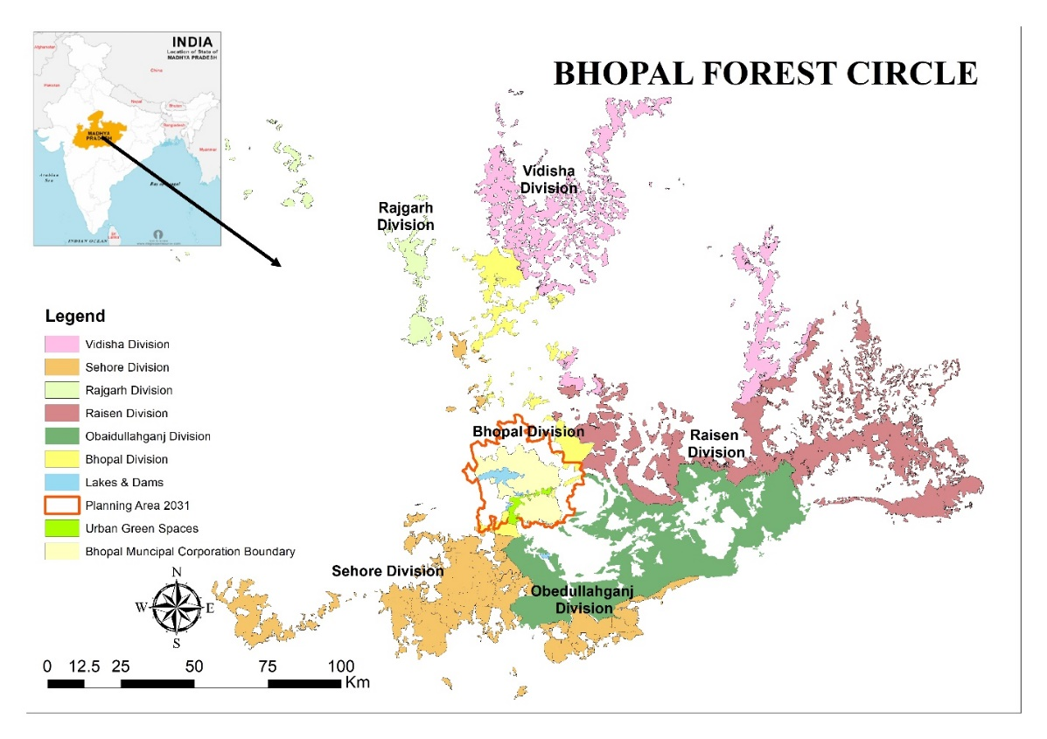
Figure 1: Bhopal Forest Circle (BFC)
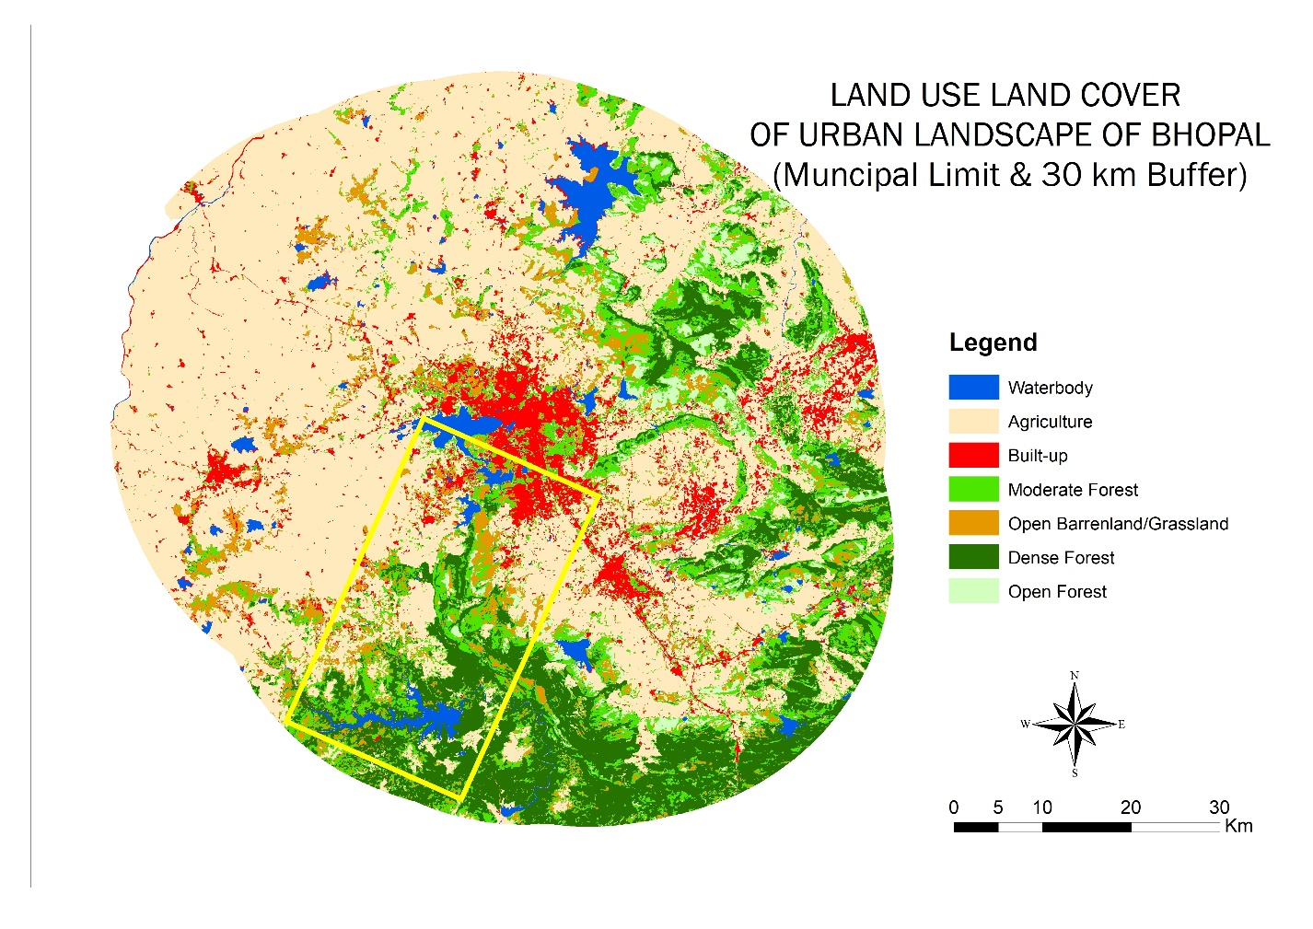
Figure 2: Urban Landscape of Bhopal City (30 km of Bhopal Municipal Limit)

CHAPTER 4
LANDSCAPE CHARACTERISTICS WITH SPECIAL REFERENCE TO TIGER PRESENCE IN DYNAMIC URBAN LANDSCAPE OF BHOPAL

CHAPTER 4
LANDSCAPE CHARACTERISTICS WITH SPECIAL REFERENCE TO TIGER PRESENCE IN DYNAMIC URBAN LANDSCAPE OF BHOPAL

4.1 Introduction
Habitat is the total of all environmental conditions of specific places occupied by wildlife species or a population of species (Tellería, 2016). Distinct species have different requirements, which can be described as suitable habitat factors, and these factors relate to important characteristics of habitat, such as vegetation, spatial structure of landscape, and different climatic conditions (Johnson, 1980). This subject has significance to conservation ecology because characterization of species habitats is essential to address the effects of habitat deprivation, fragmentation, and loss on species space use (Forman, 1995; Myers, 1997; Fahrig, 2003; Hanski, 2011). With changing land-use, the habitats of many wildlife species have become remnants of natural ecosystems, and as a consequence, species frequently occur in small and mostly unconnected populations (Saunders, 1987; Chetcuti et al., 2020; Turner et al., 2025). Wild species populations thus isolated face survival pressure, especially large carnivores that require large and continuous patches for movements and dispersal (Crooks et al., 2002; Estes et al., 2011; Ripple et al., 2014). An important challenge in ecology is to know the components and factors that determine the spatial distribution and habitat use of species (Southwood, 1977; Johnson, 1980). India is home (about 75%) to one of the world's most significant carnivores, known as the wild tiger (Panthera tigris). India has remarkable progress in tiger conservation, with the national population steadily increasing over the past decades, and according to the latest estimates, India now supports 3682 (243 SE) tigers. The central Indian landscapes, including Madhya Pradesh, Maharashtra, and Chhattisgarh, harbour one of the largest and most genetically viable populations in India, playing a key role in ensuring the long-term survival of the species (Qureshi et al., 2023). Despite this success, the survival of tigers remains unstable due to increased habitat fragmentation, urbanization, and rapidly transforming matrix around the protected areas in India (Mondal and Nagendra, 2011; Joshi et al., 2013). Understanding the spatial factors that influence tiger suitability at the landscape level is thus very important for ensuring long-term persistence of the tigers, particularly forest habitats surrounded by human-dominated regions such as Bhopal-Ratapani Landscape. This landscape was recognized as one of the potential tiger habitats due to its high tiger movements and dispersal (Qureshi et al., 2023). Recently, Ratapani has been established as Tiger Reserve and with growing tiger populations, the numbers will compete with other large tiger reserves. Despite its very high ecological importance as part of the old Vindhyas, there remains a critical knowledge gap regarding the spatial factors affecting tiger suitability in Ratapani-Bhopal landscape, particularly for the territorial forest of spread across the urban-rural gradient of Bhopal city, followed by towns of Obedullahganj, Sehore and Raisen. Understanding these spatial factors is essential for developing effective landscape-level conservation plans for future tiger habitats (Qureshi et al., 2023). Tiger management in India extends beyond the simple preservation of wildlife species it encompasses the wider approach of conserving the entire ecosystem and landscape (Wickramanayake et al., 2024; Qureshi et al., 2023).
Usually, ground-based surveys and field mapping have been central to wildlife research and various habitat assessments, which offer beneficial insights into species occurrence and habitat utilization (Rodger, 1990; Johnson, 2007). However, these traditional methods are often time-consuming and labour-intensive and also restricted in different and tough terrains (Rao et al., 2000; Henrys et al., 2019). In recent years, geospatial analysis (GIS) and remote sensing (RS) have emerged as powerful tools and methods for different habitat assessments, which offer spatially explicit and high-resolution data that overcome the limitations of previous ground-based surveys for larger areas (Rees, 1999; Turner et al., 2003; Foody, 2008). These geospatial tools enable efficient mapping of large landscape features, detection of habitat changes, and integration of multiple ecological and anthropogenic variables, thereby providing more information on wildlife habitats (Rees, 1999; Horning et al., 2010).
Among many recent approaches, spatial multi-criteria decision making, particularly the Analytical Hierarchy Process (AHP) by Saaty (1990), provides a robust and systematic approach for prioritizing and weighing diverse spatial factors that influence the habitat suitability model for tigers (Xiaofeng et al., 2011; Imam and Tesfamichael, 2013; Kumar et al, 2020; Roshani et al., 2024). The AHP method makes complex ecological problems easier by combining them into hierarchical components and enabling pairwise comparison of variables to derive important values. This method integrates both expert ground knowledge and realistic data, which ensures a logical and scientifically defensible weighing process. In habitat suitability modelling, AHP is widely applied to combine ecological and variables such as different land cover types, prey availability, terrain, and various anthropogenic variables into one model. By converting these weighted inputs into spatial layers and synthesizing through matrix-based modelling, AHP produces spatially explicit habitat suitability and presence maps for wildlife species. The outputs are essential for identifying priority habitats and potential wildlife corridors (Ahsan et al., 2025) and conflict-prone zones, and support evidence-based conservation planning. Owing to its flexibility and strong theoretical foundation, AHP has become one of the most effective tools for landscape-level habitat suitability modelling and strategic wildlife management in the critical tiger landscape (Ahsan et al., 2026).

4.2 Aim and Objective
The primary aim of this study is to evaluate the potential of tiger conservation at a larger landscape level for Bhopal-Ratapani.
The main research questions are
- What is the extent of green spaces available for tigers in the landscape?
- What is the extent of space-use by tigers in the Bhopal-Ratapani landscape?
The main objectives of this chapter are
- To create a land use land cover and forest density map using satellite imagery,
- To assess how three different spatial factors (environmental, topographic and anthropogenic) influence tiger habitat suitability and
- To develop a prioritize the suitable habitats for tigers across the larger landscape.
- To map the presence of tigers in the Bhopal-Ratapani landscape as well as the City of Bhopal.
A landscape-level understanding of tiger habitat suitability is key to management and conservation. To achieve these objectives, the present study integrated field-based ecological knowledge with geospatial factors using a multi-criteria decision-making framework employing AHP to assign weights to select variables through expert-based pairwise comparison matrices. All variables were converted into thematic raster layers, standardized, weighted, and integrated within the GIS domain to generate potential tiger suitable maps. The outcomes will highlight the potential habitats for tigers beyond the protected areas in Bhopal-Ratapani Landscape, expanding into the larger landscape of Bhopal Forest Circle.

4.3 Methodology
The study is designed into two major components.
Extent of space available in the landscape: The first step involves the generation of thorough land use and forest density (LULC) maps, providing a spatially explicit representation of the landscape ecological and anthropogenic features. The second component centers on validating the accuracy of the LULC map using the kappa coefficient, confirming the reliability and precision of the map classification. The third and final component employs the Analytical Hierarchy Process (AHP) to integrate and weigh the selected environmental, topographical, and anthropogenic variables, culminating in the creation of final tiger suitable maps using the ground data collected from the field.
The extent of space-use by tigers in the urban landscape of Bhopal city: A focused survey was carried out in the Bhopal-Ratapani landscape (with a 30 km buffer of Bhopal city) as well as the green spaces of Bhopal city.

Extent of space available for tigers in the landscape

Land use land cover map
To generate the LULC map for 2022, satellite imagery from the LANSSAT 8 Operational Land Imager (OLI) was acquired from the USGS Earth Explorer portal https://earthexplorer.usgs.gov/. Satellite imagery corresponding to the April-May period was selected to minimize the cloud cover and to ensure optimal spectral separability among land cover classes. Preprocessing of the raw data involved radiometric correction, layer staking, layer mosaicking and subsetting based on the study area boundary, and all were performed within the ArcMap 10.8 domain (ESRI, 2011). The final mosaic image was subsequently georeferenced to the Universal Transverse Mercator (UTM) coordinate system, zone 44, using WGS 84 (World Geodetic System) datum, thereby ensuring spatial congruence with the study area boundary coordinates. Following preprocessing, a supervised classification was then executed employing the Maximum Likelihood Classification (MLC) algorithm (Jenson, 1996). Representative training samples (We used 50 for waterbodies, 100 for agriculture, 80 for barren/shrublands, 70 for high dense, 90 for moderate dense, and 85 for open dense forest class) collected during extensive field surveys were utilized to train the supervised classification and generate a LULC map for seven distinct classes. The seven classes are agriculture, waterbodies, settlement, barren /shrubland, and three different forest density classes following the Forest Survey of India scheme (FSI, 2023). Based on ground observation, we classified high dense forests (70-100% canopy cover) as largely undisturbed forest regions, moderate dense forest (50-70% canopy cover) as partially disturbed, and open dense forests (10-30% canopy cover) as sparsely dense areas. The resulting classified maps were further refined using a majority filter to mitigate pixel noise, thereby enhancing spatial coherence and producing a reliable, clear land use and forest density map.

4.3.1.2 Accuracy Assessment
Subsequently, the accuracy of the final classified LULC map was assessed using ground truth points collected during the field visits. We used to set a total of 535 ground truth points to validate our final map. Quantitative measures include overall accuracy, producer accuracy, and user accuracy for the seven individual classes and finally, a kappa coefficient (κ) was then calculated for final accuracy assessment. The Kappa coefficient, also known as Cohen’s Kappa coefficient, is a statistical measure that accounts for agreement occurring by chance in classification accuracy assessments (Congalton, 2001). In contrast to overall accuracy, which just calculates the proportion of correctly classified observations, κ delivers a more reliable measure by incorporating both observed and expected agreement (Richards, 2022) and is calculated as:
𝜅 = 𝑝𝑜 − 𝑝𝑒⁄1 – 𝑝𝑒
Where p_{o} = observed accuracy (i.e., complete accuracy), calculated as:
$$p_{o}=\sum_{i=1}^{k}{\frac{kC_{ii}}{N^{2}}}$$
where Cii is the number of correctly classified samples for class i (diagonal elements of the confusion matrix), k is the number of classes, and N is the total number of samples. Expected accuracy (pe) is the proportion of agreement expected by random chance between the reference data and the classified data, calculated as
$$P_{e}= \sum_{i=1}^{k}{\frac{R_{i}× C_{i}}{N^{2}}}$$
where Ci = the column total for class i (i.e., total classified samples for class i), and Ri = the row total for class i (i.e., total reference samples for class i). Values range from -1 to 1, where values closer to 1 indicate vigorous agreement in the analysis, values close to 0 suggest agreement due to chance, and negative values indicate disagreement in the analysis. In LULC κ > 0.80 it is considered to indicate accurate agreement (Gibson, 2013; Richards, 2022), making it an extensively recognized standard for accuracy assessment in remote sensing map studies.

4.3.1.3 Habitat Suitability Analysis

Model variables
Comprehending and elucidating the factors that govern the spatial distribution of any wildlife species is pivotal for devising robust and effective strategies for habitat selection (Heinanen and Von Numers, 2009). For our study, we integrate extensive field data collected between 2019-2022, coupled with comprehensive previous secondary literature of All India tiger estimation (Jhala et al., 2019, Qureshi et al., 2023), forest department reports, and studies from different regions (Store & Jokimäki, 2003; Imam & Tesfamichael, 2013; Kumar et al., 2020; Xiaofeng, et al., 2011; Kumar et al., 2020; Roshani et al., 2024) was used to consider variables for tiger habitat suitability. Informed by previous studies, we consider environmental, topographical, and anthropogenic variables to evaluate the habitat suitability for tigers. For environmental variables, we consider land use and forest density maps; for topographic variables, we consider slope, Digital Elevation Model (DEM), and aspect; and finally, for anthropogenic variables, we consider proximity to water, roads, railways, and human settlements. Collectively, these variables were employed in the AHP framework by giving different weights to capture the complex interplay between ecological, topographical, and anthropogenic influences shaping tiger distribution. For the environmental variable, we used our LULC map prepared in the first stage, as mentioned above. For the topographical variables, we used SRTM DEM (Shuttle Radar Topography Mission 30 m resolution) obtained from https://earthdata.nasa.gov/. The downloaded DEM was further processed to generate slope and aspect maps. These thematic layers were subsequently classified into four distinct categories based on the observed suitability for tigers as determined during the field surveys and secondary literature. Finally, for our anthropogenic layers, we calculated proximity to water, roads, railways, and settlements using the Euclidean distance in ARCGIS. These layers were classified into four distinct categories described in Table 3 and showed maps in Figure 4. Areas closer to human settlements, roads, and railways represent lower suitability, while closer proximity to water indicates higher suitability (Prajapati et al., 2014).

Field data collection
We conducted tiger sign surveys within the Bhopal-Ratanpani landscape (with 30 km buffer of Bhopal city). The field was conducted in three different seasons: summer (February-July 2019), winter (November 2019-February 2020), and winter (October 2020-March 2021). A successive survey area focused on urban green spaces around Bhopal city was conducted from December 2021 to December 2022. We did not conduct the summer surveys for 2020 and 2021 due to COVID restrictions. So, data collected during winter seasons have been utilised for analysis and interpretation, which also aligns with the practices of All India Tiger Estimation, focusing on the winter season. The team of four to five members systematically examined the main trails and areas near water bodies for tiger evidence.

Analytical Hierarchy Process (AHP) and Multicriteria Decision Analysis
The AHP is a structured method for organizing and analysing complex decisions based on mathematics equations. The process involves defining the objective, selection criteria, assigning weights pairwise matrix, calculation of normalized weights, consistent ratio (CR) (Anselin et al., 1989; Saaty, 1980). The most important advantage of AHP is that it allows for marginal variations in integrating the weights depending on the species (Eastman, 1999). It is a Multi Criteria Decision Analysis (MCDA) approach that is implemented in ARCGIS, with specific weights assigned to selected layers (Saaty, 1980). The AHP depend on many measures (Saaty, 2001) selecting the parameters of multi criteria and arranging them in a hierarchical order for the criteria and determining importance by allocating them values on ranking. The rank scale of criteria ranges from 1 (equal importance) to 9 (Extreme importance) all values described in (Table 2) (Saaty, 1980, 1991). The second step is to make the pairwise matrix, which indicates the relative importance of each variable influencing tiger habitat suitability. The values of pairwise matrices were then normalized in separate tables to standardize the values from 0-1. This step is vital as it interprets ground knowledge and ecological understanding into numerical values for further analysis. The CR was then computed to ensure logical consistency and CR value less than 0.1 indicated acceptable consistency the equation is given below.
Consistency Ratio (CR) (Saaty, 1980)
Calculate weighted sum- In this step multiply the pairwise matrix (A) by the normalized weight vector (W) to get the weight sum vector (AW)
AW= A*W
Calculate Principal Eigenvalue (λ)-In this step divide each element of the weighted sum vector (AW) by the weight and then take average of this value.
$$λ_{max}=\frac{1}{n}\sum_{n=1}^{n}{\frac{AW}{W}}$$
Where:
(W<Sub>i<Sub)= maximum eigenvalue
n= number pf criteria factors
Calculate Consistency Index (CI)- This step measures how consistent the pairwise coma
This measures how consistent the pairwise comparisons are.
$$CI=\frac{{(λ}_{max}-n)}{n-1}$$
Calculate Consistency Ratio (CR)- It is a statistical measure used in AHP to evaluate how logically consistent the pairwise comparisons are when assigning relative importance to different criteria.
Where:
$$CR=\frac{CI}{n-1}$$
CI is the consistency index
RI is Random Index (n-1)
Acceptable values: CR ≤0.1
For this study we analysed AHP in two different stages 1) for land use and forest density map (the seven classes) (Table.3) and normalized values was calculated in (Table.4) separate AHP was performed for LULC and each 6 set of Euclidean distance-based layers (water, roads, railways, and human settlement) and topographic layers slope, elevation and aspect (Table 5 & 6) and normalized values was calculated (Table 7). For each run, we built pairwise comparison matrices, derived normalized weights, performed CR, and finally we produced normalized weights from (0-1). Finally, using the normalized weights combined with GIS layers generates a habitat suitability map using the linear equation (given below).

The Habitat Suitability Model
The final habitat suitability map was generated by integrating multiple environmental and anthropogenic variables using the weighted approach derived from the AHP matrix. The contribution of each variable to tiger habitat suitability was quantified through standardized weights in the AHP framework, ensuring that each variable's ecological relevance was properly accounted for in the final map. The habitat suitability model was then computed using a linear regression model as follows.
Habitat Suitability Model=β₁(LULC)+ β₂(Distance to Roads) + β₃(Distance to Railways) + β₄(Distance to Waterbodies) + β₅(Distance to Settlement) + β₆(Slope)+ β₇(DEM)+ β₇(Aspect)
Here, β1to β₇ are the regression coefficients corresponding to each explanatory variable reflecting their relative influence on tiger suitability. Following the calculation of the continuous habitat suitability values, the map was further classified into four discrete suitability classes: high, moderate, low, and very low suitability classes using a threshold determined from the ground data. The area covered by each suitability class was quantified and the proportion of each class within different forest density categories (high, moderate, open) was calculated to examine spatial relationship between forest cover and tiger habitat suitability. Finally, the predictive performance of the suitability model was evaluated by calculating the coefficient of determination (R²) between the predicted habitat suitability values and observed tiger presence collected during the field visits. This step provided a quantitative measure of model reliability and accuracy, ensuring that the habitat suitability map robustly presents the ecological and anthropogenic determinants of tiger distribution across the study area.
Table 2: Rank scale criteria for pairwise comparison matrix in AHP (Saaty, 1980, 1990)
Score | Meaning
1 | Equal Importance
2 | Between equal and moderate importance
3 | Moderate importance
4 | Between moderate and strong importance
5 | Strong importance
6 | Between strong and strong importance
7 | Vert strong importance
8 | Between very strong and extreme importance

Table 3: Weights of the criteria for each thematic layer used in Habitat suitability map
S. No. | Variable | Weight | Weight % | Suitability criteria | Sub criteria | weights
1 | Land use and density map(30*30m) | 0.34 | 34 | High | High dense, water bodies | 9
 |  |  |  | Moderate | Moderate dense | 7
 |  |  |  | low | Barren lands, open dense | 4
 |  |  |  | Very low | Settlements, agriculture | 2
2 | Distance to road | 0.16 | 16 | High | >1500 | 9
 |  |  |  | Moderate | 1000-1500 | 7
 |  |  |  | low | 500-1000 | 4
 |  |  |  | Very low | <500 | 3
3 | Distance to railways | 0.18 | 18 | High | >1500 | 9
 |  |  |  | Moderate | 1000-1500 | 7
 |  |  |  | low | 500-1000 | 5
 |  |  |  | Very low | <500 | 1
4 | Distance to water | 0.11 | 11 | High | Within 500 | 9
 |  |  |  | Moderate | 500-1000 | 7
 |  |  |  | low | 1000-1500 | 4
 |  |  |  | Very low | More than 1500 | 2
5 | Distance to settlement | 0.7 | 7 | High | >1500 | 9
 |  |  |  | Moderate | 1000-1500 | 8
 |  |  |  | low | 500-1000 | 6
 |  |  |  | Very low | <500 | 1
6 | Slope | 0.7 | 7 | High | >30 | 7
 |  |  |  | Moderate | 20-30 | 9
 |  |  |  | low | 10-20 | 5
 |  |  |  | Very low | <10 | 2
7 | DEM | 0.7 | 7 | High | 263-374 | 3
 |  |  |  | Moderate | 374-446 | 9
 |  |  |  | Low | 446-501 | 8
 |  |  |  | Very low | 501-729 | 2
8 | Aspect | 0.5 | 5 | High | North and east | 9
 |  |  |  | Moderate | Northeast and northwest | 8
 |  |  |  | low | Southeast and southwest | 6
 |  |  |  | Very low | South and west | 4

Table 4: Rank scale criteria for pairwise comparison matrix in AHP (Saaty, 1980, 1990)
LULC | High Dense | Moderate Dense | Open Dense | Shrublands | Waterbodies | Settlements | Agriculture | Total
High Dense | 1 | 6 | 3 | 3 | 5 | 4 | 3 | 25
Moderate Dense | 0.14 | 1 | 3 | 4 | 6 | 4 | 3 | 21.14
Open Dense | 0.33 | 0.33 | 1 | 3 | 8 | 5 | 2 | 19.67
Shrublands | 0.33 | 0.25 | 0.33 | 1 | 6 | 2 | 2 | 11.92
Waterbodies | 0.13 | 0.13 | 0.13 | 0.13 | 1 | 3 | 3 | 7.50
Settlements | 0.25 | 0.25 | 0.25 | 0.25 | 0.33 | 1 | 2 | 4.33
Agriculture | 0.33 | 0.33 | 0.50 | 0.33 | 0.33 | 0.33 | 1 | 3.17
Total | 2.52 | 8.29 | 8.21 | 11.71 | 26.67 | 19.33 | 16 | 92.73
Table 5: Pairwise comparison matrix for land use and density type map, which holds the preference, values for Tiger
Class | High Dense | Moderate Dense | Open Dense | Barren/ Shrublands | Water  bodies | Settlements | Agriculture | Total | Weights
High Dense | 0.40 | 0.72 | 0.37 | 0.26 | 0.19 | 0.21 | 0.19 | 2.32 | 0.33
Moderate Dense | 0.06 | 0.12 | 0.37 | 0.34 | 0.23 | 0.21 | 0.19 | 1.50 | 0.21
Open Dense | 0.13 | 0.04 | 0.12 | 0.26 | 0.30 | 0.26 | 0.13 | 1.23 | 0.18
Barren/Shrublands | 0.13 | 0.03 | 0.04 | 0.09 | 0.23 | 0.10 | 0.13 | 0.74 | 0.11
Waterbodies | 0.05 | 0.02 | 0.02 | 0.01 | 0.04 | 0.16 | 0.19 | 0.47 | 0.07
Settlement | 0.10 | 0.03 | 0.03 | 0.02 | 0.01 | 0.05 | 0.13 | 0.37 | 0.05
Agriculture | 0.13 | 0.04 | 0.06 | 0.03 | 0.01 | 0.02 | 0.06 | 0.35 | 0.05
 | 1.00 | 1.00 | 1.00 | 1.00 | 1.00 | 1.00 | 1.00 | 7.00 | 1.00

Table 6: Pairwise comparison matrix for land use and density type map and anthropogenic layers
 | LULC | Distance to road | Distance to railways | Distance to water | Distance to settlement | Slope | DEM | Aspect | Total
LULC | 1 | 5 | 4 | 3 | 7 | 4 | 3 | 4 | 31.00
Distance to road | 0.20 | 1 | 2 | 2 | 5 | 2 | 2 | 3 | 17.20
Distance to railways | 0.25 | 0.50 | 1 | 2 | 4 | 2 | 2 | 2 | 13.75
Distance to water | 0.33 | 0.50 | 0.50 | 1 | 3 | 2 | 2 | 2 | 11.33
Distance to settlement | 0.14 | 0.20 | 0.25 | 0.33 | 1 | 2 | 2 | 2 | 7.93
Slope | 0.25 | 0.50 | 0.50 | 0.50 | 0.50 | 1 | 2 | 2 | 7.25
DEM | 0.33 | 0.50 | 0.50 | 0.50 | 0.50 | 0.5 | 1 | 2 | 5.83
Aspect | 0.25 | 0.33 | 0.50 | 0.50 | 0.50 | 0.5 | 0.50 | 1 | 4.08
Total | 2.76 | 8.53 | 9.25 | 9.83 | 21.5 | 14 | 14.50 | 18 | 98.38

Table 7: Normalized pairwise comparison matrix for land use and density type map and Anthropogenic layers
LULC | Distance to road | Distance to railways | Distance to water | Distance to settlement | Slope | DEM | Aspect | Total | Weights
0.36 | 0.59 | 0.43 | 0.31 | 0.33 | 0.29 | 0.21 | 0.22 | 2.73 | 0.34
0.07 | 0.12 | 0.22 | 0.20 | 0.23 | 0.14 | 0.14 | 0.17 | 1.29 | 0.16
0.09 | 0.06 | 0.11 | 0.20 | 0.19 | 0.14 | 0.14 | 0.11 | 1.04 | 0.13
0.12 | 0.06 | 0.05 | 0.10 | 0.14 | 0.14 | 0.14 | 0.11 | 0.87 | 0.11
0.05 | 0.02 | 0.03 | 0.03 | 0.05 | 0.14 | 0.14 | 0.11 | 0.57 | 0.07
0.09 | 0.06 | 0.05 | 0.05 | 0.02 | 0.07 | 0.14 | 0.11 | 0.60 | 0.07
0.12 | 0.06 | 0.05 | 0.05 | 0.02 | 0.04 | 0.07 | 0.11 | 0.52 | 0.07
0.09 | 0.04 | 0.05 | 0.05 | 0.02 | 0.04 | 0.03 | 0.06 | 0.38 | 0.05
1.00 | 1.00 | 1.00 | 1.00 | 1.00 | 1.00 | 1.00 | 1.00 | 8.00 | 1.00

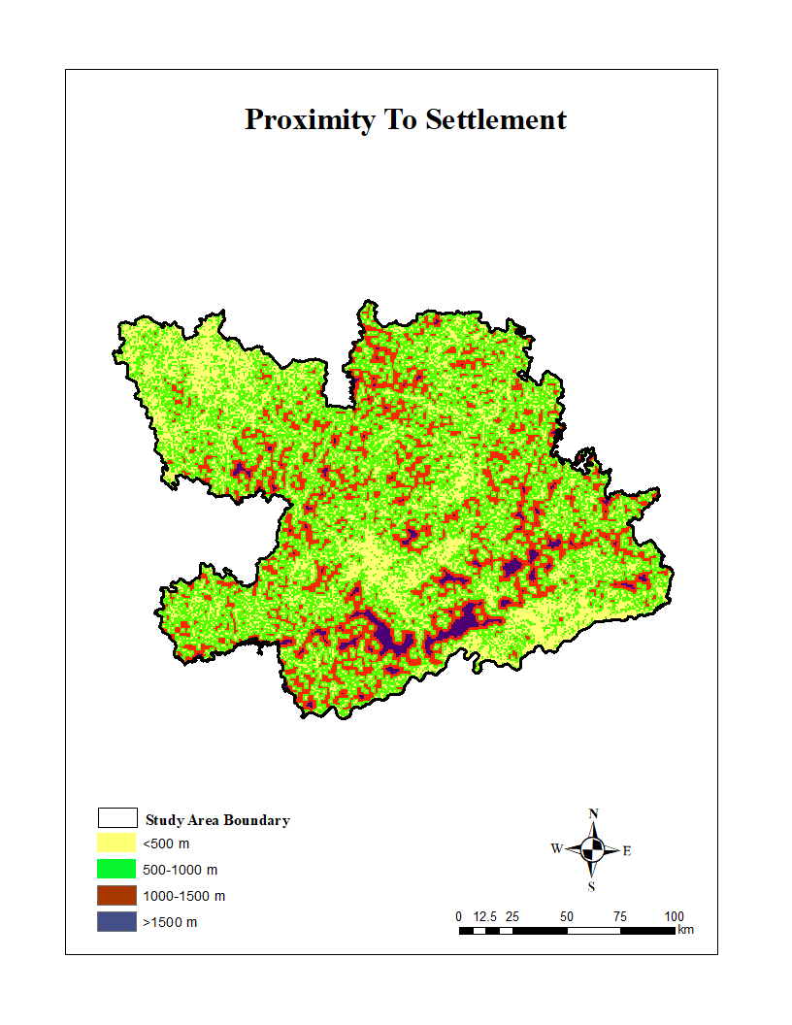
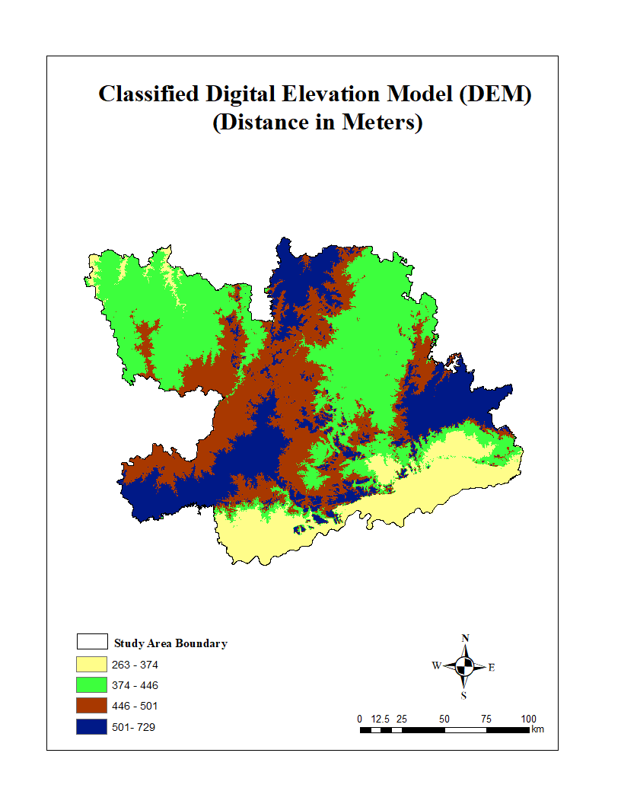
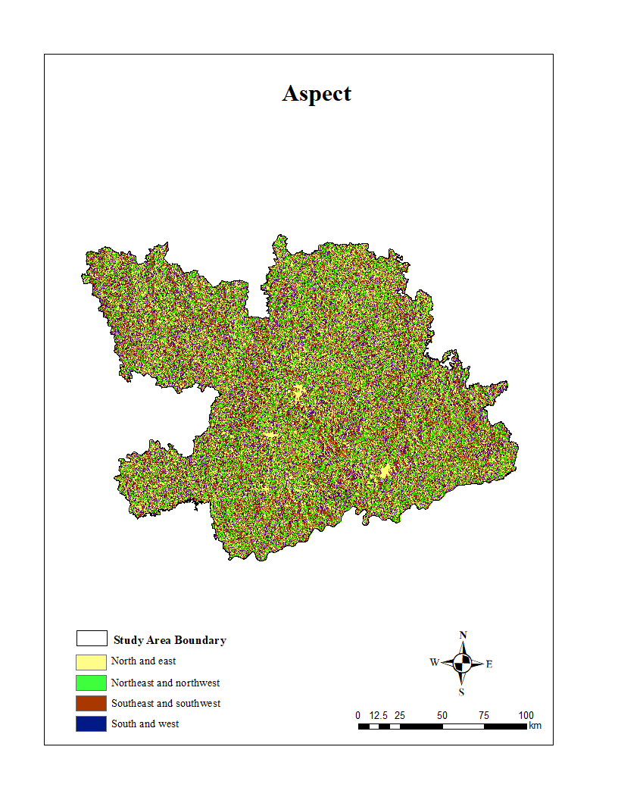
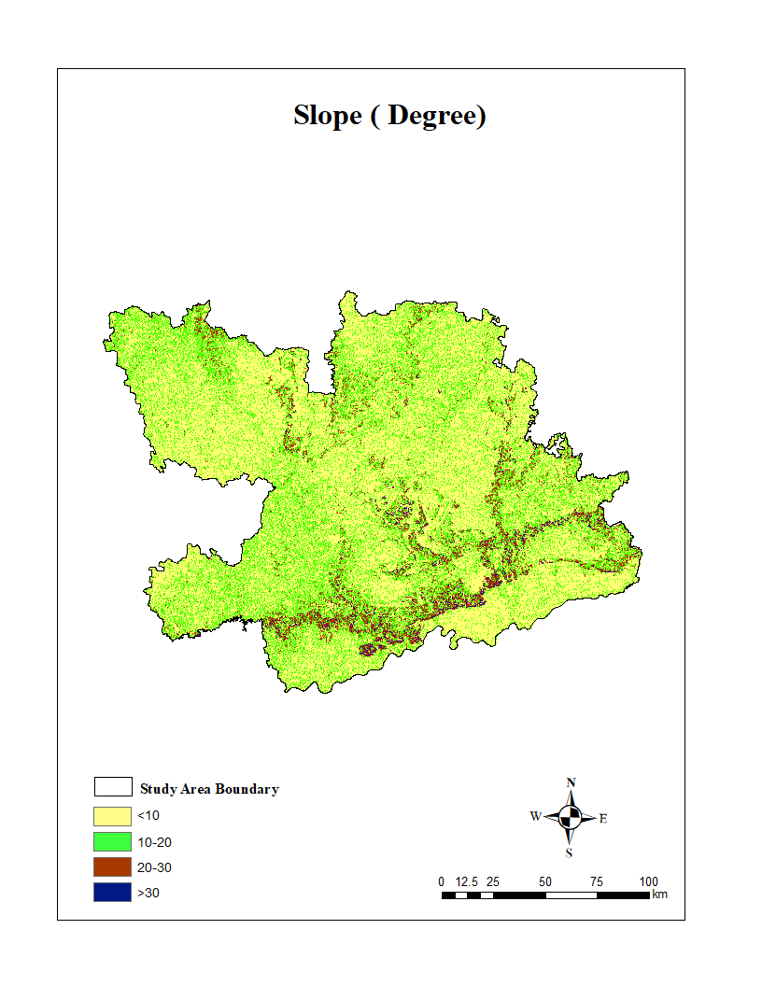
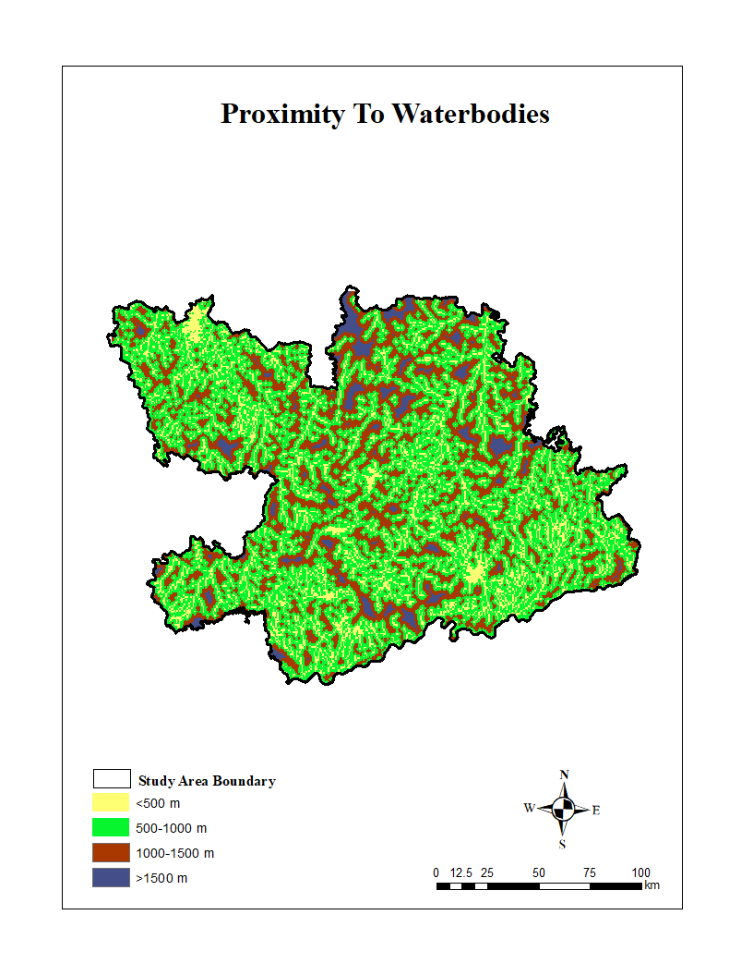
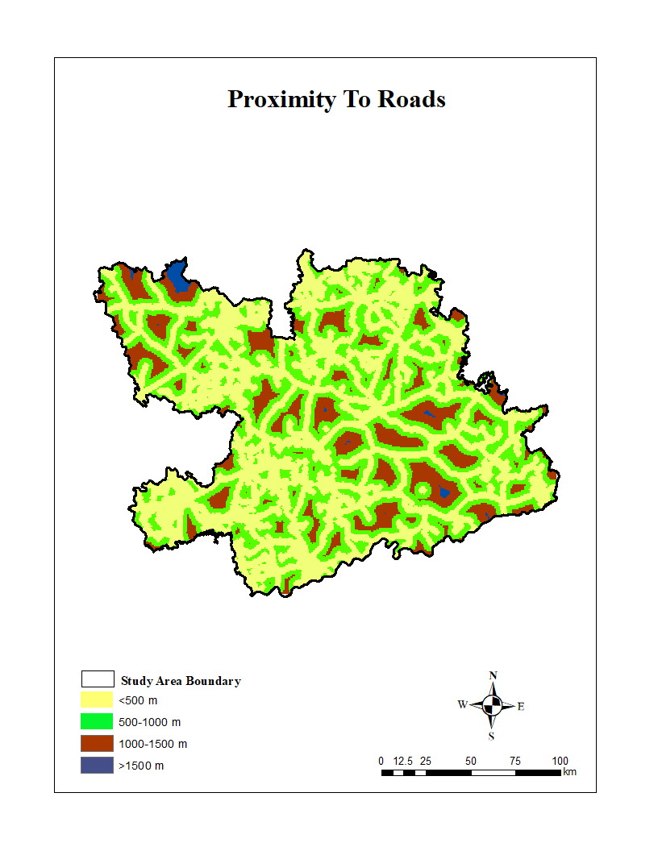
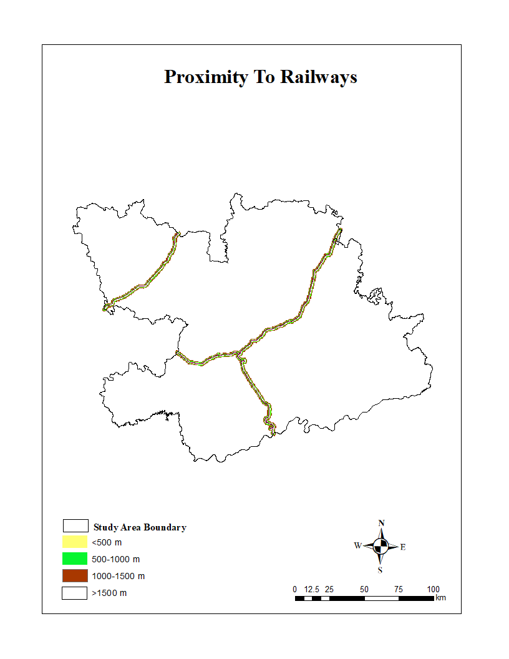
Figure 3: Classified proximity (Euclidean distance maps) generated in ArcMap for four different anthropogenic variables influencing tiger suitability

Figure 4: Classified proximity (Euclidean distance maps) generated in ArcMap for four different anthropogenic variables influencing tiger suitability (a) distance to waterbodies (b) distance to roads (c) distance to settlements and (d) distance to railways and three different classified topographical variables (e) Digital Elevation Model (DEM) (f) Slope and (g) aspect

Habitat Connectivity model
This section uses focal-species analysis for Tigers in an urban landscape to apply a graph-theoretic approach to habitat connectivity in and around the Bhopal Forest circle. The most suitable habitats derived from habitat suitability assessment results were used to analyze the habitat connectivity model. To perform connectivity analysis, we used software called Conefor Sensinode 2.6 (Saura & Hortal, 2007), and this can be downloaded from http://www.conefor.org. Conefor uses a graph theory approach, with points (nodes) representing habitat patches and lines (edges) denoting linkages between patches/habitats (Minor and Urban, 2008; Mitsova et al., 2011). The program utilizes the Probability of Connectivity (PC) index, which determines the likelihood of two habitats being randomly put together. The probability of Connectivity (PC) index is the chance of two habitats randomly put on a landscape being capable of reaching or accessing each other (interconnected by links) in a collection of n habitat patches that have a linkage level in it. The index formula (1) is as follows:
PC= $\frac{\sum_{i=1}^{n}{\sum_{j=1}^{n}{aiajPij}}}{A_{L}^{2}}$
Where ai and aj are the areas in the patch habitats i and j, and AL is the overall area of the study area landscape (Bhopal circle), which includes suitable habitats as patches. The probability of a patch (defined as a collection of steps that do not pass the same patch again) is the outcome of a pij at each step in the path between two habitats. While p*ij is defined as the greatest probability result of all pathways connecting patches i and j. If patches i and j are close enough, the greatest route probability outcome is just a step (direct movement between patches i and j). If the distance between patches i and j is longer, then the optimum probability path will consist of numerous steps through stepping stones containing 𝑝𝑖𝑗 ∗ > pij.
The information necessary for input in this program is node data, which provides a list of existing suitable habitats as nodes along with key attributes like patch area, patch size, percentage of forest cover, water bodies, settlements, and agriculture in the habitats. Connection data contains the information needed to characterize connections between two nodes (suitable habitats) in the landscape. The data used in this investigation is the Euclidean distance between each patch. This step produces a patch function based on three fractions: dPCintra, dPCflux, and connector. This percentage depicts the contribution of each patch to the connectivity and overall landscape. dPCintra displays the patch's contribution to intrapatch connection, as well as its weight if it is connected to other patches (suitable habitats). So, while being isolated, the patch retains its weight. dPCflux indicates patch capability as the first or last patch in species dispersion. Connectors demonstrate the suitable habitat role as a connecting piece or stepping stone between patch ecosystems. The degree of connectivity between patches was determined by the availability of habitat and the distance between them in the landscape. The dispersal distance used here to analyze the habitat connectivity was 10 km (Tiger dispersal distance).
Cost of tiger dispersal was defined in 30 m cells by a surface comprised of x, y and z, where z was a uniform impedance that represented the cost of moving through that cell, i.e., its resistance to dispersal. Weights were approximated, based on perceived traversability. Cells corresponding to areas of suitable habitat were given a weight of 1; all other land variables were given a weight of less than 1. We use the framework because the distance of the least-cost path is a better approximation of the actual distance covered than a straight line between patches. The full model approach was built in GIS platform using the spatial layer data sets. To focus on focal species, which is tigers, we chose only patches greater than 10ha in our analyses (Schaller). Because all habitat patches, regardless of size, are given the lowest value on the cost surface, they are implicitly included in all analyses in that the species can traverse them easily as stepping-stones, accruing minimal cost.

Extent of space-use by tigers in the urban landscape of Bhopal

Tiger presence survey in outer area
To understand the prospect of tiger conservation in the urban landscape of Bhopal, all the green spaces outside city's municipal limits (BMC) have been demarcated and mapped. These green spaces include Bhopal-Ratapani Corridor patches, Protected Areas, forest patches on revenue lands, scrublands, etc. Forest patches and Scrublands of a minimum size of 1 sq. km have been considered for the study. The total area of the study area, including Bhopal City and 30 km outside BMC limit, is 5978 sq. km, with an area of the BMC limit of 414 sq. km.
During the summer survey (Feb-July 2019), winter survey (Nov 2019-Feb 2020), and winter survey (October 2020-March 2021), we carried out an extensive field survey to understand the presence of Tigers in the urban landscape of Bhopal. We use the All India Tiger Estimation Phase I protocol for the survey. The lowest forest-administered units, i.e., beats, were considered for the survey in forest areas. The summer survey of 2020 and 2021 has been dropped due to COVID-19 Protocols. So, data collected during winter seasons have been utilised for analysis and interpretation, which also aligns with the practices of All India Tiger Estimation, focusing on the winter season. In dry-deciduous landscapes of Bhopal, wildlife movements get restricted around waterbodies during summer.
The main trails, secondary trails, and waterbodies were intensively surveyed for large carnivore presence and indirect signs during the survey. These outermost areas include the Ratapani Tiger Reserve (recently declared) and territorial forest divisions of Bhopal, Raisen, and Sehore. Each track after 100m was considered as an individual track until the same track continued.
As the survey was also conducted in AITE 2022 so, the survey results were shown in grids of 5x5 sq km for tiger presence in a 30km buffer of Bhopal city. (Figure 12)

4.3.2.2 Mapping Green Spaces of Bhopal City
To map green spaces (patches) in Bhopal city, Google Earth Pro was used. City boundary is demarcated using the city boundary shapefile (.shp) provided by the website of the Municipal Corporation of Bhopal city. Grids were placed to ensure marking of all patches. By using zoom in feature, green patches are demarcated using polygons on a 65 cm pan-sharpened image of Google Earth. Only patches with an area of more than one hectare of green cover are marked, assuming areas with less than 1 hectare would be a very small area and would not provide the minimum habitat requirement for wildlife in an urban ecosystem. The layer from Google Earth of demarcated polygons of green spaces is then exported and converted from .kml format to .shp format in ArcGIS 10.8.

4.3.2.3 Focused Tiger Presence survey in Bhopal city
Our focused surveys aimed to ascertain tiger presence within Bhopal's city limit occurred during November 2021-July 2022, including winter (November 2021-January 2022), and summer (April 2022-June 2022) seasons. As part of a long-term systematic study, prior baseline survey 2019-2021 highlighted the tiger movement area in Kaliasot-Kerwa area of southern Bhopal city. Based on this, we marked 5 trails covering major areas of Kaliasot-kerwa belt for our survey. During our fieldwork, we meticulously examined main trails, secondary trails, and water bodies for signs of large carnivores in mapped urban green spaces. This included urban green spaces, including city parks, Protected/reserved Forest (PF/RF) of Samardha Range, Bhopal Division, open green spaces along waterbodies, and institutions such as WALMI, MANIT, Khushilal Govt Hospital, etc. Each distinct track was recorded as an individual track if it extended beyond 100 meters, while tiger scats discovered during these surveys were collected, dried, and stored in ziplock bags for dietary analysis.
Based on the field surveys, the encounter rate has been calculated for each replicate as well as seasonal variation. The identified locations were also used for camera trapping during All India Tiger Estimation 2022 in 2 sq km grids. The survey results are depicted in 2 sq km grids covering major open urban green spaces.

4.4 Results

4.4.1 Extent of space-use available for tigers in the landscape

4.4.1.1 Land use land cover mapping
The Land use land cover map of the study area, covering a total area of approximately 31, 309.02km² showed a highly heterogeneous landscape. Agricultural land dominated the study area extending over about 21,079.78 km^{2,} which constitutes total 67.32% of the total area, reflecting the predominantly human-modified nature of the landscape. Among different forest density classes, moderately dense forest covers about 2,996 km² (9.56%) followed by high dense forest area, which occupies about 2,423.54 km2 (7.74%), and open dense forest region accounts approximately 673.87 km²(2.15%) of the landscape. Barren/ Shrublands span around 1,876.67km² (5.99%), representing scattered vegetation and degraded patches, whereas settlement encompasses 1614.66 km^{2,} contributing only 5.99% of the total area (Table 8 and Figure 5)
Table 8: Area of land use and land cover (2022)
S. No. | Class name | Area (km²) | Per cent (%)
1 | Water bodies | 645.07 | 2.06
2 | Agriculture | 21079.78 | 67.32
3 | Settlement | 1614.66 | 5.15
4 | Scrub/Grasslands | 1876.67 | 5.99
5 | High dense forest | 2423.54 | 7.74
6 | Moderate dense forest | 2996.03 | 9.56
7 | Low dense forest | 673.87 | 2.15
 | Total | 31309.02 | 100

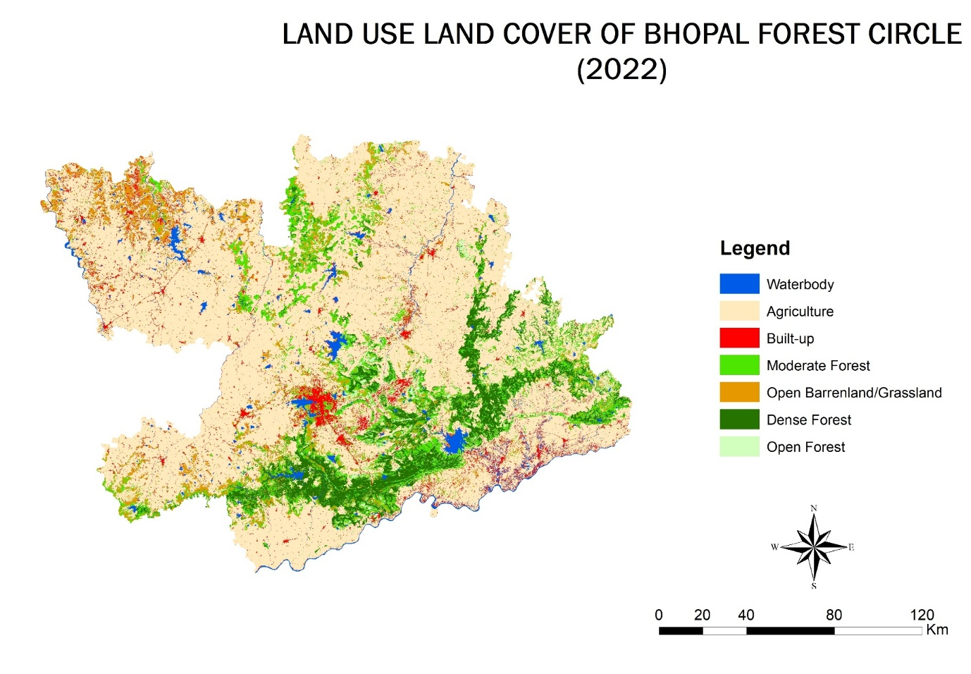
Figure 5 Land use Land cover map (2022) of Bhopal Forest Circle

Accuracy Assessment
The results of the accuracy assessment indicate that the classification accomplished is at a high level with an overall accuracy of 95.30% and a kappa coefficient 𝜅 of 0.93 (Table 9). It signifies strong agreement between the classified and reference data. Among all the classes, waterbodies appeared with a 96.00% producer accuracy and a user accuracy of 94.10%, indicating that the maximum number of waterbodies pixels were correctly classified for the study area with very little missclassification. Among other classes, the agriculture class showed 95.2% producers and 96.90% user accuracy, also indicating strong classification consistency. Among forest density types, all three categories, high, moderate, and open dense, maintained accuracies above 95% for both user and producer accuracy. The low commission and omission errors across all land use and density type classes further indicate that classification was reliable, with high precision values
Table 9: Results of accuracy assessment for the land use and forest density classification map
Class Name | Reference data | Correctly classified | Producer accuracy (PA%) | Users accuracy (UA%) | Commission error (%) | Omission error (%)
Water bodies | 50 | 48 | 96.0 | 94.1 | 5.9 | 4.0
Agriculture | 100 | 95 | 95.2 | 96.9 | 3.1 | 5.0
Settlement | 60 | 57 | 95.0 | 93.4 | 6.6 | 5.0
Barren/shrublands | 80 | 76 | 75.0 | 94.0 | 6.0 | 5.0
High dense forest | 70 | 67 | 95.7 | 94.4 | 5.6 | 4.3
Moderate dense forest | 90 | 86 | 95.8 | 95.6 | 4.4 | 4.4
Open dense forest | 85 | 81 | 95.3 | 95.3 | 4.7 | 4.7
Total | 535 | 510 | Overall accuracy= 95.3% | Kappa coefficient= 0.93

Habitat Suitability Analysis
The results of the CR values for land use and forest density map shows maximum eigenvalue of the adjusted pairwise comparison matrix was calculated as 7.00 (Table 4 above ). Using this value, the CI was determined as 0.12 and the result of the CR as 0.09. Since the CR is less than 0.1, the matrix is considered consistent, indicating that pairwise comparisons are logically coherent and acceptable for AHP analysis. For the pairwise matrix for LULC and layers with anthropogenic variable, topographical variables, the CI of the adjusted was 0.08, and the CR ratio was 0.06, and both these values are below the standard threshold of 0.1, indicating that pairwise comparisons in the matrix are consistent for decision making in AHP analysis for final tiger habitat suitability. To evaluate the influence of different land use, forest density, and anthropogenic and topographical variables on habitat suitability, a multiple linear equation model was developed using the AHP-derived weights as predictor variables and habitat suitability index as dependent variable (given below).
Habitat suitbility Index (HIS)= 0.34(Lulc)+0.16(road)+0.13(railways)+ 0.11(water)+0.07(settlement)+ 0.07(slope)+ 0.07(DEM)+0.05(aspect)
The model results explained a substantial proportion of the variance in habitat suitability (R²=0.91), indicating a strong predictive relationship between the selected variables and the suitability index (Figure 4). Among the predictors, land use land cover, and forest density type variables exhibited the highest standardised coefficient (β=0.34), confirming it as the most influential variable in determining the tiger suitability in the landscape. This was followed by distance to road (β=0.16) and distance to railways (β=0.13), signifying that proximity to these anthropogenic factors affects the tiger suitability. Topographic factors such as DEM, slope, and aspect showed relatively lower but significant contributions. The habitat suitability analysis showed a clear spatial stratification of suitability classes across the landscape. Highly suitable habitats encompass 2,609.27 km², forming the core zones most capable of supporting the tiger habitats. Most highly suitable habitats are composed of highly dense forest regions, which accounts approximately 97.37% of the total dense forest. Areas classified as highly suitable constitute 8.33% of the total study landscape. Moderately dense regions cover approximately 2,909.09 km², predominantly occurring outside the highly dense forest areas, where the majority (78.45%) is located within the moderately dense forest class. The moderately suitable regions occupy 9.29% of the total study area. Low suitability areas account for about 4547.05km², indicating marginal habitats with limited ecological support. Most low-suitable regions are comprised of open dense forest (56.86%) and barren/shrublands (43.55%). In contrast the agriculture and settlement matrix which dominated the landscape exhibits the lowest suitability covering an extensive region 21.243.43 km², occasionally through seasonal streams and nala; thereby reflecting the considerable anthropogenic footprint and reduced habitat quality in these regions (Table.9). Together Sehore and Raisen districts occupy most of the highly suitable areas totalling 2499.27 km², which accounts for 95.78% of the total high suitability area. Only 5.23% of the total highly suitable areas reside in Vidisha, Bhopal, and Rajgarh. Within the study region, Raisen district accounts for 1783.55km² of the total highly suitable area out of 2609.27 km². Out of the total state area of 8458.94 km² this represents about 21.04% of the highly suitable area. The Sehore district encompasses a total district area of 6564.57 km^{2,} with 715.72km² identified as a highly suitable habitat, roughly 10.90% of the total state area. Raisen district occupies 1607.02 km² of the total moderately suitable region of 2909.52 km^{2,} while Sehore district occupies 1607.02 km² of the moderately suitable occupies 596.57 km². Together they account for 2303.59 km^{2,} representing approximately 75.00 % of the total moderately suitable region and the remaining 25.01% distributed across Vidisha, Bhopal and Rajgarh districts. The low suitability regions are distributed across all five districts within Raisen, contributing (27.16%) Rajgarh (23.66%), Vidisha (18.46%), Sehore (15.70%), and Bhopal (15.02%), summing to 4547.34 km² (Figures 6 & 7).
Table 10: Habitat suitable areas in Bhopal Forest Circle
Class | Area (Km²) | Percentage
High Suitable | 2,609.27 | 8.33
Moderate Suitable | 2,909.52 | 9.29
Low suitable | 4547.34 | 14.52
Very Low Suitable | 21243.5 | 67.84
Total | 31,309.62 | 100.00

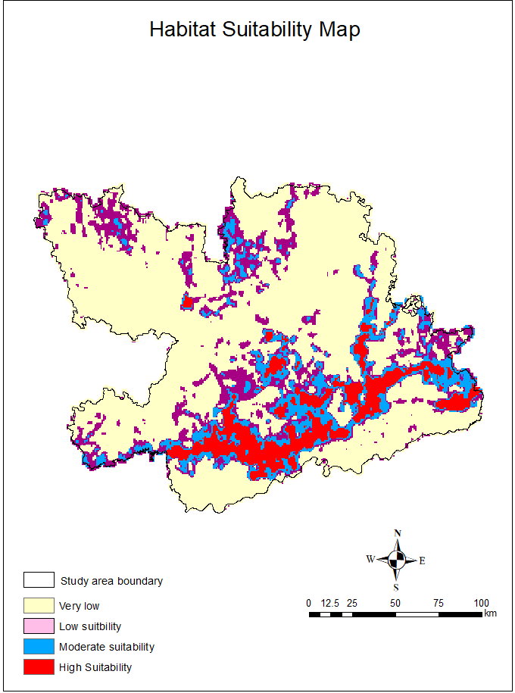
Figure 6: Spatial distribution of tiger habitat suitability across the study area
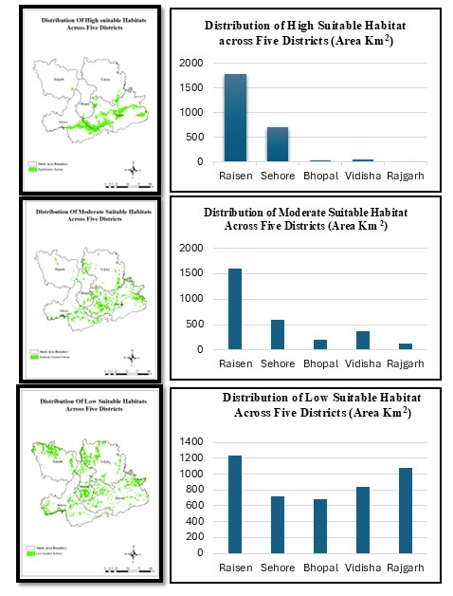
Figure 7: Spatial distribution of various tiger habitat suitability across five districts of Bhopal Forest Circle

Figure 8 The graph shows the relationship between observed and predicted values of the modeled variables, with the coefficient of determination(R2) indicating the goodness of fit.

Graph theory-based connectivity model
Twenty patches generated from habitat suitability modelling ranked by the degree of importance of each patch in the overall habitat management. The results of Probability of connectivity index showed that patch 4 becomes the most important tiger habitat with (dPC = 74.2%, dPCflux = 22.5%, dPCintra = 49.9%), followed by patch 5 (dPC = 21.9%, dPCflux = 17.3%, dPCintra = 3.2 %), patch 6 (dPC = 13%, dPCflux = 1.24%, dPCintra = 10.8%), patch 7 (dPC = 7.1%, dPCflux = 0.001%, dPCintra = 7.1%) and patch 10 (dPC = 6%, dPCflux = 1%, dPCintra = 5.9%). These five patches are the large (dA> 10%) and become the most important patched in terms of habitat connectivity. The next order of the degree importance is patch patch 7, patch 14, patch 8, patch 17, patch 1, patch 9, patch 5, patch 10, patch 12, patch 15, patch 4, patch 3 and the lowest rank patch is patch 2.
Highest suitability patches includes the Samardha-Veerpura Connecting forest, Ratapani Core (Dahod, Delawari, Barkheda, Bineka), Obedullahganj Territorial (Chiklod), Samardha-Raisen West Patch, and part of Silwani-Garhi in Raisen. The moderate suitability patches include Ichawar, Ladkui, Rehti of Sehore, Chilwaha, Sultanpur of Obedullahganj Terrritorial, Begamganj of Raisen and Part of Rajgarh division along Narsinghgarh Sanctuary. The lowest suitability patches including parts of Sajapur area of Sehore and neighburing areas of Kheoni WLS and territorial parts of Rajgarh, majority of them are disconnected patch.
Table 11: Patch areas and details
Patch number | Area
1 | 322
2 | 249
3 | 278
4 | 334
5 | 331
6 | 358
7 | 475
8 | 329
9 | 248
10 | 392
11 | 367
12 | 402
13 | 337
14 | 278
15 | 259
16 | 412
17 | 377
18 | 276
19 | 387
20 | 376

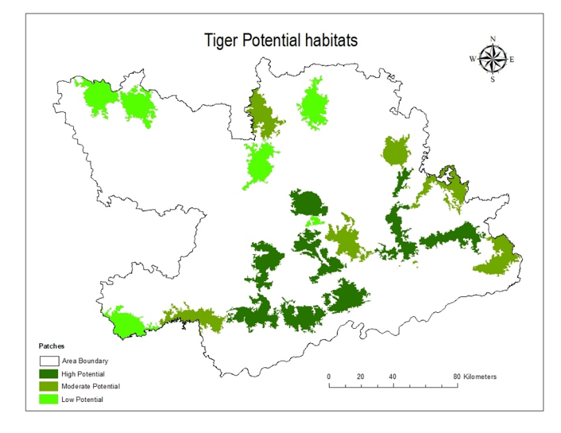
Figure 9: Habitat suitability across different patches of BFC
The outputs of the graph theory results are illustrated in Figure 10. The application of weighted graph model using least cost path model calculates a total of 703 vertices and 246 nodes (Linear connections). This shows that landscape consists of 246 important habitats and those relate to 703 connectivity vertices. The frequency distribution of vertices demonstrates that maximum vertices are of length from 8.5km to 10km. The minimum length evaluated was 55.1 km that means the patches less than 5 km are not connected hence indicate fragmented landscape. The mean distance path length was 5666 km with the standard deviation of 2845.5 value. The maximum nodes and vertices were obtained for the southern region that comprises the maximum high dense forest region and the undisturbed habitats. Highest suitable patches show large number of nodes and vertices making clusters of maximum connectivity. Out of 246 nodes we obtain 129 nodes in the Ratapani region with land use covering high dense region. The results show subgraphs and breaking of the smaller connection in the moderate suitable habitats with only 57 vertices and rest of them shows no connections with other patches indicating low connectivity in the northern most region with least connections but moderate suitable landscape. The eastern part also shows high connectivity with good patches of moderate suitable habitats. there are only 4 habitat patches with low suitability that gain shows minimum connectivity only one among them that in the southern west region shows some amount of habitat connectivity with other patches. The minimum spanning tree based on area-weighted dispersal flux is very different. the tree is weighted by larger patches which produce a larger amount of connectivity. We found that tigers perceived this landscape differently, as a function of their dispersal capabilities. For instance, Figures 11 show that the landscape has a great variability in connectivity depending on dispersal distance.
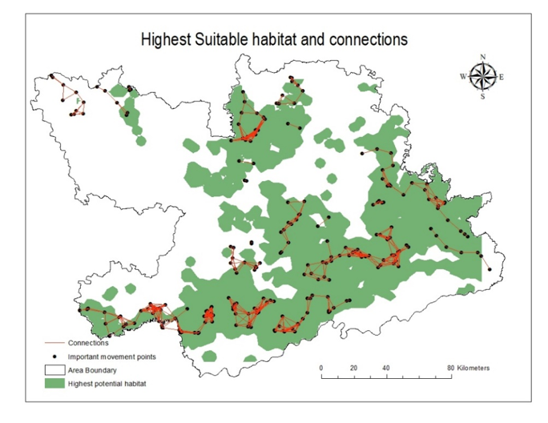
Figure 10: Vertices and nodes Identified using Graph Theory in Bhopal Forest CIrcle
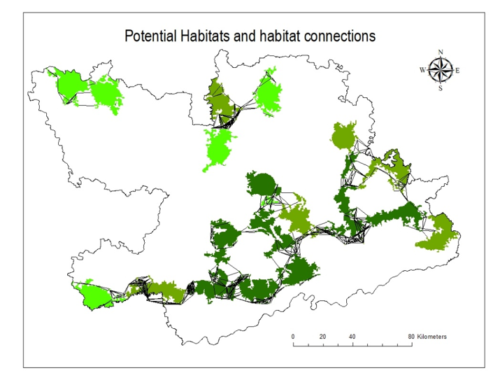
Figure 11: Potential habitats and habitat connections across Bhopal Forest Circle

Extent of space-use by tigers in the urban landscape of Bhopal

4.4.2.1 Tiger presence in outer areas
Tiger presence in the urban landscape of Bhopal, all green areas in BMC, and forest areas in a 30km buffer have been surveyed in beats and depicted in 112 grids of 5x5 sq km. The results state a total of 112 grids were surveyed in Ratapani Tiger Reserve (Dahod, Delawari, Bineka, & Barkheda range) as well as the territorial forest of Bhopal (Samardha Range), Sehore (Veerpura, Sehore & Rehti), and Obedullahganj (Chiklod & Gauharganj Range), and 78 grids recorded with tiger presence within connected forest patches around Bhopal city. (Figure 12)
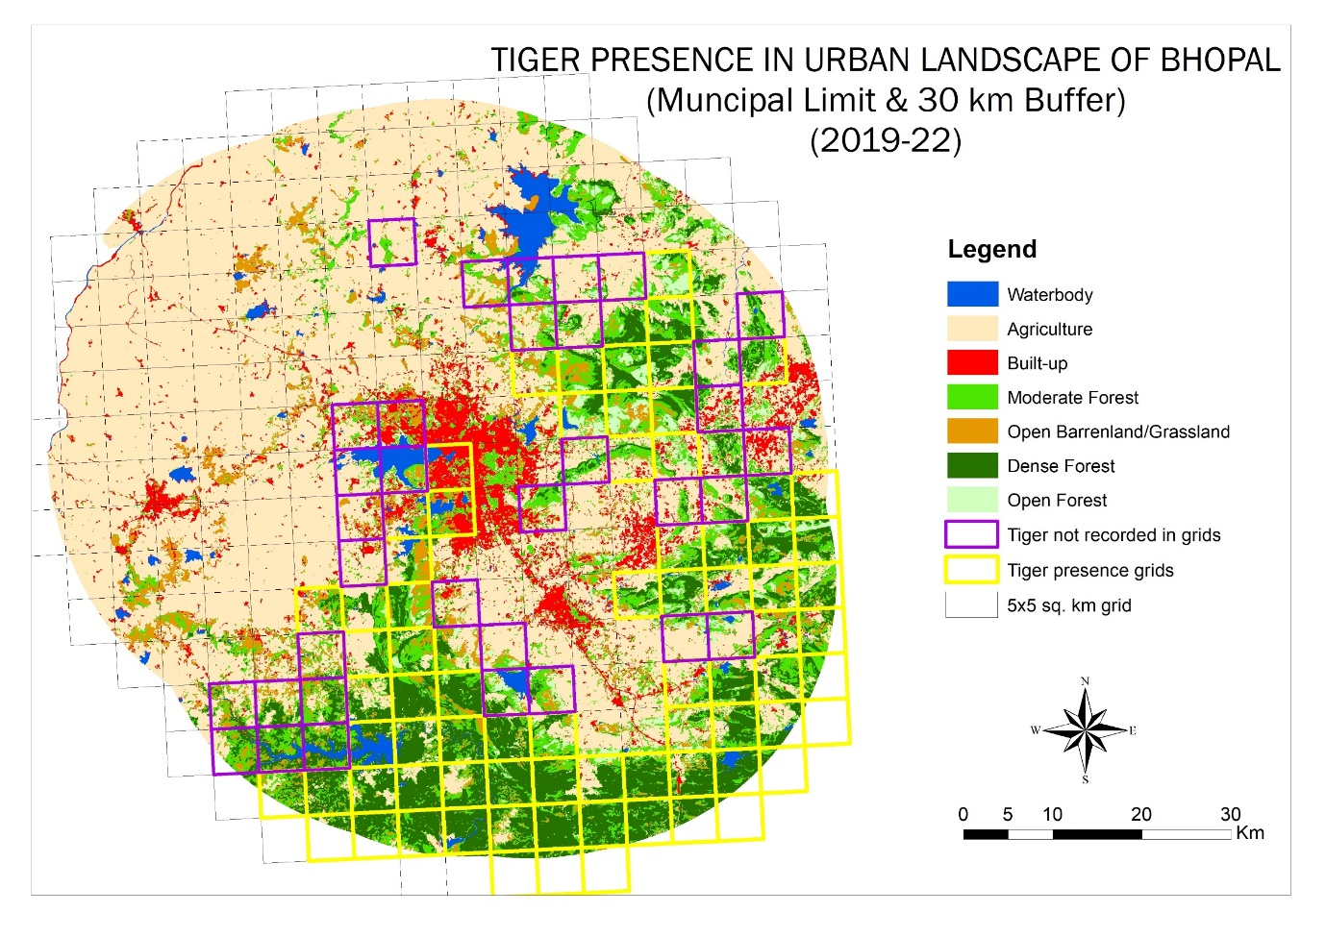
Figure 12: Tiger presence in Urban landscape of Bhopal (Municipal limit & 30km buffer) 2019-22
AITE 2022 identifies Bhopal-Ratapani complex as the largest tiger population in the Malwa region, with Phase I data estimating tiger sign less than 0.5 per km and density based on camera traps Ď SECR (per 100 sq. km) 2.30 (SE 0.31) in Ratapani Tiger Reserve (part of Obedullahganj Territorial Forest). (Status of Tigers, 2022)

Mapping Greenspaces in Bhopal City
The results of the land use and cover map for Bhopal city conclude that the total area comprises 413.97 sq. km of which Settlement dominate covering 37.16% (153.86 sq. km) followed by Agriculture class was covering the outer areas of the city around 29.73% (123.07 sq. km); Urban Green Spaces constituting 25.01% (103.55 sq. km) and Waterbodies constituting 8.08% (33.47 sq.km) (Table 12 & Figure 13). The Khapa value came to 0.88 for the LULC maps, which indicates the classification of land use and land cover is estimated better.
The KML files of green spaces have been converted into vector format using ArcGIS 10.8. A total of 535 patches have been identified, of which 248 green patches were more than 1 hectare, and numerous small patches are present in the city. The 248 patches have been extracted and merged with the Land Use Land Cover map. (Figure 14)
Table 12: Results of the Land Use Land Cover Classified Map for 2022
S. No | Class name | Area in sq. km | % of Area
1 | Water bodies | 33.477625 | 8.086852
2 | Agriculture | 123.076894 | 29.73044
3 | Settlement | 153.861904 | 37.16687
4 | Urban Green Spaces | 103.559582 | 25.01584
 | Total | 413.976005 | 100

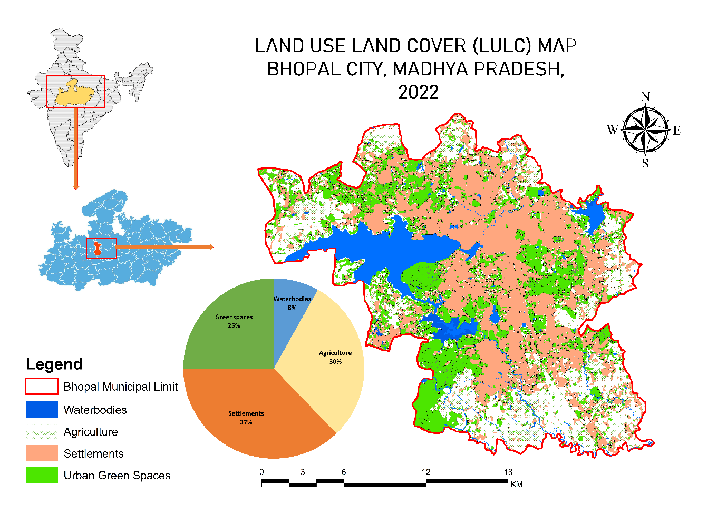
Figure 13: Land use land cover map of Bhopal city
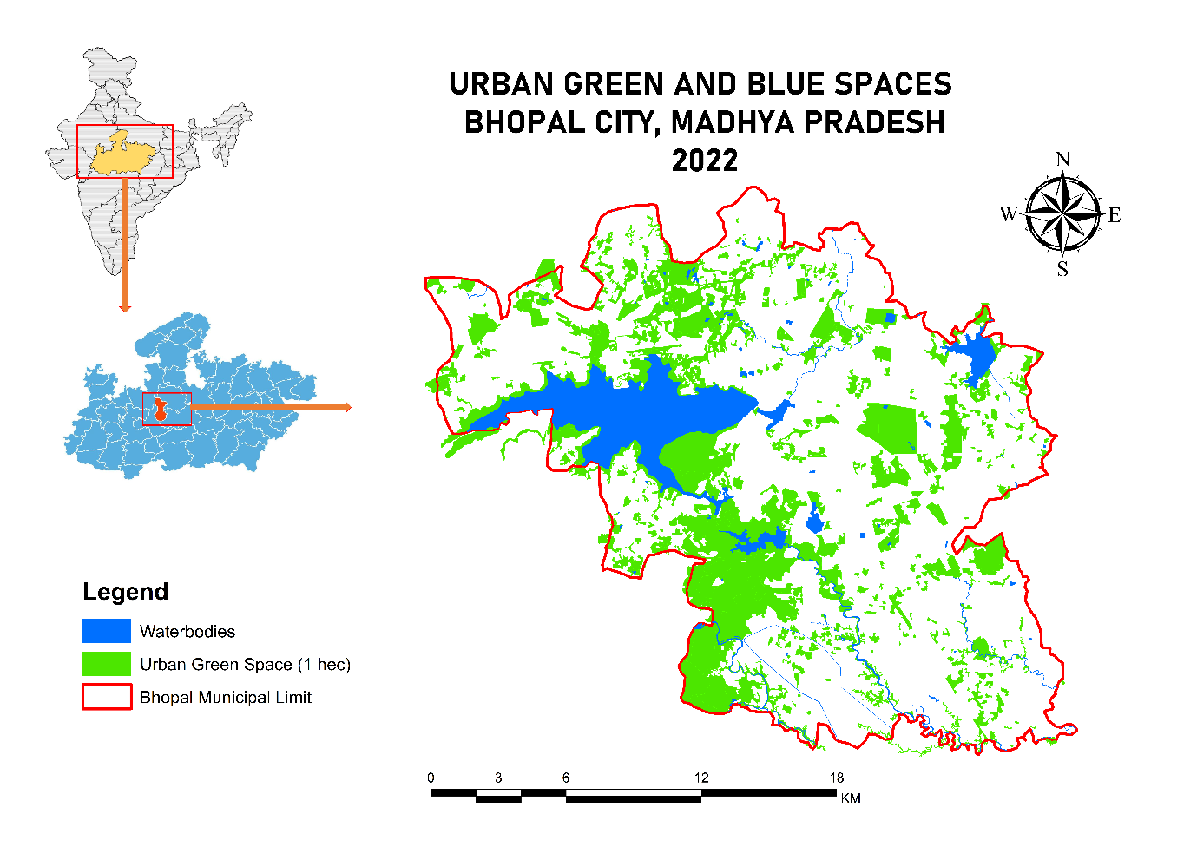
Figure 14: Mapped Blue-Green spaces of Bhopal city

Focused Tiger Presence survey in Bhopal City
During the field survey 2021-22, we intensively monitored urban green spaces of Bhopal city, focusing Kaliasot-Kerwa area. Out of 250 grids of 2 sq km, tiger presence has been recorded in 19 grids of the southern-western part of Bhopal city. Based on camera trap records, 4 individuals were recorded during the survey period of AITE 2022 in city limits, including a dominant male (T3), a breeding female (T 123), and 2 sub-adult cubs (T1233 & T1234). A transient male also used the green space (ST 21-421), which was captured and relocated from MANIT in October 2022, followed by a litter of four cubs of T123 in late 2022. (Table 13)
During the survey, a minimum of 45 Km has been covered with a trail length of 7.65-10.80 km. During the survey, the encounter rate for field tracks and signs of tigers is Highest in Winter Replicate 1, i.e., 1.82 signs/km, and lowest in Summer Replicate 3, i.e., 0.88 signs/km (Table 2). As per seasonal variations, the mean signs recorded per km in Winter is 1.45 signs/km (SD 0.33), and Summer is 0.93 signs/km (SD 0.06) estates lower encounter rate in summer.
The field survey was also supported with camera trap reports on tiger presence and movement from 2021-22, including AITE 2022 and field monitoring.
Table 13: Tiger sign encounter rate with respect to survey efforts in Bhopal city
Season | Survey Replication | No. of signs |  |  |  |  |  | Encounter
Season | Survey Replication | Trail 1 | Trail 2 | Trail 3 | Trail 4 | Trail 5 | Total | Signs/km
Winter | 1 | 15 | 27 | 11 | 21 | 9 | 83 | 1.82
Winter | 2 | 11 | 15 | 13 | 13 | 9 | 61 | 1.34
Winter | 3 | 10 | 12 | 12 | 14 | 6 | 54 | 1.18
Summer | 1 | 5 | 15 | 7 | 10 | 5 | 42 | 0.92
Summer | 2 | 8 | 11 | 10 | 9 | 7 | 45 | 0.99
Summer | 3 | 7 | 8 | 11 | 7 | 7 | 40 | 0.88
 | Length KM | 7.73 | 9.21 | 7.65 | 10.2 | 10.8 | 45.59
 | Details | Kerwa-Chichali beat | Daulatpur-chichali-kerwa | Mendora beat | Walmi-Kaliasot River | Kaliasot dam-Manit

4.5 Discussion

4.5.1 Extent of space available for tigers in the urban landscape of Bhopal
The present study features the complex interactions between landscape structure, anthropogenic pressure, and topographical factors in shaping tiger habitat suitability across a highly human-modified matrix of central India. The land use and forest density assessment showed that agricultural land dominated the study area, accounting for more than two-thirds of the total area. Forested habitats, particularly high and moderately dense forests, are limited to Sehore and Raisen districts, particularly within Ratapani tiger reserve and the territorial forest of Obedullahganj, Raisen and Sehore. A small proportion of low-density forest coupled with barren /shrubland, indicated patchiness in the landscape, specifically in the Bhopal, Rajgarh, and Vidisha districts. This patchiness specifies forest degradation and habitat isolation in the region. The settlement region occupies 5.15% of the landscape, furthermore emphasizing the strong human footprint. Most of the settlement regions occur in the Bhopal district. Settlement together with agriculture form continuous stretches of human-dominated land that disrupt ecological flows, contribute to habitat fragmentation, and increase the risk of conflicts. Overall, the ecological interpretation of the land use map showed that landscape forest habitats are restricted to small and scattered patches embedded within a matrix of agriculture. The high classification accuracy (95.30%; k=0.93) further improves the reliability of the land use and forest density map used for later habitat suitability modelling. Both producer and user accuracy for land use and forest density exceeded 93%, and omission/commission errors remained comparatively low, indicating that the underlying spatial data offers a strong framework for habitat assessment. The strong agreement between the classified and reference datasets also underscores the effectiveness of Landsat 8 imagery and supervised classification techniques for mapping the heterogeneous central India region. The Analytical Hierarchy Process (AHP) provided a consistent and scientifically defensible weighting framework for integrating land use, anthropogenic, and topographic variables into tiger suitability models. Consistency Ratio (CR<0.1) confirmed that expert conclusions in the pairwise comparisons were coherent and reliable. The multiple regression model derived from the AHP weights exhibited a very high explanatory power (R²=0.91), demonstrating that the selected variables collectively offer a strong positive capacity for determining tiger habitat suitability. Among all predictors, land use and forest density emerged as the most influential variables, reinforcing that dense forest structure remains the primary determinant for tiger habitat suitability. This outcome suggests that tigers show a very clear pattern of habitat selection in our study area; they prefer dense forest areas surrounded by moderately suitable forests. This pattern aligns with earlier studies emphasizing the importance of the forest dense and core region with minimal human disturbance in supporting tigers (Karanth et al., 2004; Kanagaraj et al., 2011; Sarkar et al., 2018; Yumnam et al., 2014; Roshani et al., 2024; Qureshi et al., 2023). Although topographic variables contributed very less contribution in tiger habitat suitability (Kerley et al., 2002). Consistent with other studies (Sunquist & Sunquist, 2001), our findings also show that proximity to water sources is an important variable for tiger habitat suitability. The spatial distribution of habitat suitability reflects a clear ecological gradient driven by forest continuity and anthropogenic intensity. Highly suitable habitats are strongly concentrated in dense forest, particularly within Sehore and Raisen districts, specifically a long forest stretch around the Ratapani Tiger Reserve. Raisen alone contributes two-thirds of the highly suitable region, underscoring the primary ecological threshold in the study area. The forest patch located in the extreme eastern part of Raisen district exhibited a high suitability area, indicating that the forest outside the Ratapani TR possesses substantial potential to support tiger populations. Sehore district also contributes significantly to the overall habitat suitability, indicating strong potential tiger habitat. These findings align with earlier studies indicating that dense forest belts in central India serve as crucial tiger habitats (Qureshi et al., 2023). Moderately suitable habitats were mostly at the periphery of the core dense forest regions outside the RTR regions. These areas in Raisen and Sehore districts are dominated by moderately dense forest areas and partly disturbed habitats embedded around the agriculture and settlement matrix, and these may serve as buffer zones or dispersal pathways for tiger movements. The dominance of moderately suitable regions in Raisen and Sehore indicated that districts not only contain core forest habitats but also potential expansion zones for future tiger corridor development. Low suitability habitats are widely distributed across all five districts, with the largest portion in the Raisen district. Notably, a major continuous low suitability habitat patch in upper Bhopal forms a critical linkage with high suitability areas extending towards Rajgarh and RTR regions, indicating the potential future strengthening of tiger habitats and connectivity across the landscape. The area used to have tigers in the Berasia area around 10 years ago. The AITE 2022 results states presence of 96 individual tigers in the Bhopal-Ratapani-Kheoni Landscape, which aligns with the outcomes of the study proved the AHP as a robust and scientifically demonstrable multicriteria decision-making framework for integrating diverse ecological, anthropogenic, and topographical variables into tiger habitat suitability, like previous studies (Imam & Tesfamichael, ,2013; Kumar et al., 2020). AHP enables the systematic incorporation of expert knowledge while maintaining logical consistency in variable weighing, making it particularly effective for landscape-level analysis with limited ground data and in a mosaic landscape (Saaty, 1980). The low consistency ratio obtained in our study confirms that expert ground knowledge used in different pairwise matrices was strong and reliable, thereby strengthening the credibility of the derived habitat outcomes.
The graph model results show high connectivity in the urban landscape of Bhopal, those indicate the movement zones that are of high potential for tiger habitats. One patch of suitable habitat is coming in the urban city representative the urban spaces as stepping stones for tigers with a good probability of connectivity with the southern and northern forest regions. The overall combined results of the landscape metrics and habitat suitability model give the best outcomes, which show that spatial layers water and dense forest are the key variables playing a role in tiger presence. The study also highlights that settlements are not playing a negative role in the tiger presence. The study also highlights northern forest areas of Raisen-Vidisha as stepping stones in the agricultural land cover regions having disconnected and less connectivity in the upper part that constitute less suitable patches and high open dense forest mostly dominated by agriculture. The eastern zone has a moderate amount of connectivity in the form of Raisen Division for tigers with the most dense forest class, which is connected with other classes with high connections in recent surveys, and opportunistic records of tigers have been reported from this area. The southern portion has maximum continuity, more tiger presence, high suitable patches, more water bodies, far from the density of roads and railways, but the existing roads and railways are severely impacting Ratapani Core, etc.
The outcomes of the study demonstrate that tiger habitat in the higly human modified landcape is primarily governed by the forest density and proximity to several anthropogenic variables, with topographic varibles factors playing a comparitively a minor role in the model.

Extent of space-use by tigers in the urban landscape of Bhopal
The study demonstrates that urban landscapes, when embedded with green and blue spaces and connectivity in the larger landscape, can support large carnivores, including Tigers (Panthera tigris). With integrated assessment of LULC mapping focusing on urban green spaces and systematic sign-based surveys, the study provides empirical evidence that Bhopal city functions as an ecologically important fundamental of the broader tiger conservation landscape of central India.
LULC analysis states a heterogeneous urban matrix dominated by settlement and surrounded by agriculture in the outskirts of municipal limits, retaining substantial urban green spaces and waterbodies comprising more than 25% of the city area and extending the connectivity with the larger landscape of Bhopal-Ratapani-Dewas Complex, which has been identified as an important tiger habitat of central India (Qureshi et al., 2023). The tiger estimated population states doubled number since 4th cycle to 5th cycle, i.e., 2018-2022, at 96 tigers (SE 9) within an area of 4,530 sq km (Qureshi et al., 2023). The identified 248 green patches highlight the continuity of vegetated habitats across the city, associated with riparian and institutional matrix forming a structurally connected network facilitating tiger movement, foraging, and sharing space with human society.
Systematic tiger sign surveys conducted across standardised trails and repeated seasonal replicates confirmed the consistent presence of tigers in urban green spaces. The encounter rates ranged from 0.88 to 1.82 signs per km, with mean values substantially higher during winter compared to summer. The seasonal variations explain the role of ecological factors such as prey and water availability, and anthropogenic influences such as space use. The continuous presence of tiger signs on the same trails ensures frequent use as territory rather than sporadic incursions.
The presence of tigers in urban green spaces of Bhopal city underscores conservation values of urban green spaces and the importance of integrating them in urban planning to support wildlife as well as sustainability. Protecting key green-blue spaces, regulating development in critical areas, and adopting proactive conflict mitigation are essential to ensure continued connectivity between urban areas and the adjoining Ratapani Tiger Reserve, as well as sustaining human-wildlife coexistence.

CHAPTER 5
PREY-BASE AVAILABILITY AND UTILISATION BY TIGERS IN URBAN LANDSCAPE OF BHOPAL

CHAPTER 5
PREY-BASE AVAILABILITY AND UTILISATION BY TIGERS IN URBAN LANDSCAPE OF BHOPAL

5.1 Introduction
Tigers (Panthera tigris), as apex predators, play a vital role in maintaining ecosystem balance by regulating prey populations and influencing trophic dynamics. Their survival is inherently tied to prey availability, diversity, and habitat quality, which dictate their population density, spatial distribution, and overall health (Fuller and Sievert, 2001; Karanth et al., 2004; Hayward et al., 2007; Fuller et al., 2010; Simcharoen et al., 2014; Upadhyaya et al., 2018). However, these ecological relationships are increasingly influenced by anthropogenic pressures, habitat fragmentation, and shifting prey compositions within a given landscape, necessitating a deeper understanding of predator-prey interactions and adaptability in such contexts. Prey choice by large felids including tigers, plays a key part in determining their life history strategies, including movement, habitat selection, social structure, geographical distribution and reproductive success (Sunquist and Sunquist 1989). Although tigers kill prey ranging in size from small mammals to a larger heavy gaur (Bos gaurus), the bulk of their diet is obtained predominantly from deer species (Grey 2009), which contribute up to 75% of the prey biomass requirement of the Tiger in most parts of its range (Sunquist 1981, Sunquist et al., 1999, Stoen and Wegge 1996, Biswas and Sankar 2002, Grey 2009).
Prey species and diet are central to understanding carnivore ecology (Karanth and Sunquist, 1995, 2002; Ramakrishnan et al., 1999; Jiang et al., 2017). While easily available prey has been linked to growing tiger, the distinction between potential prey, prey availability and prey selection remains crucial (Odden and Wegge, 2009). Tigers diet is shaped by factors such as prey body size, habitat conditions, availability, and human disturbances (Bagchi et al., 2003). In human-modified environments, dietary shifts may occur, including increased predation on domestic livestock, which has significant implications for conservation and conflict mitigation (Kolipaka et al., 2017).
In areas with high prey abundance, tigers consumed a diverse range of prey species, including sambar deer, chital, and wild pigs. However, in areas with low prey abundance, tigers primarily fed on smaller prey such as hares and rodents. Finally, competition with other carnivores, such as leopards and dholes, can also influence tiger food preferences (Ramesh et al., 2012). In areas where large ungulates are abundant, tigers may specialize in hunting specific species such as sambar deer. Multiple prey items are rare in scats of large predators such as tigers (Biswas & Sankar, 2002) and lions (Mukherjee et al., 1994), whereas they are common in smaller carnivores like canids (Reynolds & Aebischer, 1991).
In a study conducted by Sankar et al. (2002), the authors found that the food habits of tigers in the dry deciduous forest of Sariska Tiger Reserve, India, were significantly different from those of tigers in the tropical moist forest of Periyar Tiger Reserve, India. Tigers in the dry deciduous forest primarily fed on chital, while tigers in the tropical moist forest primarily fed on sambar deer. Similarly, a study conducted by Karanth et al. (2004) in the Bandipur National Park, India, found that the food habits of tigers varied depending on the type of forest habitat. Tigers in the dry deciduous forest primarily fed on chital, while tigers in the moist deciduous forest primarily fed on sambar deer. A study conducted by Matt W Hayard (2012) suggested that wild boar and sambar deer are significantly preferred by tigers, with red deer and barasingha likely to be significantly preferred also with a larger sample size.
Recent studies have highlighted that despite the presence of abundant wild prey, tigers in different life stages often exhibit reliance on livestock, indicating possible constraints on prey access, habitat suitability, and easy accessibility (Karanth and Sunquist, 1995; Bagchi et al., 2003; Sharma et al., 2013; Kolipaka et al., 2017). Given the rapid urban expansion and habitat transformation to suit human uses in Central India, the interface between tigers and human landscapes demands urgent attention.
The current study focuses on the urban landscape of Bhopal, Madhya Pradesh, and seeks to address two critical questions:
(1) How does wild and domestic prey distribution, abundance, and composition change across Bhopal urban - peri-urban gradients and land Mosaic?
(2) What is the diet of tigers using these mosaic landscapes?
By examining these dynamics, the study aims to contribute to a more nuanced understanding of prey-predator interactions in human-dominated mosaic landscapes, ultimately informing conservation interventions, habitat prioritization, and conflict mitigation strategies in rapidly changing environments.
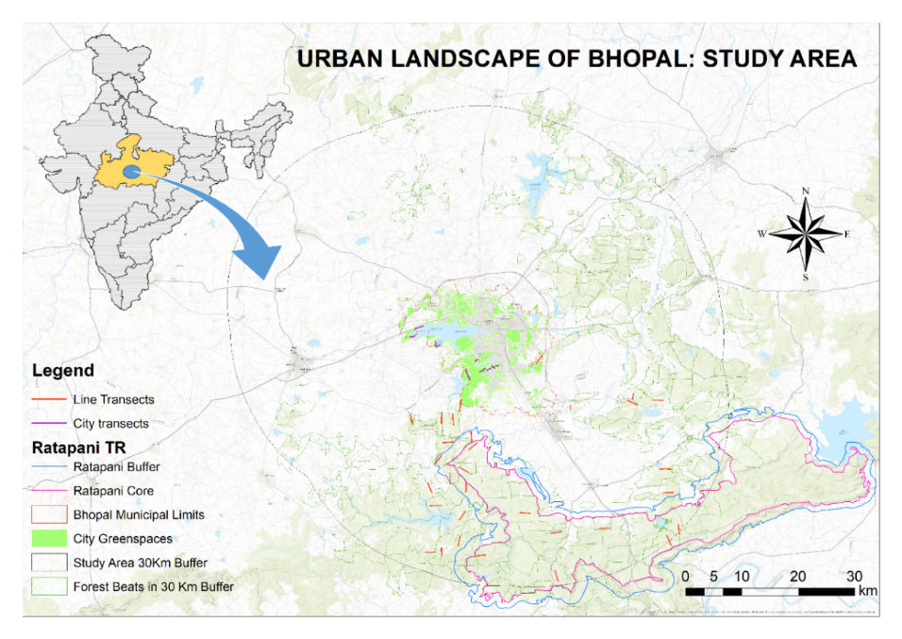
Figure 15: Map showing distribution of Line transects utilised for prey-base estimation (2019-2021)
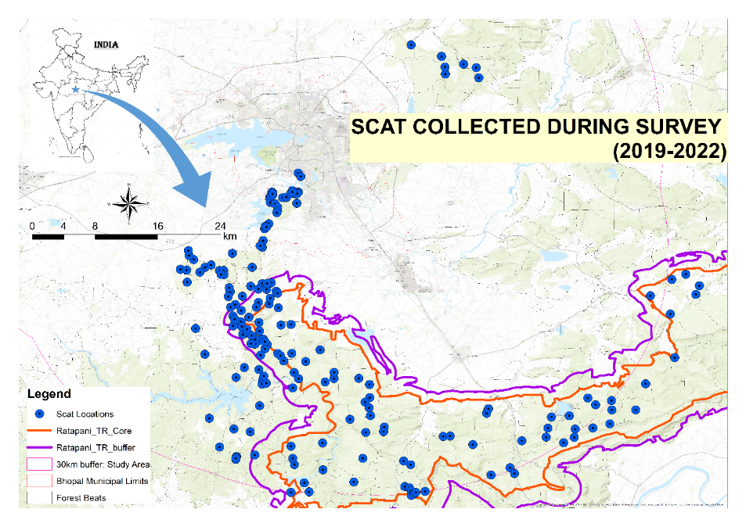
Figure 16: Map of Scat locations (n=227) utilized for estimating prey-preference for tigers in urban landscape of Bhopal

5.2 Methodology

5.2.1 Method

5.2.1.1 Sampling Design
Forest Beats were designated as the primary sampling units in this study. Line Transects were established as part of the All India Tiger Estimation (AITE), a comprehensive four-year initiative aimed at assessing tiger populations, co-predators, and prey across India. A total of 40 transects were selected: 14 in the Samardha Range of Bhopal, 11 in the Veerpura Range of Sehore (which connects Bhopal city to the Ratapani Forest), and 15 in the Obedullahganj division, selected based on a random number generator in Microsoft Excel 2016 to ensure unbiased placement.
Green spaces of Bhopal city were mapped using Google Earth, selecting those with a minimum 1-hectare size, while patches smaller than this threshold were excluded.
Additionally, 12 transects were identified within the green spaces of Bhopal. These included two AITE-based line transects (Mendora and Laharpur beats), along with ten newly established 1 km transects established specifically to evaluate prey availability within the urban landscape. (Figure 15)

5.2.1.2 Field Survey Procedures

Line Transect Survey for Prey Base
The line transect survey was conducted across 40 transects, within a 30 km buffer zone around the urban landscape during the winters of 2019–20 and 2020–21. In 2022, a rapid assessment method (Jhala et al. 2021) was employed to survey the 12 additional transects in green spaces of Bhopal city. Each transect was surveyed three times across both winter and summer seasons to account for seasonal variation in the city.

5.2.1.3 Tracks and Sign Survey for Scat Collection
Surveys for tiger presence within Bhopal’s urban landscape were conducted during summer (February–July 2019), winter (November 2019–February 2020), and winter (October 2020–March 2021). A subsequent survey (December 2021–December 2022) specifically focused on urban green spaces. Due to COVID-19 restrictions, summer surveys for 2020 and 2021 were not conducted (Figure 16). So, data collected during winter seasons have been utilised for analysis and interpretation, which also aligns with the practices of All India Tiger Estimation focusing during the winter season.
Field teams systematically examined main trails, secondary trails, and water bodies for evidence of large carnivores, particularly in areas adjacent to the Ratapani Tiger Reserve and the surrounding forest divisions of Bhopal, Raisen, Obedullahganj, and Sehore. Distinct tracks exceeding 100 meters were recorded as individual observations. Tiger scats discovered during these surveys were collected, air-dried, and stored in ziplock bags for subsequent dietary analysis.

5.2.1.4. Analysis

Prey Base Estimation
Prey community diversity was assessed using established methodologies for estimating species richness and abundance (Müeller-Dombois and Ellenberg, 1974). The density and frequency of prey species were calculated to quantify their distribution across surveyed habitats.

Dietary Preferences of Tigers
Scat analysis was conducted to determine the dietary preferences of tigers, following well-established methods for identifying undigested prey remains (Schaller, 1967; Johnsingh, 1992; Karanth and Sunquist, 1995; Biswas and Sankar, 2002). Scats collected along transects and forest trails were distinguished from those of other predators based on morphology and associated field signs such as scrapes and tracks. Hair remnants within scats were compared to reference samples prepared according to Mukherjee et al. 1994 for species identification.
For microscopic hair analysis, 15 hairs were randomly selected from each scat sample to ensure unbiased representation. The hairs were treated with ethanol (2–5 minutes) to remove surface oils before embedding in a nail polish cast on a glass slide. A single hair strand was placed in the wet polish and allowed to dry for 5–10 minutes, creating an impression that was subsequently examined under a compound microscope at 10x and 40x magnification. A grid-based random selection method was employed to enhance analytical rigor, ensuring representative sampling of hair specimens.
Species identification was based on cuticular, medullary, and cross-sectional characteristics, using the reference guide "Species Identification from Guard Hair of Selected Indian Mammals." This enabled precise matching of histological features to prey species.
Prey Base Richness and Abundance
Species diversity was calculated using the Shannon diversity index
Shannon Index (𝐻’). Species diversity was calculated using the Shannon Index:
𝐻’ = −∑𝑝𝑖 ln 𝑝𝑖.
Here, 𝑝𝑖 is the proportion of the 𝑖th species in the total sample. The number of species (species richness) in the community and their evenness in abundance (or equitability) are the two parameters that define 𝐻’.
Pielou’s Evenness Index (Equitability) or 𝐽’. The species evenness is the proportion of individuals within a species. Evenness of species indicates their relative abundance on the site
𝐽’= 𝐻/ ln 𝑆
Here, 𝑆 is the number of species present in the site.
Recognizing that initial surveys often underestimate species richness, we applied various sampling models and estimators such as Chao 1, ACE, and Jackknife estimators to account for undetected species (Gotelli et al. 2010). These estimators were specifically utilized on abundance data to derive estimated species richness through the Palaeontology Statistics (PAST 5.0) software (Hammer and Harper, 2001).
Chao 1
Chao1 = S + F1(F1 - 1) / (2 (F2 + 1)), where F1 is the number of singleton species and F2 the number of doubleton species. Equation 1
ACE: Abundance Coverage-based Estimator of species richness
S_ace=S_abund+S_rare/C_ace +F1/C_ace *〖γ_ace〗^2 Equation 2
Where:
S_rare=∑_(k=1) ^10 F_k is the number of rare species in a sample (each with 10 or fewer individuals).
S_abund=∑_(k=11) ^(S_obs) F_k is the number of abundant species in a sample (each with more than 10 individuals)
n_rare=∑_(k=1) ^10 〖kF_k 〗 is the total number of individuals in the rare species.
C_ace=1-f_1/n_rare is the sample cover estimate which is the proportion of all individuals in rare species that are not singletons.
〖γ_ace〗^2 is the coefficient of variation,
〖γ_ace〗^2=max [S_rare/C_ace (∑_(k=1) ^10〖k(k-1) f_k 〗)/ (n_rare) (n_rare-1) -1,0] Equation 3

5.2.2 Statistical Analysis
Analysis of Variance (ANOVA) was performed to assess significant differences in prey base availability across landscapes (Bhopal, Sehore, and Obedullahganj division) and Bhopal city. Additionally, seasonal variation in prey availability within Bhopal city was examined to determine fluctuations in prey dynamics.
ANOVA was also performed to assess significant differences in prey base preferences in tiger scats across landscape gradients (Bhopal city, Bhopal-Ratapani Connecting Forest, and Ratapani Tiger Reserve) and Bhopal city.

5.3 Results

5.3.1 Prey Distribution

5.3.1.1 Community Diversity and Richness
During the survey, 14 prey species were recorded within a 30 km buffer zone encompassing Bhopal, Sehore, and Obedullahganj, while 12 prey species were documented within Bhopal city. Rarefaction curves at both the landscape and city levels indicate that the sampling effort was adequate, as the species accumulation curve approaches an asymptote, suggesting sufficient representation of prey diversity (Figure 17).
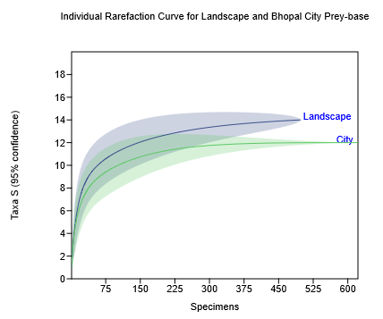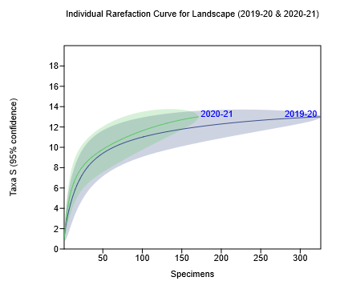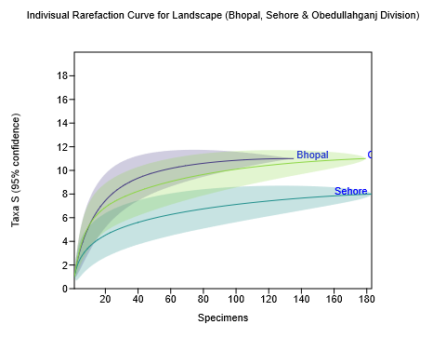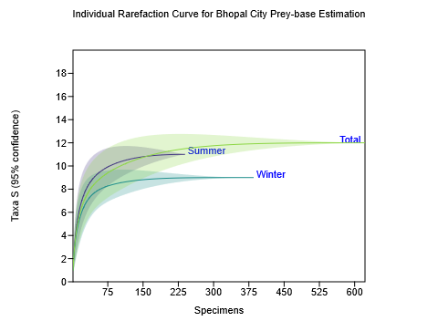
Figure 17: Individual rarefaction curve for Prey-base in the landscape and Bhopal city
Among the larger prey species (Figure 18), nilgai exhibited a widespread distribution, with a frequency of occurrence of 58.33%, a density of 2.75 individuals per trail, and an abundance of 4.71 individuals per trail within Bhopal city. In contrast, nilgai in the broader landscape had a lower frequency (30%), density (1.125 individuals per trail), and abundance (3.75 individuals per trail). Domestic cattle were another prevalent prey species, with a frequency of 58.33%, a density of 11.83 individuals per trail, and an abundance of 20.29 individuals per trail in Bhopal city, compared to a frequency of 37.5%, a density of 5.175 individuals per trail, and an abundance of 13.8 individuals per trail in the broader landscape. Blackbuck and four-horned antelope were recorded in both the landscape and urban settings, while domestic goat and buffalo were also commonly observed across both areas.
Pigs and free-ranging domestic dogs were particularly abundant in Bhopal city, reflecting the impacts of urbanization. Conversely, the buffer zone exhibited a higher frequency and density of cheetal (25% frequency, 0.7 individuals per trail density, 2.8 individuals per trail abundance) and langur (1.48 individuals per trail density and 9.83 individuals per trail abundance). Additionally, Indian gazelle, sambar, and barking deer were exclusively recorded in the outer zone, indicating that urban expansion in Bhopal primarily favors species such as nilgai, blackbuck, domestic livestock, and dogs, while certain wild ungulates are restricted to peripheral forested areas.

Figure 18: Community structure of Prey base in Landscape and Bhopal city
A comparative analysis of species diversity and richness across the landscape (Bhopal, Sehore, and Obedullahganj divisions) and Bhopal city revealed that Sehore division exhibited the lowest Shannon diversity index (H = 1.28), indicating both low species richness and evenness within the community. Similarly, Simpson's dominance index (1 - D) was lowest in Sehore (1-D=0.616), suggesting a higher degree of species dominance in this region. (Figure 19)

Figure 19: Diversity and Species richness
Given that field surveys often underestimate true species richness, we employed multiple species richness estimators. In the broader landscape, these estimators projected the presence of 15 species (Chao 2), 17 species (Jackknife 1), 19 species (Jackknife 2), and 15 species (Bootstrap), compared to the 14 species directly observed. Similarly, within Bhopal city, estimators predicted 13 species (Chao 2), 15 species (Jackknife 1), 16 species (Jackknife 2), and 13 species (Bootstrap), compared to the 12 species recorded during the survey (Table 14).
Table 14: Richness estimators for Bhopal city and Landscape
 | Landscape (Bhopal, Sehore, Obedullahganj) |  | Bhopal city
Estimators | Species | Std. | Species | Std.
Observed S: | 14 |  | 12
Chao 2: | 15.46 | 2.54 | 12.92 | 1.69
Jackknife 1: | 16.92 | 1.64 | 14.75 | 1.44
Jackknife 2: | 18.84 | NA | 15.73 | NA
Bootstrap: | 15.37 | NA | 13.34 | NA

5.3.1.2 ANOVA Analysis of Spatial and seasonal variability in Prey species

ANOVA for Spatial variation in Prey species
Null Hypothesis (H₀): There is no significant spatial variation in the availability of the prey for tigers.
Alternative Hypothesis (H₁): There is a significant spatial variation in the availability of the prey for tigers.
To evaluate spatial differences in prey for tigers, an ANOVA analysis was conducted comparing prey across three landscape divisions (Bhopal, Sehore, and Obedullahganj) and the green spaces within Bhopal city. The results (Table 15) indicate that the mean prey presence in the landscape areas is 33.13, whereas in Bhopal city, it is 41.46, suggesting a relatively higher prey base within urban green spaces. However, the variance in Bhopal city (4511.981) is markedly higher than that observed in the landscape areas (2695.695), indicating greater fluctuations in prey abundance within the urban setting.
Statistical analysis revealed an F-value of 0.144, which is substantially lower than the critical F-value (4.195). Furthermore, the obtained P-value (0.706) exceeds the 0.05 significance threshold, indicating that the observed spatial variation is not statistically significant. These findings suggest that while differences in prey base exist between the landscape regions and urban green spaces, they do not constitute a statistically significant spatial effect. From an ecological standpoint, this result implies that tiger prey populations are unlikely to experience abrupt shifts in availability due to the additional presence of domestic and urban-adapted prey species in Bhopal city. Consequently, we fail to reject the null hypothesis.

ANOVA for Seasonal Variation in Prey
Null Hypothesis (H₀): There is no significant seasonal variation in the prey base for tigers.
Alternative Hypothesis (H₁): There is a significant seasonal variation in the prey base for tigers.
To assess seasonal fluctuations in prey base, an ANOVA analysis was performed comparing prey abundance between the summer and winter seasons. The results (Table 16) indicate that the mean prey availability during summer is 19.83, whereas in winter, it increases to 32, suggesting a relatively higher prey base in the colder months. However, variance analysis shows that prey abundance exhibits greater fluctuations in winter (variance = 2254) compared to summer (variance = 609.78), indicating seasonal variability in prey distribution.
The statistical analysis yielded an F-value of 0.620, which is considerably lower than the critical F-value (4.300). Additionally, the P-value (0.439) exceeds the 0.05 significance level, demonstrating that the seasonal differences in prey are not statistically significant. Ecologically, these findings suggest that tiger prey populations do not undergo drastic seasonal fluctuations, potentially due to stable food resources or adaptive foraging behaviors of prey species within the study area. Therefore, we fail to reject the null hypothesis, indicating no statistically significant seasonal impact on prey base.
Table 15: ANOVA to determine spatial variation in the availability of prey base
ANOVA SUMMARY
Groups | Count | Sum | Average | Variance
Landscape (Bhopal, Sehore, Obedullahganj) | 15 | 497 | 33.13 | 2695.69
Bhopal City | 15 | 622 | 41.47 | 4511.98
ANOVA
Source of Variation | SS | df | MS | F | P-value | F crit
Between Groups | 520.83 | 1 | 520.83 | 0.14 | 0.71 | 4.19
Within Groups | 100907.5 | 28 | 3603.83
Total | 101428.3 | 29

Table 16: ANOVA to determine seasonal variation in the availability of prey base in city
ANOVA SUMMARY
Groups | Count | Sum | Average | Variance
Summer | 12 | 238 | 19.83 | 609.78
Winter | 12 | 384 | 32 | 2254
ANOVA
Source of Variation | SS | df | MS | F | P-value | F crit
Between Groups | 888.17 | 1 | 888.16 | 0.620 | 0.439 | 4.300
Within Groups | 31501.67 | 22 | 1431.89
Total | 32389.83 | 23

5.3.1.3 Cluster Analysis for Prey Composition Across Sites
Cluster analysis at the landscape level was conducted using the Unweighted Pair Group Method with Arithmetic Mean (UPGMA), which iteratively merges the most similar clusters based on average linkage. The analysis employed the Bray-Curtis dissimilarity index, with a cophenetic correlation value of 0.8635, indicating a strong fit between the original dissimilarity matrix and the hierarchical clustering structure. The Bray-Curtis index quantifies dissimilarity in community composition between sites, where higher values denote greater divergence in prey, and lower values indicate similarity.
Sites grouped within the same cluster exhibit comparable prey composition characteristics. The analysis revealed that O33 (Jawara) and S6 (Sarus) are the most similar, clustering at an early stage due to the absence of recorded prey. Additionally, distinct clusters were observed between B1 (Mendora) and S1 (Amamay); B14 (Amoni) and O41 (Karmai); S2 (Charmandli) and S7 (Sevaniya Parihar); and O2 (Barusot-I) and O9 (Ratapani), indicating strong structural similarities in their respective prey communities. (Figure 20)
The hierarchical dendrogram visually represents the similarity in prey composition among different sites. The Y-axis denotes similarity, ranging from 0 (no similarity) to 1 (identical community structure). Sites clustering together exhibit comparable prey abundance and diversity. The analysis identified high similarity between Laharpur Ph 2 (C9) and Mendora LT (C1), indicating analogous prey composition. Similarly, Bishenkhedi (C10) and Mugalia Chap (C11) formed a close cluster, suggesting a shared prey composition. Conversely, Laharpur/Khajuri LT (C2) and WALMI (C4) were relatively distinct from other sites, implying significant differences in prey composition across sites. (Figure 21)
The overall clustering pattern suggests that certain locations share ecological characteristics that support similar prey composition, whereas others exhibit unique prey compositions likely influenced by habitat heterogeneity, anthropogenic influence or disturbances, or behavioral adaptability of prey. These findings provide critical insights for conservation planning by identifying sites where specific compositions of prey are high and those requiring targeted interventions thus making the entire area suitable for human-prey-tiger coexistence.

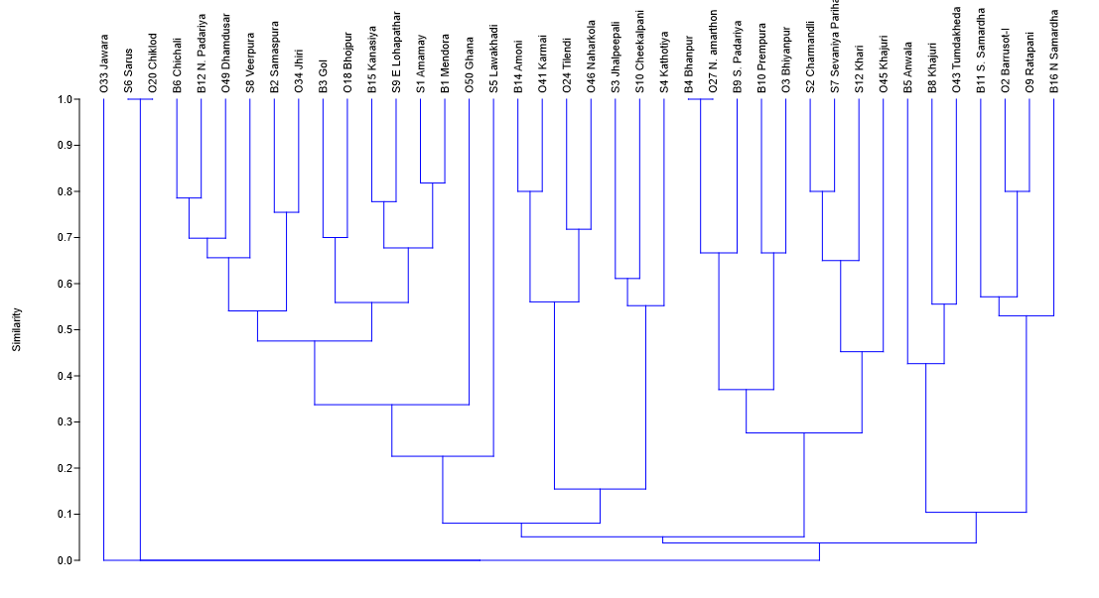
Figure 20: Cluster analysis of availability of prey base tiger among sites at landscape level

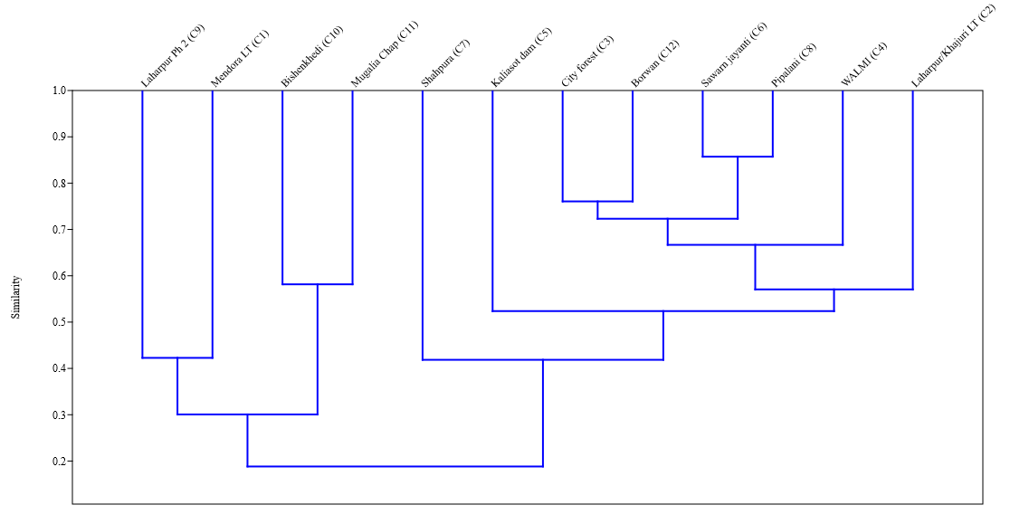
Figure 21: Cluster analysis of availability of prey base tiger among selected sites in Bhopal city

Dietary Preference by Tigers

5.3.2.1 Prey diversity and richness in diet
Microscopic hair analysis of 227 scat samples collected from the field identified 19 distinct prey species. The composition of prey species in tiger scats varied significantly across the three study regions: Bhopal City, the Bhopal-Ratapani (B-R) Connecting Forest, and the Ratapani Tiger Reserve (TR). The highest species diversity and occurrence were recorded in the Bhopal-Ratapani Connecting Forest. (Figure 22)

Figure 22: Species diversity and richness of prey-base (n=227)
Out of the sampled scats, the frequency of Nilgai in scats is highest (n=40) followed by cow (n=37) and chowsingha/four-horned antelope (n=32). The Radar graph shows clearly the variety of species occurrence, including leopard, wolf, and even Gaur, which is not found in Ratapani Landscape.

Figure 23: Species occurrence in the diet of tigers assessed through Scats (n=227)
Rarefaction curves at different landscape gradients suggest that additional sampling effort could further approach the asymptote; however, scat samples from Bhopal City indicate that species richness is nearing saturation. (Figure 24)
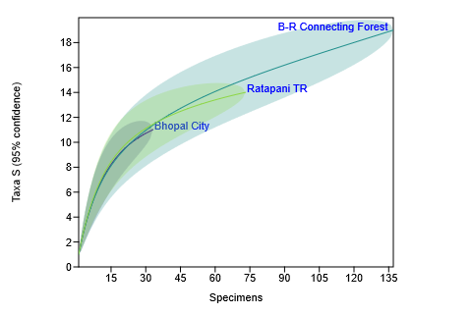
Figure 24: Individual rarefaction curve at various gradients of landscape
Given that field surveys often underestimate species richness; species richness estimators were applied. The estimators predicted the presence of 20 species (Chao 2), 22 species (Jackknife 1), 22 species (Jackknife 2), and 20 species (Bootstrap) within the landscape, compared to the 19 species directly observed (Table 17).
Table 17: Richness Estimators for Prey-base occurrence in scat samples
Observed S: | 19
Chao 2: | 19.6667 | 1.1547
Jackknife 1: | 21.6667 | 2.66667
Jackknife 2: | 22.1667 | NA
Bootstrap: | 20.3704 | NA

Principal Component Analysis (PCA)
The Principal Component Analysis (PCA) results illustrate the correlation of species presence in scats across the studied landscapes. PC1, which corresponds to areas near Bhopal city, is predominantly influenced by species such as nilgai (3.51), chowsingha (2.39), domestic cattle (2.21), and Indian muntjac (1.33), indicating their significant contribution to this principal component. In contrast, PC2 exhibits a distinct ecological gradient, with higher loadings for species such as sambar (2.05) and blackbuck (1.05), suggesting a stronger association with the Ratapani Tiger Reserve. These findings underscore the differential distribution of species along ecological gradients, highlighting species-specific habitat associations and potential influences of anthropogenic and natural factors on species assemblages.

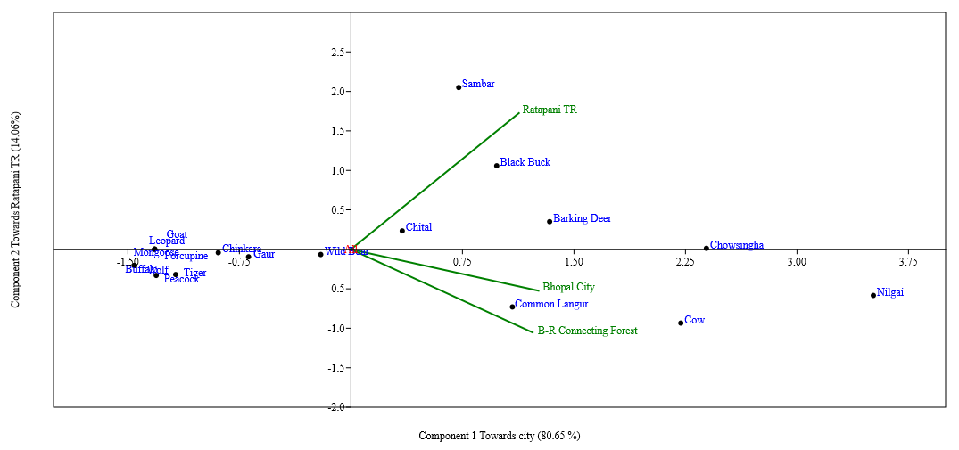
Figure 25: PCA for correlation among landscape gradient for distribution

ANOVA Analysis for differences in tiger diet across sites
Null Hypothesis (H₀): There is no significant difference in the prey consumed through scat analysis across sites.
Alternative Hypothesis (H₁): There is a significant difference in the prey consumed through scat analysis across sites.
An ANOVA test was conducted to determine whether prey consumed by tigers differs significantly across the three landscape gradients: Bhopal city, the Bhopal-Ratapani Connecting Forest, and the Ratapani Tiger Reserve. The results (Table 18) indicate that the mean of prey species in scats in the Bhopal-Ratapani Connecting Forest (7.21) is notably higher than in the Ratapani Tiger Reserve (3.84) and Bhopal City (1.73). However, prey consumed had a greater variance in the Bhopal-Ratapani Connecting Forest (64.17) compared to the other two sites.
Statistical analysis yielded an F-value of 5.12, exceeding the critical F-value of 3.16, with a corresponding p-value of 0.009 (p < 0.05). These results confirm a statistically significant difference in prey consumed across the three landscapes. Ecologically, this suggests that tigers exhibit preferences based on prey compositions, which likely vary due to habitat differences, prey distribution, and prey-predator behavior. Consequently, the alternative hypothesis (H₁) is accepted, affirming that prey consumption patterns differ significantly among the study sites. (Table 18)
Table 18: ANOVA to determine spatial variation in the dietary preferences
ANOVA Summary
Groups | Count | Sum |  | Average |  | Variance
Bhopal City | 19 | 33 |  | 1.74 |  | 4.76
B-R Connecting Forest | 19 | 137 |  | 7.21 |  | 64.17
Ratapani TR | 19 | 73 |  | 3.84 |  | 15.92
Source of Variation | SS | df |  | MS |  | F |  | P-value |  | F crit
Between Groups | 289.68 | 2 |  | 144.84 |  | 5.12 |  | 0.0092 |  | 3.17
Within Groups | 1527.36 | 54 |  | 28.28
Total | 1817.05 | 56

5.4 Discussion

5.4.1 Prey Distribution across Landscape Gradients
The assessment of prey distribution revealed notable differences between Bhopal city and its surrounding 30 km buffer zone. Within the city, nilgai (Boselaphus tragocamelus) and domestic cattle (Bos taurus) were the most frequently observed prey species among the twelve recorded in urban green spaces. The presence of cow shelters with thousands of abandoned cattle within the city contributes to the high abundance of domestic cattle. Bhopal’s extensive green spaces provide suitable habitat for a diverse range of wildlife species too, many of which have successfully adapted to human-modified environments, thereby serving as a potential food source for tigers. These findings align with previous research documenting the ability of a wide range of large carnivores to exploit anthropogenic resources in human-dominated landscapes (Karanth and Sunquist, 1995; Bagchi et al., 2003; Radeloff et al., 2005; McKinney, 2006; Bateman, 2012; Athreya et al., 2014; Surve et al., 2015; Kerley et al., 2015). The high abundance of feral pigs (Sus scrofa) and stray dogs (Canis lupus familiaris) in urban areas further underscores the influence of urbanization on prey availability, although their contribution to the tiger diet requires further investigation (Kolipaka et al., 2017).
In contrast, the 30 km buffer landscape exhibited a distinct urban to peri urban difference in prey species, with fourteen prey species recorded during field surveys. Nilgai (Boselaphus tragocamelus), cattle (Bos taurus), chital (Axis axis), and wild boar (Sus scrofa) were the most frequently observed. This assemblage suggests a more natural wild prey species composition characteristic of less disturbed habitats compared to the urban core. The presence of Indian gazelle (Gazella bennettii), sambar (Rusa unicolor), and Indian munjack/barking deer (Muntiacus muntjak) in a few transects further underscores the significance of intact forest ecosystems for supporting diverse prey populations, which are often more vulnerable to human disturbances. These findings reinforce the crucial role of habitat quality and habitat mosaics in shaping prey composition and, consequently, tiger foraging strategies (Karanth et al., 2004; Kolipaka et al., 2017).

Tiger Dietary Preferences and Adaptation
Scat analysis revealed a diverse diet comprising nineteen prey species, with nilgai, cattle, and four-horned antelope constituting the most frequently consumed species, collectively accounting for over 47% of the identified prey items. While field surveys suggested a relatively even prey distribution, scat analysis indicated that tigers are opportunistic feeders, primarily targeting the most accessible prey (Linnell et al., 1999; Banerjee et al., 2013; Miller et al., 2015; Sharma et al., 2015; Kolipaka et al., 2015; Kolipaka et al., 2017). A statistically significant variation in dietary preferences across the urban core, connecting forest, and tiger reserve (p=0.01) underscores the dietary adaptability of tigers in response to varying environmental conditions and prey availability patterns. This flexibility is critical for their persistence in fragmented landscapes where natural prey populations may be limited or periodically inaccessible (Karanth and Sunquist, 1995; Hayward et al., 2006; Kapfer et al., 2011; Suryawanshi et al., 2012; Simcharoen et al., 2014).

CHAPTER 6
PEOPLE’S KNOWLEDGE, ATTITUDE, AND PERCEPTION TOWARD SHARING SPACE WITH TIGERS IN THE URBAN LANDSCAPE OF BHOPAL

CHAPTER 6
PEOPLE’S KNOWLEDGE, ATTITUDE, AND PERCEPTION TOWARD SHARING SPACE WITH TIGERS IN THE URBAN LANDSCAPE OF BHOPAL

6.1 Introduction
Humans have been coexisting with wildlife since the era; with transforming landscapes, the situation is also evolving. The 21st-century global landscape is increasingly human-dominated, with reports that every ecosystem on the Earth’s surface has now been influenced by human activities (Vitousek et al., 1997). The ever-increasing human population has led to encroachment of natural habitats either directly (i.e., physical intrusion by converting natural land into developing areas such as agriculture, infrastructure development, or industrial activities, etc.) or indirectly (i.e., human activities that indirectly affect these habitats, such as deforestation, pollution, resource extraction, etc.). In such circumstances, competition between carnivores and people is inevitable for space and food resources, often leading to severe conflicts. These conflicts are particularly intense in countries like India, which juxtapose spectacular biodiversity and widespread concerns over habitat and species loss alongside the pressing development needs of human populations.
Understanding and managing the factors influencing these human-wildlife interactions remains important for effective conservation and management strategies. Most often, the research on human-wildlife interactions is focused on negative interactions such as livestock loss, property damage, crop damage, human injury, and death (Madden, 2004; Kahler and Gore, 2015; Karanth and Surendra, 2018), while in comparison, little research has focused on the neutral or positive interactions (Peterson et al., 2010; Redpath et al., 2015). This review attempts to study the available literature on these interconnected topics and provides an insight into the complex relationship between humans, wildlife, and conservation.
Human-wildlife coexistence refers to the ability of humans and wildlife to share and inhabit the same landscapes harmoniously. Human-wildlife coexistence doesn’t have specific definition yet researchers and conservationists have developed different approaches to promote human-wildlife coexistence, such as, compensation schemes for livestock and crop damage (Jordan et al., 2020), changes to governance and implementation of mitigation policies (Karanth and Surendra, 2018; Karanth et al., 2009), physically separating the landscape of humans and wildlife through mechanisms like fencing and zoning to minimize the human wildlife conflict (Nyhus, 2016).
Human-wildlife interactions are the diverse range of encounters and engagements between humans and wildlife. It explores the positive aspects of wildlife interactions, such as ecotourism and recreational activities, as well as the negative aspects, such as wildlife damage and safety concerns. Human-wildlife interactions are not random; the increasing population of humans and encroachment in the natural habitats of wildlife are some factors for most human-wildlife interactions, which sometimes can have a strong seasonal component (Soulsbury and White 2016). Bhatia et al. (2020) say human-wildlife interaction is a positive human value, attitude, and behavior indicating tolerance for the wildlife. On the spectrum, human-wildlife interactions can be negative, neutral, or positive.
Human-wildlife conflict arises when there is a negative impact resulting from interactions between humans and wildlife. Nils Peterson et al. (2010) in their research “Rearticulating the myth of human-wildlife conflict” provide another angle to researchers for the term ‘human-wildlife conflict’. According to them, HWC should be seen as one actual conflict between humans and wildlife, and in other cases where wildlife damage or consume crops or livestock, researchers should use terms such as animal damage-crops and animal damage-livestock, respectively.
Wildlife conservation lies at the heart of human-wildlife interaction. It refers to the protection, preservation, and management of wildlife, including wild animals, plants, and their habitats, to ensure their survival and well-being.
Human-wildlife perception examines the cognitive, emotional, and cultural factors that shape or influence human attitude, belief, and perception towards wildlife in response to human-wildlife conflict (Kahler and Gore, 2015). Researchers often use TRA and TPB to understand the influence of human perceptions towards wildlife.
The theory of reasoned action says that behavioral intentions, which are immediate experiences of behavior, are a function of salient information or beliefs about the likelihood that performing a particular behavior will lead to specific outcomes (Ajzen and Fishbein 1980). TRA aims to explain the volitional behaviors, i.e., behaviors that are spontaneous, habitual, impulsive, or mindless. Engaging in such behaviors might not involve a conscious decision (Hale et al., 2002; Bentler and Speckart, 1979).
The theory of planned behavior is an extension of TRA (Ajzen and Fishbein, 1980). TPB details the determinants of an individual’s decision to perform a particular behavior. Unlike TRA, TPB attempts to predict nonvolitional behaviors by incorporating perceptions of control over performance of the behavior; thus, an individual’s control over the performance of the behavior is high (Ajzen, 2020).
The chapter aims to understand how people coexist with tigers by understanding their knowledge, attitude, and perception through the following research question
- What is the attitude and perception of people coexisting with large carnivores?
- What are the underlying factors shaping current attitudes and perceptions?
- What is the level of acceptability of the co-existing approach in suburban and rural human-dominated areas?
- What are the perceptions of the forest department, personally, of managing tigers in these human-dominated landscapes and near urban areas?

6.2 Methodology
The study is one of the explorative types of research, trying to study the key factors behind Human-Tiger Coexistence in the Urban Landscape of Bhopal.
The majority of the data were collected using interviews of local communities living in the Bhopal-Ratapani Landscape. Methods used included both semi-structured and unstructured interviews for different parts of the thesis, while additional relevant data were collected from analyses of the habitat around, livestock husbandry methods, and corral characteristics. A range of parametric and non-parametric statistics was used.

6.2.1 Semi-structured interviews
Semi-structured interviews (SSIs) formed the primary method of data collection. These interviews have previously been used to assess attitudes in a wide range of situations, such as measuring views on deforestation in Vietnam (Pham and Rambo, 2003), knowledge of biodiversity in the U.S. (Hunter and Brehm, 2003), and perceptions of wildlife conservation in the U.S., Germany, and Japan (Kellert, 1991). Semi-structured interviews enable respondents to provide more elaborate and complete answers than fully structured questionnaires, and are flexible enough to allow people to explain their views in their own words, which can be valuable in terms of truly understanding the nature of a particular situation (Hunter and Brehm, 2003; Schensul et al., 1999). However, SSIs have drawbacks in terms of the time and money needed to collect and analyse large amounts of data this way, and they can also be biased both by the interviewer and by the articulacy of the respondent concerned (Glastonbury and MacKean, 1991). Specific interviews designed to assess losses to and conflict with wildlife are subject to particular biases, such as the general exaggeration of losses, lack of accuracy, the tendency of respondents to overestimate losses caused by more high-profile species compared to less visible, smaller ones, and the inclination to attribute losses as depredation even if they may have been caused by other causes such as disease or theft (Cozza et al., 1996; Rasmussen, 1999; Niskanen, 2005). Moreover, gaining sufficient trust from interviewees in order to be told potentially sensitive information (such as the killing of protected species) is a process that takes considerable time (Scholte et al., 1999), so this has to be considered during both the study design and interpretation of results.
However, despite these caveats, SSIs can be used to effectively assess attitudes, and have provided valuable information regarding people’s perceptions of large carnivores in previous studies (Conforti and de Azevedo, 2003; Marker et al., 2003; Oli et al., 1994). The interviews used here (Annexure I) were designed in a similar way to those used by Maddox (2002) to assess attitudes of pastoralists towards wildlife in northern Tanzania. The survey was designed following the guidelines set out by Schensul et al., 1999, with simpler and less contentious questions posed towards the start of the survey and more complex or sensitive issues only raised later on, when there was more chance that the confidence of the respondent had increased. However, it must be borne in mind that, as with all surveys, people will only report what they feel comfortable doing so, meaning that the results should always be interpreted with some caution (Srivastava, 2014).
The household was chosen as the sampling unit, following Maddox (2002), but interviews were not restricted to one respondent of household as presence of all members and onlookers narrow down the general exaggeration of losses, lack of accuracy and the tendency of respondents to overestimate losses. Most of the interviews were conducted in early morning and late evenings so that most of members were present for the same reason. At each village, the headman was approached and the purpose of the research explained. The headman was then asked for the full details of the village like how old the village is, number of households, different caste within village, total livestock and annual loss of cattle. The most senior member of the household present was asked for permission to conduct the interview, and asked to participate. Women deferred to men in seniority, so interviewees were predominantly male, but interviews were conducted with women where they were happy to do so.
In total, 130 initial surveys were conducted, so the sample size is 130 for the analyses. All the surveys (n = 130) were administered with the principal investigator (PI) present, along with a local assistant. The majority of interviews were conducted at the respondent’s household; Interviews were conducted in Hindi with some local touch and took approximately 30-40 minutes to complete. At the majority of interviews, people apart from the target individual were also present, and the number and status (whether superior, equal or inferior social rank) of onlookers was recorded. In order to avoid biasness, we selected 10 household from 14 major village/hamlets falling in Bhopal-Ratapani Connecting Forest patch, each from different caste and different locations of village, so that each social must participate.
Key issues covered during the SSI included socio-economic profile of households, knowledge and identification of local wildlife species, details of human-wildlife interactions, their individual and social perceptions and livestock management strategies employed etc.
Respondents were also asked to independently list (‘free-list’) all species that they could think of that occurred around their household. This can be used to see whether or not respondents viewed carnivores as a distinct grouping and the most species which regularly come in front of them.
Levels of conflict were also assessed in a similar way to Maddox (2002): respondents were shown picture cards of common wild species and were asked whether or not they recognized the species, and if they misidentified it then they were told the correct species. If they knew which species it was, they were then asked whether or not it occurred in the area around their household (defined as within a day’s walk), and if so, were asked to classify them as either posing no problem, a small problem or a large problem, and to explain the reasons for any problems. Also following Maddox (2002), a hierarchical cluster approach was used to examine which species tended to have similar reported conflict scores.

6.2.2 Examination of livestock husbandry through cattle walks and corral construction
The aim of this examination was to assess the management strategies used by different households to manage livestock. Employing certain livestock husbandry strategies has been identified as an important factor in previous carnivore conflict studies (Hemson, 2003; Ogada et al., 2003; Marker et al., 2005), and the information gathered here was used to try to identify the most effective strategies for reducing livestock depredation in this particular area. Data on reported livestock husbandry techniques was collected through questions in the semi-structured interviews, with particular attention paid to the reported use of herders and dogs to protect stock, and how livestock was said to be managed both in the day and at night (e.g., herded, corralled, enclosed in huts, free-ranging, etc.).
Analysis of habitat around the village along with forest type and animals present around the village, was conducted to try to identify whether certain habitat characteristics seemed to predispose specific locations to a higher risk of depredation. High levels of conflict close to reserve boundaries have been demonstrated by researchers in a range of locations, such as India (Mukherjee, 2009), Kenya (Patterson et al., 2004), the United States (Primm and Murray, 2005), and Tanzania (Newmark et al., 1994). However, previous research has also revealed additional factors which may be important as they can influence large carnivore habitat selection and use, including elevation (Mace et al., 1999), slope (Chundawat, 1990), local topography (Jackson and Ahlborn 1988), aspect (Ortega-Huerta and Medley 1999) amount of woody cover (Comiskey et al., 2002; Gros and Rejmanek, 1999), prey availability (Glenz et al., 2001), distance to dense vegetation and the height and percentage cover of grass and bushes (Fernandez and Palomares 2000; Muntifering et al., 2006). Therefore, variation in local habitat factors can potentially be significant in influencing disparities in the levels of large carnivore depredation experienced at a household level.
Herding practices, such as the extent to which people take their cattle and livestock for grazing, also contribute to the background factor of predation. To know the extent herders travel for grazing, a local assistant accompanied the herders to a few villages (n= 53) and tried to follow them from morning to evening with a GPS. Along with it, an attempt was made to note down the activities done by herders throughout the day, with the location.

6.2.3 Analysis
The framework includes the learnings from Theory of Reasoned Action (TRA) and Theory of Planned Behavior (TPB), but has limitations in the context of Human-Wildlife Interactions related studies. TRA links attitudes/subjective norms to intentions (e.g., conservation support), while TPB adds perceived behavioral control, relevant for barriers like compensation access.
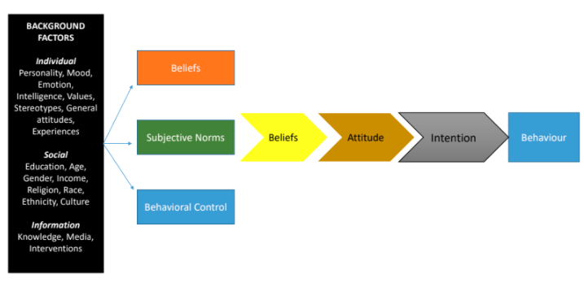
Figure 26: Framework of Theory of Reasoned Action and Planned behavior showing a particular behavior is governed by various Individual-social factors influencing attitude and intention toward an event or subject
With questions about individual factors and societal factors toward knowledge, attitude, and perception about human-tiger interactions in the urban landscape of Bhopal, the section tried to understand how these individual and societal factors are shaping their action and behaviour when they encounter a tiger or wildlife. However, due to being part of the qualitative domain of these, the data cannot have mathematical weighting, but have been used to understand the attitude and perceptions of local communities.

6.2.3.1 Descriptive Analysis
The semi-structured interviews, cattle kill compensation data from the forest department, and cattle walk data have a combination of qualitative and quantitative datasets. We tried to categorize qualitative data into themes and categories to present in the form of graphs, as well as combined to interpret the findings. The data analysis was conducted using MS Excel 2016.

6.2.3.2 Thematic Analysis
Thematic Content Analysis (Bernard 2006) was utilised to analyse the qualitative component of the interviews. The respondent’s views and perceptions on the core topics (Value, attitude, acceptance, and behaviour) were placed into predefined themes.

6.3 Results

6.3.1 Semi structured interviews
Determining the drivers of human-wildlife interactions is essential for managing people and wildlife in shared landscapes (Walpole, 2003). Studies have shown that severe interactions are often common around the borders of protected areas, which affect both human-dominated land and within adjacent protected areas (Woodroffe and Ginsberg 1999; Walpole, 2003; Woodroffe and Frank 2005).
In this chapter, we aim to understand the factors supporting low human-tiger interactions in the shared landscape, which is a dynamic in nature due to urbanisation. The bulk of the data for this chapter was collected using a semi-structured survey design (Appendix I), following a similar format to that used by Maddox (2002) to survey Maasai pastoralists in northern Tanzania.
The survey was pre-tested on 10 households to ensure clarity before use. It assessed the socio-economic conditions of households, Livestock herding and fencing strategies employed by different households of the area, along with the knowledge and attitude of people toward wildlife, frequency of attacks and loss within the last year, attitudes towards wildlife, and effective measures as perceived by households to protect their livestock.
130 interviews were carried out in Bhopal-Ratapani Connecting Forest, which is part of the urban-rural/wilderness gradient as well as an important tiger habitat in the Bhopal-Ratapani Landscape. On average, 10 interviews were carried out in each hamlet/village, but due to a misconception among villages close to the newly formed Ratapani Tiger Reserve that this survey is done to relocate them, we had to limit the survey to 4 interviews in Kathotiya and 7 interviews in Bodhakho. Both of the villages are now in the buffer zone of Ratapani Tiger Reserve. (Figure 27)

Figure 27: Village-wise interviews and the number of respondents

6.3.1.1 Socio-economic profiles of respondents
Out of 130 respondents, the dominant group of respondents belongs to 31-40 years (26%), followed by 41-50 years, while the least belongs to respondents belonging to the age above 60 years.
Figure 28: Age of respondents
Out of 130 respondents, 76% are male, and 24% belongs to female respondents. However, the presence of males of the family skewed the answers toward male perspectives dominantly.

Figure 29: Gender of respondents
On enquiry about the timeline of their families at their current location, 95% of the respondents agreed that they have been living at their current location for more than 25 years, while only 5% families have been shifted in the last 10-25 years from near areas of Bilkishganj, Sehore & Berasia to Jhabua, Alirajpur, Dhar, as well as Rajasthan. The reason behind the transfers was mainly for labour work as well as to join their relatives who had relocated long ago.

Figure 30: Duration of respondent's residence at current location
Out of 130 respondents, 54% belongs to the Hindu religion, while 41 % belonging to tribal communities and 5% belonging to Islam.

Figure 31: Religion of the respondents
Regarding educational qualification of the respondents, 44.61% were recorded with no formal education, followed by 30.76% respondents with secondary education, while non recorded with university education. However, 36.92% stated having knowledge about environmental education, while others have no environmental education or could not understand the environmental education. The respondents having environmental education are sort of informal and learnt from forest staff, elders and self-learning.

Figure 32: Education level of respondents
Respondents were not comfortable or clear about speaking about the source of income. Out of 130 respondents, 66 reported agricultures as primary, while 60 respondents reported labour work as secondary, while other including shop and government job as tertiary sources.

6.3.1.2 Individual or social factor profiles of respondents
Individual and social factors play important roles in defining intention and behavior toward any event.
On enquiry about their frequency of visiting wildlife area or green spaces where the chances of human-wildlife interactions are high, 40 respondents visit on daily basis while 53 respondents visit on an average 2-5 days a month. 25 respondents do not visit to these areas.

Figure 33: Frequency of outdoor visits by respondents
On enquiry on the personality types of the respondents, we recorded that the majority, i.e. 83% are average, while 17% are reserved in personality. The majority of respondents around 87%, are found in an average mood during the survey, while 12 respondents were in a good mood and 2 respondents were reported in the worst mood. 75% of respondents reported no impact of any recent event on their current mood or personality.

Figure 34: Mood and personality of respondents

6.3.1.3 Knowledge among respondents
The majority of the respondents, i.e., 123 states awareness about tiger presence near their home and villages, while a few were not sure about it.

Figure 35: Awareness of tiger presence near their home and villages
To assess the knowledge of respondents about the wildlife in their neighbourhood and work area, we asked them to create a free checklist of species they can count. 37 respondents took tiger in first place, followed by nilgai (26), spotted deer (20), wild boar (12) at first place. Second place is dominated by spotted deer (26) followed by nilgai & wild boar (18), Tiger (15) while third place is dominated by wild boar (26) followed by spotted deer (21), nilgai (19), and tiger (13). The least included Porcupine, jungle cat, wild dog, chinkara, wolf, honey badger etc. A few of the species, including wolf, wild dog, chinkara, jungle cat, etc., are shy in nature as well as of lesser risk, so free checklist often ignores these species. While the species on the first, second and third place are often larger animals which either been encountered recently or are risky.

Figure 36: Free-checklist of species observed by respondents during daily routine
We checked their knowledge of identification through photo-cards of common species recorded in the area. Out of 130 respondents, 124 identified tigers, followed by wild boar (117), sloth bear (110), mongoose (109), while the least identified species includes civet (15).

Figure 37: Species identified by respondents using photo-cards

6.3.1.4 Attitude and Perception of respondents toward Human-Tiger Interactions in the study area
As per the perception of respondents toward wild animal population in the last few decades and majority of respondent i.e. 87 believes it has increased over time, while 31 believes it has decreased while 9 stated no response.

Figure 38: Perceptions of respondent toward wild animal population trends
On enquiry about their emotional perception toward tiger presence 76 respondents feel fearful about their presence while 62 respondents feel happy, followed by 30 respondents feel proud while 6 respondent feel nothing about their presence.

Figure 39: Emotional response to tiger presence near the village
On enquiry about their values and attitude toward wildlife, and 30% respondents value wildlife as a socio-cultural value, while 17% believes spiritual & religious values toward wildlife. Only 9% have a negative value toward wildlife and don’t want them in their vicinity.

Figure 40: Value/Attitude of respondents toward wildlife
On enquiry about the acceptance of tigers and other wildlife in the neighbourhood, respondents feel they should stay away from the village (107), followed by wildlife staying away from the field (74), while 26 respondents feel they will accept until there is no risk of human causality.

Figure 41: Response to wildlife acceptance
92 respondents’ states that their fellow villagers are source of knowledge on wildlife movement and risks in neighbouring areas followed by direct sightings (60), forest department (34) and others including social media and news (6).

Figure 42: Source of knowledge on wildlife and dangers

6.3.1.5 Livestock and interaction management
When asked about the decision-making on routes and areas in forest, when wildlife is active, 78 respondents avoid that area while 45 respondents’ states that they do not avoid that area.

Figure 43: Decision-making for routes and areas in the forest by respondents
The majority of the respondents believe that keeping cattle in fences and stall feeding is the prime way of reducing Human-wildlife interactions. While monitoring areas, doing nothing, or informing the forest department can promote human-wildlife interactions in this landscape.

Figure 44: Strategies to promote Human-wildlife coexistence
The last question was asked to all respondents to test the Theory of reasoned action and planned behavior that individual and societal factors shape actions and behaviour of the individual. All the respondents asked about their reaction or behaviour if they encounter a tiger in wild in current situation and majority (n=31) believes making loud noise will drive animal away while 28 respondents believe they will try to hide and 27 respondent says they will inform forest department.

Figure 45: Response to tiger encounter in the wild
Based on the responses, the themes were prepared, and it states clearly that 48% of respondents prefer avoidance, followed by stewardship and active engagement.
Table 19: Thematic analysis of behavioural response by respondents on encountering a tiger in the wild
Themes | Indicative Evidence from responses | Approx. Prevalence
Avoidance | Hiding, Run, Avoid, NA | - 48%
Active | Making noises to deter | - 25%
Stewardship | Informing management and other | - 28%

6.3.1.6 Informal discussion with forest staff
27 participants were informally surveyed from different strata of forest officials to understand their knowledge and perception regarding human-tiger interaction and management in the Bhopal-Ratapani connecting forest.
Out of the 27 participants, 11 belong to daily wage labourers who monitor tigers and other wildlife on the ground on a regular basis, followed by 6 forest guards and 6 SDO and above level officers.

Figure 46: Field position of respondents from the forest
Out of the 27 respondents, 10 had field experience of over 15 years, while 6 had less than 5 years.

Figure 47: Field experience of respondents
All the respondents from the forest department are well aware of tiger presence in the landscape, and 63% of the respondents believe that the current tiger population in the area is not new; they have been in and around Bhopal since always, while 18% believe that these are there because the number has grown in the current Ratapani Tiger Reserve.

Figure 48: Knowledge and understanding of tiger presence in the study area
Understanding the perception of field staff toward managing tigers in the landscape, 23 out of 27 respondents believe there is a need for management in the urban landscape of Bhopal. The current management is focused on fencing and area development (66%) and regular monitoring (19%).

Figure 49: Perception of respondents in managing tigers in the landscape
The major reason behind the management of the tigers and the landscape is interest and efforts from higher officials (78%), while the personal interest and socio-political reasons contribute 11% each.

Figure 50: Reason behind the current actions to manage tigers in the landscape
Informal discussion states that lack of resources and man-power are major concerns in the area, as the area is part of the territorial forest division, as well as pressure of human societies is highest.

6.3.2 Cattle walk and participant observation on herding practices
53 cattle walks have been done in Nov 2020- May 2021 with local herders or free roaming cattle using the Bhopal-Ratapani Forest patch. A GPS record of all trail was recorded, and livestock herding practices were recorded.
30 walks have been walked during Nov-Dec 2020 and 24 walks have been walked during April-May 2021. 21 walks were assisted with herders of various age groups. (Figure 50)
In the areas, Cows were the main livestock because of their low economic value they were mostly left unattended. They were left on forest edges in the morning, where they graze all day and return to the village in the evening. In livestock-dominant communities such as Yadav, they have a large number of cows, and they either go with the cows in the forest or hire a herder who will assist the cattle in the forest. The herders are mainly old males from the village or middle-aged people. Buffaloes are important and economic cattle; hence, they were observed mainly with a herder or in mixed livestock with a herder. Buffaloes near city areas are observed left unattended. Goats were always observed with herders. The herders are mainly kids or females and rarely males.
During summer, the average of walks were 2.3km, and during winter, the average walk was found to be 5.7km. During the summer, as the fields are not under agriculture, water is a limiting factor in the forest. During the survey, we observed that the presence of herders is not significant for trail; they just assist in taking back important cattle, such as goats and buffalo, back home. Cows are not treated the same.
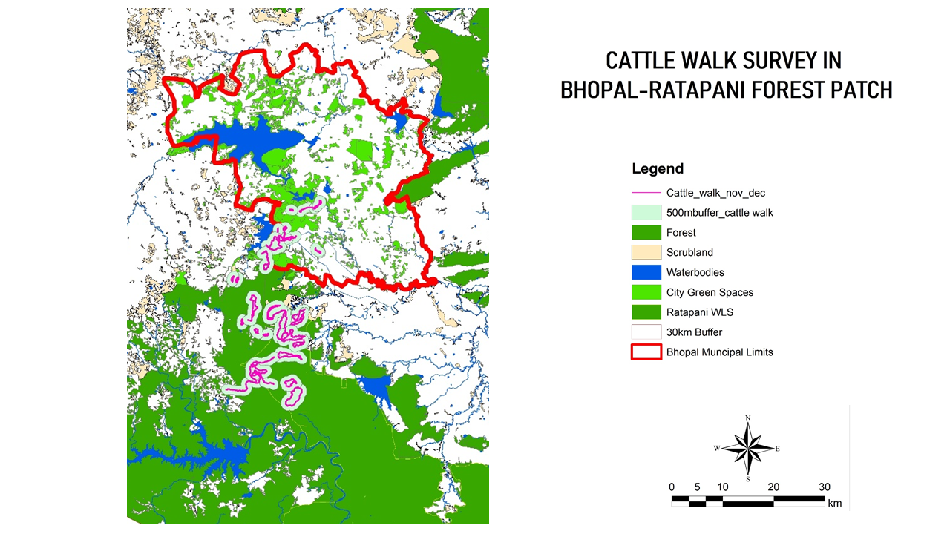
Figure 51: Cattle walk maps (Nov 2020-May 2021)

6.4 Discussion
Human-tiger coexistence in urbanizing landscapes like Bhopal-Ratapani represents a critical challenge for conservation, where local communities' knowledge, attitudes, and perceptions play pivotal roles in shaping outcomes.
Human-wildlife interactions, particularly with large carnivores like tigers, are framed by theories such as the Theory of Reasoned Action (TRA) and Theory of Planned Behavior (TPB), which link attitudes, subjective norms, and perceived control to behavioral intentions like supporting conservation (Ajzen and Fishbein, 1980). In the Bhopal context, TRA helps explain spontaneous tolerance behaviors, while TPB addresses barriers like limited control over tiger movements in shared spaces (Ajzen, 2020). These frameworks reveal how socio-cultural values and past experiences influence perceptions, with 30% of respondents valuing wildlife for socio-cultural reasons and 17% for spiritual ones, aligning with studies showing cultural reverence for tigers in Central India (Bhatia et al., 2019).
Similar applications in India highlight that those positive attitudes stem from beliefs in tigers' ecological roles, but negative encounters erode them (Karanth and Surendra, 2018). For instance, in Nagarhole, villagers' intentions to retaliate correlate with perceived risks, underscoring TPB's relevance (Karanth et al., 2018). This study's respondents, mostly from low-education backgrounds (44.6% illiterate), draw knowledge from peers (92%) rather than formal education, mirroring global patterns where informal networks shape norms (Kahler and Gore, 2015). In spite of around one-fourth of female respondents, we realised that the answers to the questions of semi-structured interviews were skewed toward the attitude and perception of male members present at the time of the interview.
Local knowledge in the Bhopal-Ratapani landscape is practical yet uneven, with 123 of 130 respondents aware of tigers nearby and high identification rates via photo-cards (124 for tigers, 117 for wild boar). Free-listing prioritized visible, risky species like tigers (37 first mentions) over shy ones like civet (15 identifications), indicating salience driven by encounters rather than biodiversity awareness. This echoes findings from Central Indian studies where frequent sightings boost recognition but not ecological understanding (Sharma et al., 2013).
Comparatively, in Nepal's forest corridors, communities with ecotourism exposure show better species knowledge, correlating with coexistence (Carter et al., 2012). In Bhopal, 87% perceived wildlife populations as increasing, fostering pride (30%) despite fear (76%), a duality seen in Ratapani where rising tiger numbers from reserves spill into fringes (Urban Tigers Project, 2020). Low formal education (no university graduates) limits deeper insights, akin to Vietnam's deforestation surveys, where experiential knowledge dominates (Pham and Rambo, 2003).
Attitudes blend fear, pride, and conditional acceptance: 62 felt happy about tigers, but 107 wanted them away from villages. The conditional acceptance by 26% of respondents states clearly that they accept tigers till they are not involved in human causality (Carter et al., 2023). Emotional responses fearful (76%) yet proud (30%) reflect India's tiger icon status, where cultural symbolism buffers negativity (Kellert, 1991). Only 9% held outright negative views, lower than in high-conflict zones like Nagarhole, where livestock losses amplify intolerance.
Acceptance hinges on no human casualties (26%), aligning with coexistence models emphasizing mitigation over exclusion (Nyhus, 2016). Gender and age influence this: male-dominated responses (76%) from 31–50-year-olds (dominant group) show resilience from long residency (>25 years for 95%), contrasting urban migrants' intolerance elsewhere (Woodroffe and Frank, 2005). In Central India, socioeconomic profiles like agriculture-labor reliance (66% primary agriculture) predict tolerance if losses are low, as here (Maddox, 2002).
Forest staff perceptions add nuance: all 27 interviewees knew of a longstanding tiger presence, with 63% viewing it as historical, not reserve spillover, and there is a need for management (85%) in a dynamic urban landscape. Management focuses on fencing (66%) amid resource shortages, echoing departmental challenges in overlapping boundaries (Jhala et al., 2025).
Socioeconomic and behavioral factors drive dynamics. Frequent outdoor visits (40 out of 130 respondents daily, and 53 respondents visit 2-5 days/month) heighten exposure without proportional fear, suggesting habituation (Soulsbury and White, 2016). Average personalities (83%) and moods (87%) during interviews indicate stable baselines, with minimal event impacts (75%).
Livestock practices mitigate risks: summer walks averaged 2.3 km (water-limited), winter 5.7 km, with herders for valuables (buffaloes, goats) but free-ranging cows. This reduces depredation, as unsupervised low-value stock faces less predation than clustered herds (Ogada et al., 2003). Habitat edges and herding extent influence encounters, with urban gradients complicating zoning (Woodroffe and Ginsberg, 1998).
Religiously diverse respondents (54 Hindu, 41 tribal) draw from elders/forest staff (36.9% informal eco-education), fostering tolerance via shared norms (Hunter and Brehm, 2003). Political pressures motivate staff (78% higher officials' interest), but manpower gaps persist, similar to contested lands in Central India (Primm and Murray, 2005).
Findings support low-conflict coexistence, with high awareness and conditional positivity enabling interventions like community monitoring (Jordan et al., 2020). Compensation addresses losses, but education via photo-cards and free-listing builds knowledge (Marker et al., 2003).
Staff training on TPB could enhance control perceptions, integrating herding data for targeted fencing (Ajzen, 2020). Urban gradients demand landscape-scale plans, prioritizing consensus corridors (70% village-overlapped) over reactive measures (Jhala et al., 2025).
Challenges include biases in self-reports (exaggerated losses) and male skew, warranting female-inclusive surveys (Cozza et al., 1996). Future research should quantify losses via verified data, building on this exploratory base.

CHAPTER 7
SPATIO-TEMPORAL ADAPTATIONS OF TIGERS, AND ASSOCIATED SPECIES TO COEXIST IN BHOPAL-RATAPANI LANDSCAPE OF CENTRAL INDIA

CHAPTER 7
SPATIO-TEMPORAL ADAPTATIONS OF TIGERS, AND ASSOCIATED SPECIES TO COEXIST IN BHOPAL-RATAPANI LANDSCAPE OF CENTRAL INDIA

7.1 Introduction
Globally, cities grapple with habitat fragmentation and ecosystem disruption due to population growth, unplanned urbanization, and climate change (Bateman et al., 2012; Govindarajulu, 2014). Urban green spaces serve critical ecological and socio-economic roles (Kong et al., 2010), yet urban expansion disrupts large carnivore movements, such as tigers, by altering resource availability and connectivity (Buchmann et al., 2013; Wallach et al., 2015; Kuijper et al., 2016). Anthropogenic activities force wildlife to adapt through temporal, spatial, and dietary niche adjustments to minimize human overlap, reducing competition and enhancing coexistence (Massara et al., 2018; Farris et al., 2014). However, frequent human-carnivore encounters can escalate conflict, undermining conservation efforts (Kolipaka et al., 2015; Suraci et al., 2019).
The majority of the historical forest cover in central India has been lost to agriculture and urbanization in the past 300 years, severely limiting tiger dispersal (Sharma et al., 2013). Despite studies on carnivore distribution, research gaps persist on tiger-prey-human interactions in human-dominated landscapes (Kolipaka et al., 2015). The Bhopal-Ratapani connecting forest exemplifies these challenges, where urban expansion threatens critical forest linkages to the Ratapani Tiger Reserve. This underscores the urgency of understanding coexistence dynamics in peri-urban mosaics to balance conservation and development. The study addresses two key questions:
- How do spatio-temporal space-use patterns facilitate coexistence among tigers, their prey base, and humans in the Bhopal-Ratapani Connecting forest?
- How are tigers and other co-predators temporally active in a larger landscape?
The study contributes to a more nuanced understanding of human- wildlife interactions in such dynamic landscapes by examining these dynamics.

7.2 Methodology

7.2.1 Method for Bhopal-Ratapani Connecting Forest

7.2.1.1 Sampling design and survey technique
Forest Beats of Bhopal Forest Circle were designated as the primary sampling units in this study, apart from green spaces of Bhopal city. Using Google Earth, we mapped green areas exceeding 1 hectare in size, keeping in mind that Patches smaller than this threshold were excluded, as they were deemed insufficient to support regular tiger presence.
Surveys for tiger presence within the study area were conducted between February 2019 to December 2022, systematically examining main trails, secondary trails, and water bodies for evidence of large carnivores. Distinct tracks exceeding 100 meters were recorded as individual observations.
Camera traps are recognized as a valuable method for studying wildlife. In a study area spanning 135.52 km² of dry deciduous forests, data were gathered on carnivores, prey species, and human presence using ten camera stations, each equipped with one camera, which were set up over two months (February 19 to April 13, 2020) using systematic sampling. The cameras operated for an average of 570 trap nights in the Bhopal-Ratapani Connecting forest. (Figure 51).
Statistical analysis
In this study, Exif Pro software was used to organize photographic data. Radar graphs and Stack Bar Charts using Excel and Past 5.0 were used to visualize temporal activities and overlaps among focal groups. Hourly photographic captures over 24 hours quantified temporal correlations between tigers, co-predators, wild/domestic prey, and humans. A Non-metric Multidimensional Scaling (NMDS) plot represented temporal relationships based on a correlation matrix. ANOVA assessed spatial and temporal variations in focal group occurrences, offering insights into coexistence dynamics in a human-dominated landscape.
Null Hypothesis (H₀): There is no significant spatial and temporal variation in the space used by tigers, prey base, and people.
Alternative Hypothesis (H₁): There is a significant spatial and temporal variation in the space used by tigers, prey, and people.

7.2.2 Method for Bhopal-Ratapani Landscape

7.2.2.1 Sampling design and survey technique
A camera trap is recognized as a valuable method for studying wildlife. In a larger landscape of over 4000 sq km and over 769 camera trap points over the territorial division of Bhopal, Sehore, and Obedullahganj, and 28761 trap nights, 73 individual tigers have been recorded. (Figure 52)
Statistical analysis
In this part of the study, Exif Pro software was used to organize photographic data. Radar graphs and Stack Bar Charts using Excel and Past 5.0 were used to visualize temporal activities and overlaps among focal groups. Hourly photographic captures over 24 hours quantified temporal correlations between tigers, co-predators, wild/domestic prey, and humans. ANOVA assessed spatial and temporal variations in focal group occurrences, offering insights into coexistence dynamics in the larger human-dominated landscape of Bhopal-Ratapani.
Null Hypothesis (H₀): There is no significant spatial and temporal variation in the space used by tigers and co-predators.
Alternative Hypothesis (H₁): There is a significant spatial and temporal variation in the space used by tigers and co-predators.

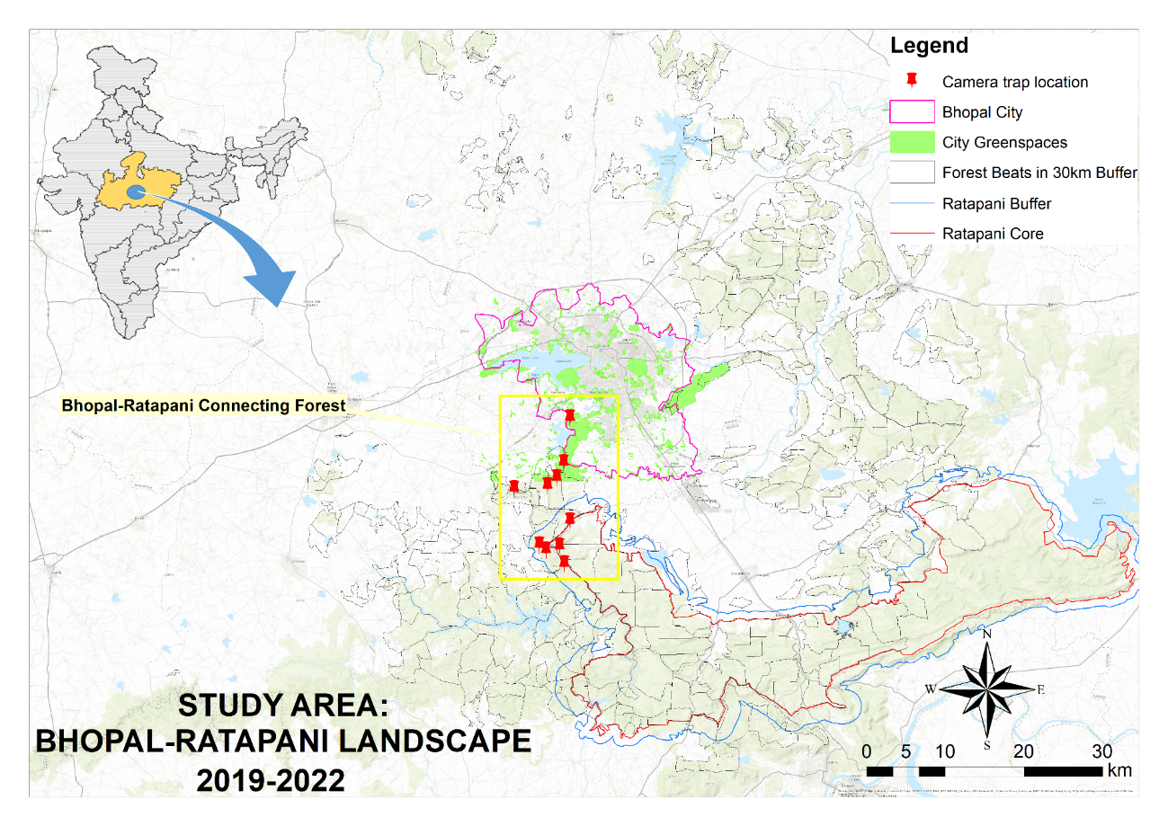
Figure 52: Camera trap location in the Bhopal-Ratapani Connecting Forest
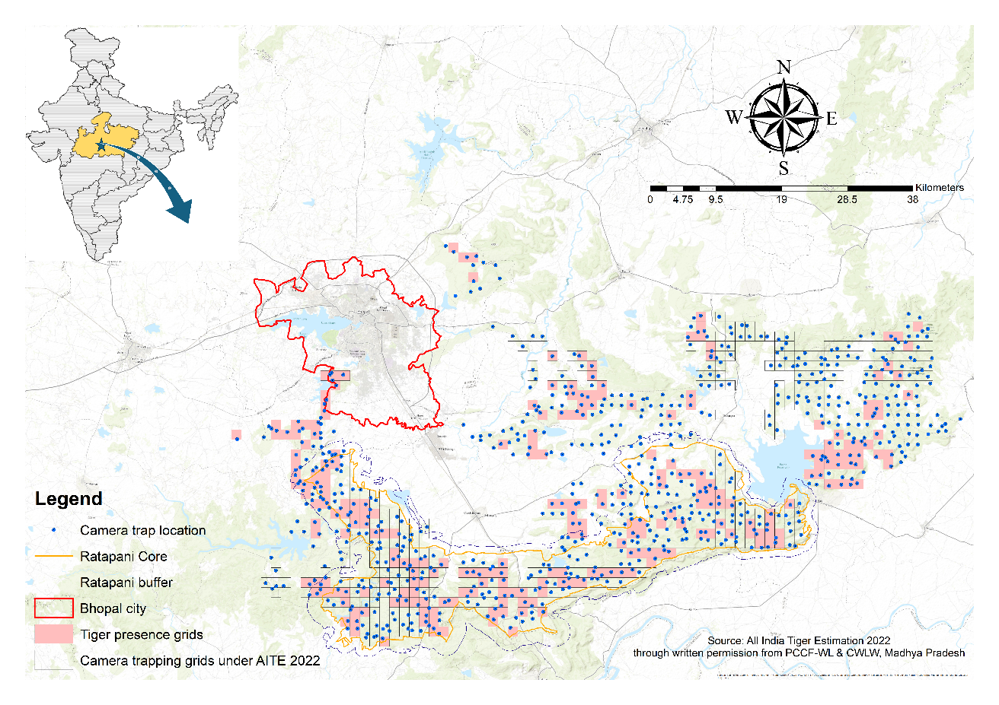
Figure 53: Camera trap locations and grids under AITE 2022

7.3 Results and Discussions

7.3.1 Bhopal-Ratapani Connecting Forest Patch
Forest beats were selected based on animal presence, village locations, green spaces, water bodies, road networks, and the wild-urban gradient. Camera traps were set up in 10 beats, capturing 8641 independent photographs. The images comprised 52% human activity, 4.89% carnivores, 24% wild prey, and 19% domestic prey. Based on 10 camera traps in 10 beats of Bhopal-Ratapani Connecting Forest, the presence-absence matrix states the presence of Tigers and People in all the beats, with varying prey-based species presence.
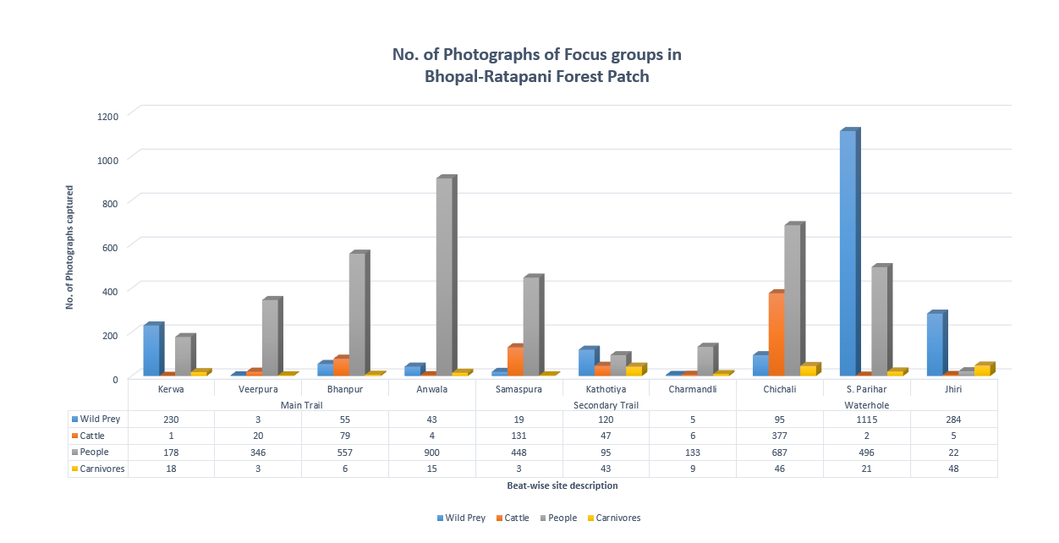
Figure 54: No. of photographs of focus groups in Bhopal-Ratapani Connecting Forest Patch

7.3.1.1 Temporal Overlap
The photographic data revealed temporal overlap (Figure 54) patterns among focal groups. Large carnivores, including tigers, were most active from 6:00 PM to 7:00 AM. Small carnivores showed daytime activity with a midnight peak. Wild prey was active throughout the day, peaking during daylight, while domestic prey and humans shared similar daytime activity patterns, influenced by local herding practices.

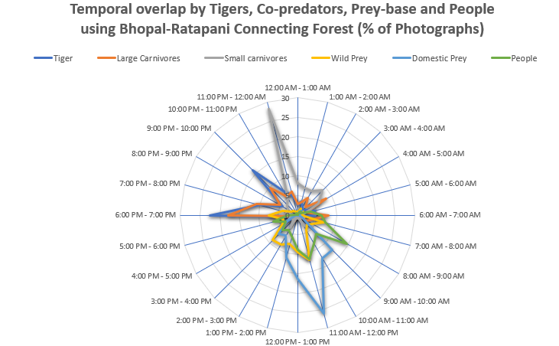
Figure 55: Temporal overlap among tigers, co-predators, prey base, and humans in the Bhopal-Ratapani Connecting Forest

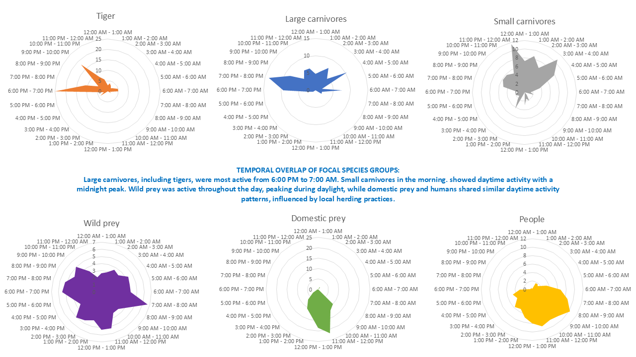
Figure 56: Temporal space-use by focused groups in Bhopal-Ratapani Connecting Forest

Activity Pattern of Carnivores
The stacked bar chart (Figure 56) illustrates the encounter percentages of different animal species across various hourly time slots throughout 24 hours. Tigers are primarily nocturnal, with peak encounters from 8 PM to 5 AM. Leopards show a more spread-out pattern but are mainly active at night and early in the morning. Striped Hyenas also exhibit nocturnal behavior, peaking from 8 PM to 5 AM. In contrast, Sloth Bears display crepuscular behavior, with most sightings during early morning (4 AM – 7 AM) and evening (6 PM – 9 PM), and are largely absent during midday hours.
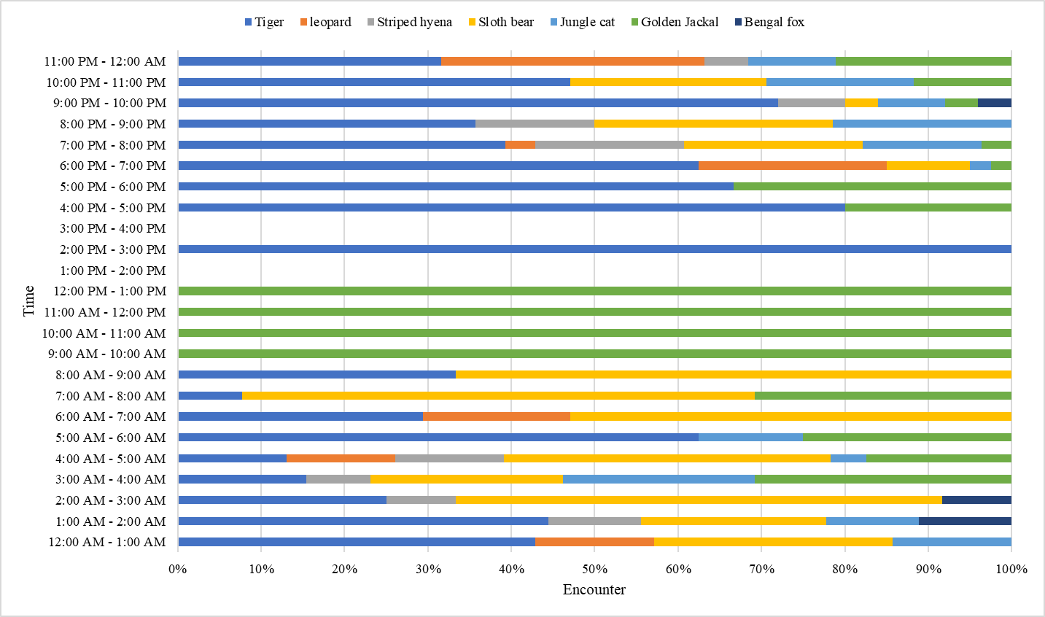
Figure 57: Activity pattern of carnivores in the Bhopal-Ratapani Connecting Forest

Activity Pattern of Prey Species
Activity pattern of Wild Prey (Figure 57) states that langurs dominate encounters, reflecting their strictly diurnal nature with peak activity. Blackbuck and nilgai show some early morning and late afternoon activity, i.e., crepuscular behavior. Spotted deer and four-Horned Antelope (FHA) are frequently observed in the morning and early evening, with spotted deer having a more evenly distributed pattern and FHA having a scattered presence. Indian hares and Porcupines exhibit strong nocturnal activity. The wild boar is active both at night and early morning, showing flexible behavior.
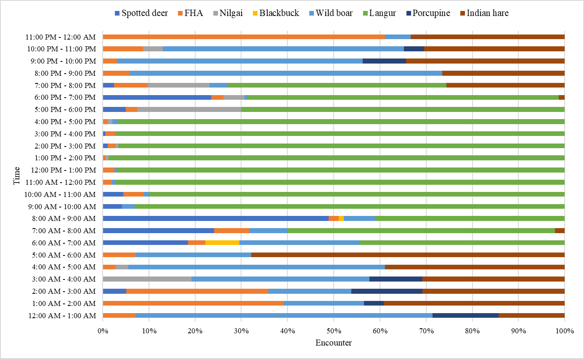
Figure 58: Activity pattern of Prey-base in the Bhopal-Ratapani Connecting Forest
Cows are the most frequently encountered, active throughout the day and night. Buffalo shows a more scattered pattern. Goats are predominantly diurnal, with higher activity in the morning (6 AM – 10 AM) and afternoon (2 PM – 5 PM), aligning with grazing patterns. (Figure 58)
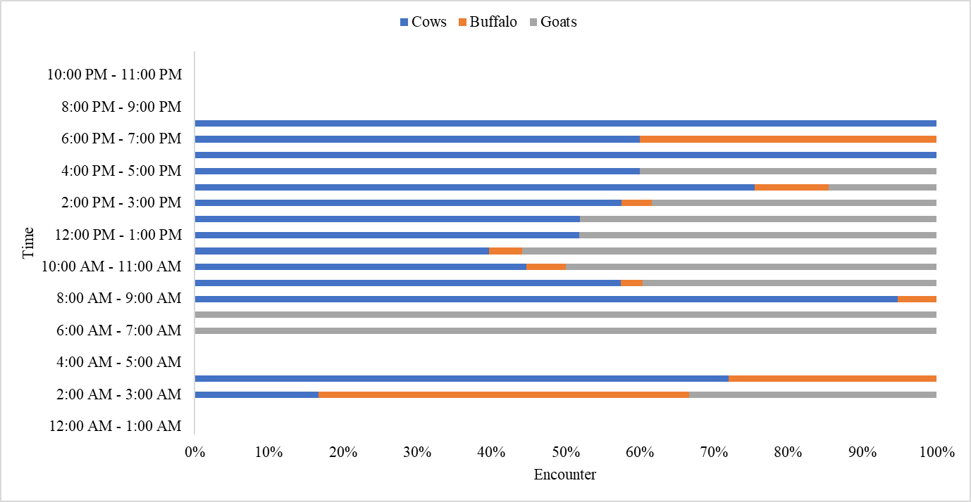
Figure 59: Activity pattern of domestic prey base in the Bhopal-Ratapani Connecting Forest

Activity Pattern of People
Human encounter data shows a distinct temporal pattern aligning with typical daily routines, with most activity during morning, midday, and early evening hours, and minimal movement at night and early morning.

7.3.1.2 Non-metric Multidimensional Scaling (NMDS)
The Non-metric Multidimensional Scaling (NMDS) plot, based on a correlation matrix of species activity, visually represents temporal relationships (Figure 59) among the studied animals in the Bhopal-Ratapani Connecting Forest. Species positioned closer together on the plot exhibit more correlated activity patterns, while those further apart show less synchronicity in their temporal niches. Two distinct clusters emerge, enclosed within ellipses. The first, associated with the "Blue" timeframe (Darkness to Sunlight), contains primarily nocturnal species: small carnivores (Sc), Indian hare (IH), porcupine (Porco), and wild boar (WB). The proximity of sloth bear (Sb), striped hyena (Sh), jungle cat (J cat), leopard (L), and tiger (T) to each other indicates their similar activity pattern and potential to avoid golden jackal (GJ).
The second cluster is encircled in green, indicating sunrise and sunset, and comprises blackbuck (Bb), spotted deer (Sd), nilgai and langur (Lang), suggesting a group of prey base that are active during the day. FHA lies between these two clusters, indicating that the species exhibits activity that is intermediate between day and night.
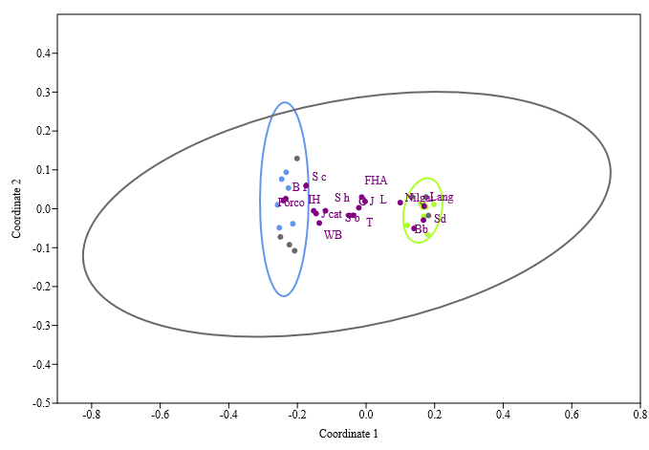
Figure 60: Non-MDS of temporal space-use

7.3.1.3 ANOVA Analysis of Spatial and Temporal variability in focal group
The ANOVA analysis for spatial variation (Table 19a) in the occurrence of tigers, co-predators, wild and domestic prey, and humans across ten camera trap locations reveals significant differences in spatial distribution. The statistically significant F-value of 4.2 (p = 0.003, critical F-value = 2.386) supports the alternative hypothesis (H₁), confirming that there is substantial spatial variation in how these groups use space. This finding rejects the null hypothesis (H₀) that there is no significant spatial variation.
The ANOVA analysis for temporal variation (Table 19b) in the occurrence of tigers, co-predators, wild and domestic prey, and humans, based on the presence/absence of these focal groups across ten camera trap locations and a 24-hour cycle (Zar, 1999). The analysis yielded a statistically significant F-value of 4.221 (critical F-value = 2.280; p = 0.001, α < 0.05), indicating substantial differences in temporal distribution across sites. These findings reject the null hypothesis (H₀) and support the alternative hypothesis (H₁), confirming distinct temporal space-use patterns among focal groups (Manly et al., 2002). (Table 19)

Table 20:ANOVA table for Spatial & Temporal Variation among focal groups
a. Anova: Single Factor  Spatial variation in different focal groups |  |  |  |  |  |  |  | b. Anova: Single Factor  Temporal variation in different focal groups
SUMMARY |  |  |  |  |  |  | SUMMARY
Groups |  | Count | Sum | Average | Variance |  | Groups |  |  | Count | Sum | Average | Variance
Tiger |  | 10 | 10 | 1 | 0 |  | Tiger |  |  | 24 | 18 | 0.750 | 0.196
Co-predators |  | 10 | 9 | 0.9 | 0.1 |  | Co-predators |  |  | 24 | 18 | 0.750 | 0.196
Small Carnivores |  | 10 | 6 | 0.6 | 0.267 |  | Small carnivores |  |  | 24 | 22 | 0.917 | 0.080
Wild Prey |  | 10 | 10 | 1 | 0 |  | Wild Prey |  |  | 24 | 24 | 1.000 | 0.000
Domestic Prey |  | 10 | 10 | 1 | 0 |  | Domestic Prey |  |  | 24 | 16 | 0.667 | 0.232
People |  | 10 | 10 | 1 | 0 |  | People |  |  | 24 | 24 | 1 | 0
ANOVA |  |  |  |  |  |  | ANOVA
Source of Variation | SS | df | MS | F | P-value | F crit | Source of Variation |  | SS | df | MS | F | P-value | F crit
Between Groups | 1.283 | 5 | 0.257 | 4.2 | 0.003 | 2.386 | Between Groups |  | 2.472 | 5 | 0.494 | 4.221 | 0.001 | 2.280
Within Groups | 3.300 | 54 | 0.061 |  |  |  | Within Groups |  | 16.167 | 138 | 0.117
Total | 4.583 | 59 |  |  |  |  | Total |  | 18.639 | 143

Ecologically, this suggests habitat preferences or niche partitioning at the landscape scale, likely driven by resource availability, anthropogenic pressures, or interspecific interactions.

7.3.2 Bhopal-Ratapani Landscape
Out of the 769 surveyed grids of 2x2 sq km, following the All India Tiger Estimation 2022. All the large carnivore pictures are segregated, and a total of 2213 independent photographs have been utilized to understand the temporal adaptation of large carnivores in the Bhopal-Ratapani Landscape.
All the grids were recorded with the presence of carnivores (small or large), wild herbivores, domestic prey, and humans in varied timelines. All the independent pictures of large carnivores (one picture at each trigger) were considered for analysis. Out of 2213 independent pictures, 273 pictures were captured in Bhopal-Sehore Forest, while 652 pictures were captured in Ratapani Core, and 1288 pictures were recorded in Obedullahganj territorial area (Figure 60). Collectively, 38.95% belongs to leopards, 36.91% to tigers, followed by 11.52% by sloth bear and 9.53% by hyena. Wolf and wild dogs were only captured in the Ratapani Core.

Figure 61: Share of photographs of tigers and co-predators in Bhopal-Ratapani Landscape

7.3.2.1 Temporal space-use adaptation
The radial plots show clear temporal partitioning between tigers and co-predators across the Bhopal-Ratapani Landscape in 2022. Tigers were seen most active during late evening to early morning (5PM to 7AM), while leopards were active early evening to early morning (4PM to 7AM). Hyenas were also showing late evening to early morning behaviour with various time peaks, while wolves were active till late morning with various time peaks. Sloth bear activity seems interesting with various time peaks across day time, while wild dogs were mainly active during daytime and only a single peak at midnight.
Tigers and Leopards can be seen depicting crepuscular and nocturnal behavior in the human-dominated landscape of the Bhopal-Ratapani Landscape. Hyena and Wolf were recorded with strict nocturnal behavior, while the wild dog showed more of a diurnal behavior. Sloth bear shows more erratic and widespread activity stating a cathemeral behavior (Figures 61 & 62).

Figure 62: Temporal space-use by tigers and co-predators in Bhopal-Ratapani Landscape (AITE 2022)

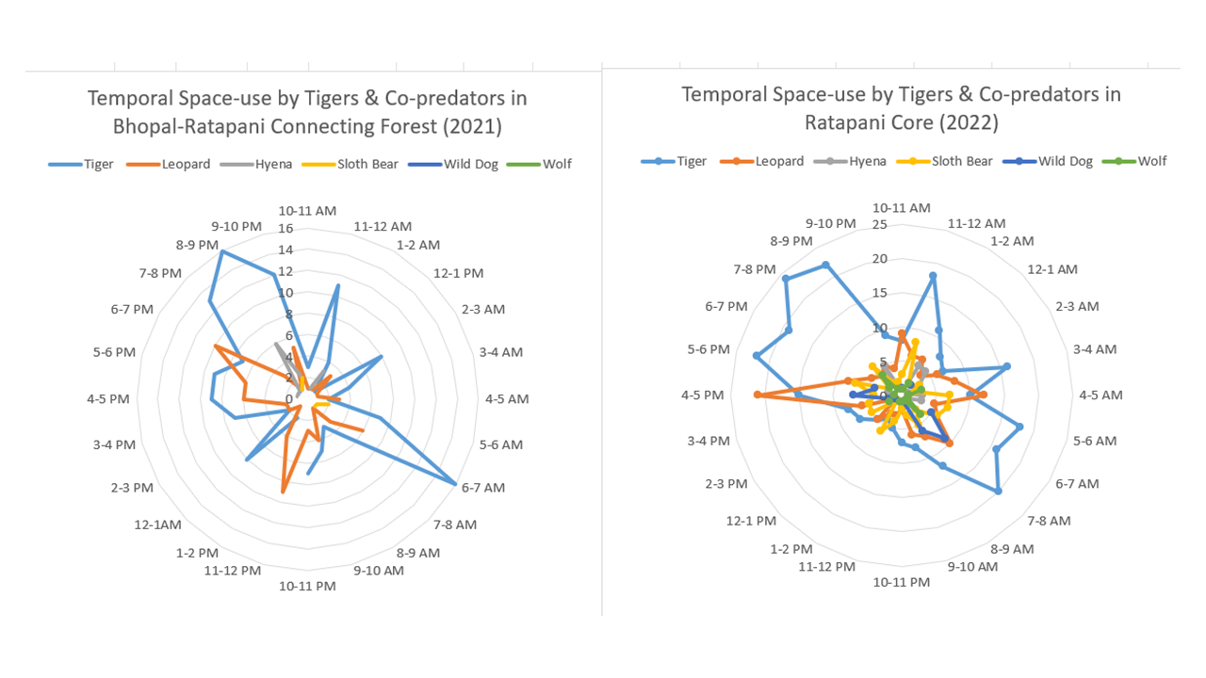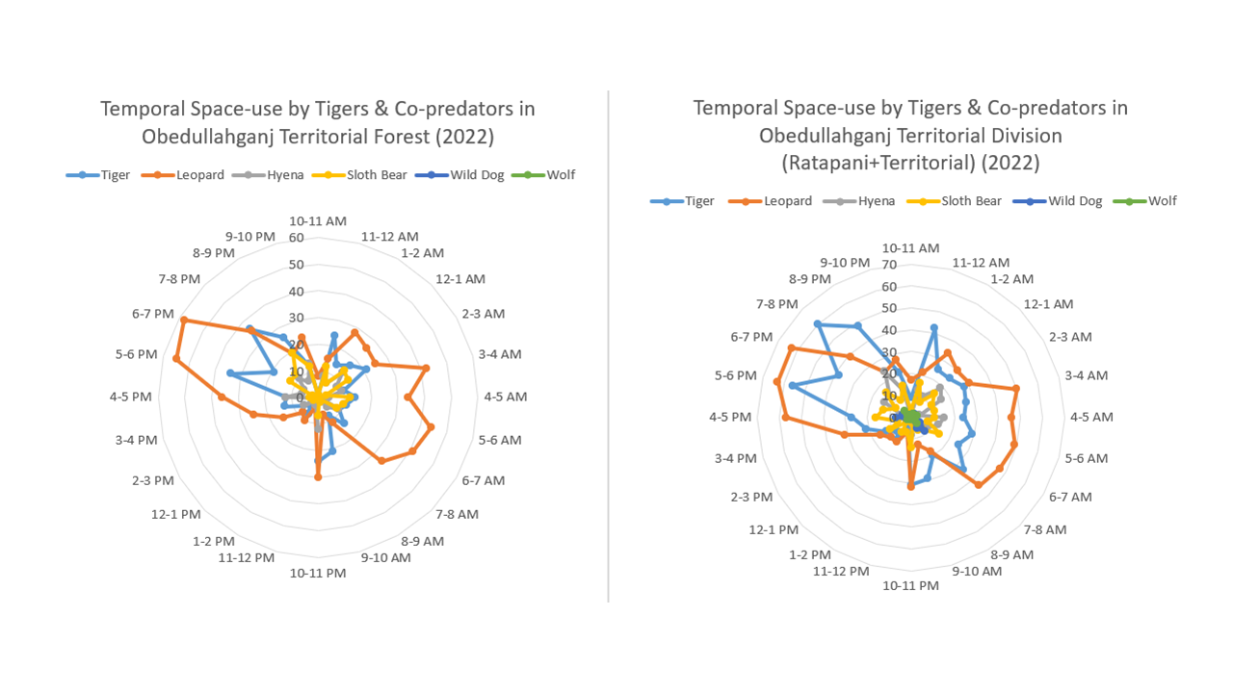
Figure 63: Temporal space-use across a) Bhopal-Sehore Territorial b) Ratapani Core c) Obedullahganj Territorial Forest d) Obedullahganj division (Ratapani core+territorial forest)

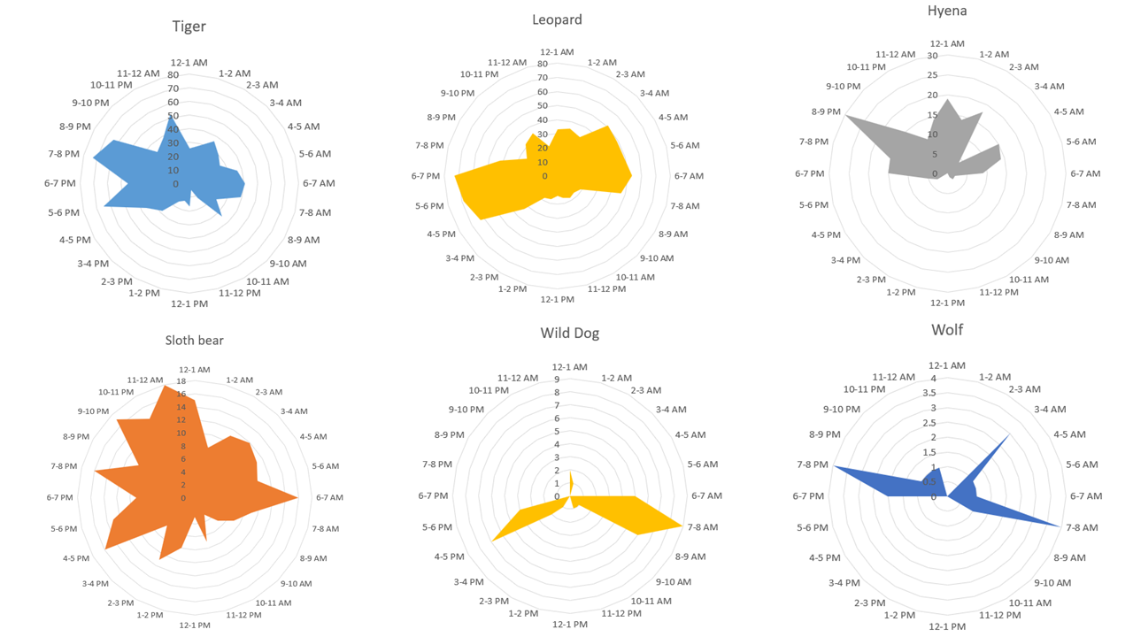
Figure 64: Temporal adaptation of Tigers and co-predators in Bhopal-Ratapani Landscape (AITE 2022)

7.3.2.2 ANOVA Analysis of Temporal and Spatial variability in large carnivores
The ANOVA analysis for temporal variation (Table 20) in the occurrence of tigers, and co-predators, across Bhopal-Ratapani Landscape reveals significant differences in temporal space-use among the carnivores. The statistically significant F-value of 51 (p = 0.001, critical F-value = 2.280) supports the alternative hypothesis (H₁), confirming that there is substantial temporal variation in how these carnivores use space. This finding rejects the null hypothesis (H₀) that there is no significant temporal variation.
Table 21: ANOVA table for Temporal Variation among tigers and co-predators
Groups | Count | Sum | Average | Variance
Tiger | 24.000 | 817.000 | 34.042 | 291.694
Leopard | 24.000 | 862.000 | 35.917 | 309.036
Hyena | 24.000 | 211.000 | 8.792 | 63.911
Sloth Bear | 24.000 | 255.000 | 10.625 | 18.940
Wild Dog | 24.000 | 41.000 | 1.708 | 6.563
Wolf | 24.000 | 27.000 | 1.125 | 1.418
ANOVA
Source of Variation | SS | df | MS | F | P-value | F crit
Between Groups | ######## | 5.000 | 5885.507 | 51.063 | 0.001 | 2.280
Within Groups | ######## | 138.000 | 115.261
Total | ######## | 143.000
The ANOVA analysis for temporal variation (Table 20) in the occurrence of tigers and co-predators across different sections of the Bhopal-Ratapani Landscape (Territorial Forest of Bhopal-Sehore, Ratapani core, and Obedullahganj territorial) reveals no significant differences in spatial space-use by tigers. The statistically significant F-value of 20.69 (p = 2.75569E-10, critical F-value = 2.70) supports the null hypothesis (H₀), confirming that there is no substantial spatial variation in how tigers use space. This finding accepts the null hypothesis (H₀) that there is no significant spatial variation. Similarly, all the co-predators show no spatial variation in space-use, stating the whole landscape as homogenous in nature.
Table 22: ANOVA table for spatial Variation among tigers
Groups | Count | Sum | Average | Variance
Bhopal-Sehore | 23 | 161 | 7 | 19
Ratapani Core | 24 | 299 | 12.45833 | 38.25906
Obedullahganj Territorial | 23 | 357 | 15.52174 | 81.07905
Obedullahganj division (Ratapani included) | 24 | 656 | 27.33333 | 196.3188
ANOVA
Source of Variation | SS | df | MS | F | P-value | F crit
Between Groups | 5241.746 | 3 | 1747.249 | 20.69919 | 2.75569E-10 | 2.705838
Within Groups | 7597.031 | 90 | 84.41145
Total | 12838.78 | 93

7.4 Discussion
Our findings highlight the importance of spatial-temporal partitioning as a key mechanism enabling the persistence of a tiger population in a human-dominated landscape. Specifically, the observed activity patterns reveal that tigers and other carnivores largely adopt nocturnal behaviors to minimize overlap with human activity (Gallo et al., 2022), while prey species exhibit diverse strategies, including diurnal, nocturnal, and crepuscular patterns, to balance resource acquisition with predation risk (Oksanen et al., 2020; Chaudhuri et al., 2022). The dominance of human activity during daylight hours underscores the significant influence of anthropogenic pressures on wildlife behavior in this urban environment (Xiao et al., 2018; Naha et al., 2021). These findings contribute to a more nuanced understanding of human- wildlife interactions and can inform targeted conservation interventions aimed at promoting long-term tiger survival and coexistence in rapidly changing environments.
The study at the Bhopal-Ratapani Landscape level states similar temporal adaptation of tigers and co-predators. However, the ANOVA results state clear temporal variation among Tigers and co-predators in space use, but no significant difference in spatial context, such as Bhopal-Sehore, Ratapani core, and Obedullahganj territorial, stating the homogenous landscape availability. Further research is needed to explore this spatial and temporal aspect of these interactions at a larger landscape level and to assess the effectiveness of different management strategies in ensuring human- wildlife coexistence in human-dominated landscapes.

CHAPTER 8
CONCLUSION: HUMAN-TIGER COEXISTENCE IN URBAN LANDSCAPE OF BHOPAL

CHAPTER 8
CONCLUSION: HUMAN-TIGER COEXISTENCE IN URBAN LANDSCAPE OF BHOPAL

The study on tiger presence in the urban and peri-urban landscape of Bhopal is unique in the context of Human-Tiger Coexistence. The case study is unique as in previous studies its often seen that large carnivores often create fear and risk (Kolipaka et al., 2017) while in Bhopal, the ecological structure, social tolerance, and efforts of the forest department are promoting coexistence. Tigers have been using the blue-green spaces of Bhopal city and adjoining Vindhyan landscape, including the recently declared Ratapani Tiger Reserve since long back without any conflict. The royal families in the British era used this area as a hunting ground. Despite an expanding city in last decades, tigers continue to survive and use the urban and peri-urban landscape of Bhopal city.
The agriculture-dominated Bhopal Forest Circle has good forest cover in the southern portion of it and is now preserved as Ratapani Tiger Reserve. The tiger presence and movement across the municipal limits of Bhopal city, as well as Peri-urban and rural areas in the territorial forest of Obedullahganj, Bhopal, Sehore, and Raisen. There are very few articles related to tiger aspects and landscape perception in urban regions in India, and therefore, one large potential research field is uncovered. Hence, the current work is to understand the spatial features of the urban landscape and the impact of anthropogenic variables on the tiger presence. The study found that tigers perceived this landscape differently, as a function of their dispersal capabilities.
The study concludes that tiger suitability in the human-modified environment of central India is majorly governed by forest density and among defined land use variables, moderate forest indicates extreme importance as it is mostly connected with other classes and also shows maximum tiger presence and movement regions (Ahsan et al. 2026). The integration of high-accuracy land use and forest density maps coupled with the AHP framework and regression analysis modelling, provides a robust framework for tiger suitability evaluation (Imam and Tesfamichael, 2013; Kumar et al., 2020; Lavania et al., 2024).
The dense forest indicates the high postnatal region for tiger habitats, and these habitat patches inhibit a high number of graph nodes, which indicates that the region is of importance for tiger presence and movement (Karanth et al., 2004; Kanagaraj et al., 2011; Sarkar et al., 2018; Yumnam et al., 2014; Roshani et al., 2024; Qureshi et al., 2023). The moderately dense patches show high diversity in terms of fragmentation, which means this class is highly fragmented and covers mostly the outer edges of the dense forest. This class is vulnerable to fragmentation but has high potential for tiger connectivity in the southern region. The Raisen and Sehore districts are composed of most of the highly suitable habitats with some isolated patches embedded in an extensive agricultural matrix. Ratapani Tiger Reserve and its surrounding forest habitats showed critical tiger habitats (Verma & Nag, 2022). Raisen alone contributes nealrly two third of the highly suitable habitats, forest patches outside the RTR areas, specifically in the eastern Raisen and western Sehore, exhibit strong suitable habitats. The low suitability continuous patch in the Bhopal district surrounding the settlement regions, through widespread include key linkage zones by connecting highly suitable forest habitas of Bhopal city to Ratapani Tiger Reserve.
The graph model results show high connectivity in the urban landscape of Bhopal, those indicate the movement zones that are of high potential for tiger habitats such as Kerwa-kaliasot (Dwivedi et al., 2009). Similar studies prioritizing spatial prioritization and broader applicability, such as Ranganathan et al., 2008; Reddy et al., 2017, and Yumnam et al., 2014. One patch of suitable habitat is coming in the urban city representative the urban spaces as stepping stones for tigers with a good probability of connectivity with the southern and northern forest regions. The overall combined results of the landscape metrics and habitat suitability model give the best outcomes, which show that spatial layers of water and dense forest are the key variables playing a role in tiger presence. The study also highlights that settlements are not playing a negative role in the tiger presence in the context that they don’t act as resistance, as mentioned in other studies across the globe (Krishnamurthy et al., 2016). The study also highlights northern forest areas of Raisen-Vidisha as stepping stones in the agricultural land cover regions having disconnected and less connectivity in the upper part that constitute less suitable patches and high open dense forest mostly dominated by agriculture. The eastern zone has a moderate amount of connectivity in the form of Raisen Division for tigers with the maximum dense forest class, which is connected with other classes with high connections in recent surveys and opportunistic records tigers have been reported from this area. The southern portion has maximum continuity, more tiger presence, high suitable patches, more water bodies, far from the density of roads, and railways, but the existing roads and railways impacting severely on Ratapani Core, etc. This southern portion is well used by tigers and other large predators. All India Tiger Estimation 2022 states Bhopal-Ratapani-Dewas Landscape as an important complex and has witnessed a doubled population since the last AITE 2018, having a population of 96 tigers (SE 9) within an area of 4530 sq. km.
One of the highly suitable patches overlapping urban areas of Bhopal can be seen as a representative urban stepping stone, connecting southern and northern forest regions, establishing a role for urban green space networks as part of a tiger conservation landscape rather than as purely antagonistic land uses (Hosaka and Numata, 2016). This also aligns with emerging global literature on large carnivores in urban landscapes, which shows that appropriately configured green space networks, riparian corridors, and peri-urban forests can facilitate movement and persistence of predators from coyotes and black bears in North America to hyenas in African cities (e.g., Bateman & Fleming, 2012; Magle et al., 2012; Aziz and Rasidi, 2014; Yirga et al., 2015; Gallo et al., 2017).
The study highlights mixed prey-base availability and tigers utilizing this mixed prey base (Harihar & Pandav, 2012), with domestic livestock comprising less than 20% of their diet. The livestock densities in the landscape are dominated by cows, followed by langurs and nilgai in the landscape, while pigs dominate in city areas after cows. However, the increasing proportion of domestic prey in areas closer to human settlements raises important conservation concerns (Chundawat et al., 2008; Dickman, 2008; Reddy et al., 2004; Kolipaka et al., 2017; Jhala et al., 2021). While livestock offers a predictable and readily available food source, reliance on domestic prey heightens the risk of human-wildlife conflict, including retaliatory killings of tigers by local communities and negative attitudes escalating rapidly (Distefano, 2005; Thirgood et al., 2005; Karanth et al., 2011; Goodrich et al., 2015). To mitigate such conflicts, proactive conservation strategies are necessary, including habitat augmentation to bolster wild prey populations, promotion of improved livestock guarding practices, implementation of compensation schemes for depredation losses, and community capacity building and engagement programs to foster coexistence (Misra and Madhusudan, 2003; Rostro-García and Woodroffe, 2012; Karanth et al., 2011; Gubbi et al., 2014; Nyhus, 2016; Sharma et al., 2017). This study underscores the complex ecological resilience of tigers and their capacity to persist in human-altered landscapes by adjusting their dietary strategies and prey availability.
Concluding the ecological aspect of the study, the results align with large tiger landscape studies across Central India and Asia, highlighting the importance of contiguous or semi-contiguous forest cover, prey availability and structural-functional connectivity between PA and non-protected territorial forest in human-dominated landscapes supporting tiger populations (DeFries et al., 2010; Joshi et al., 2013; Dutta et al., 2018; Sanderson et al., 2023).
Understanding the human dimension of the study is an important part of management. The low conflict levels, timely compensatory practices, and non-retalitory attitude of the local community are playing an important role, as they have played across the globe (Mishra & Madhusudan, 2003; Rostro-García & Woodroffe, 2012; Gubbi et al., 2014; Sharma et al., 2017). Human-wildlife interactions, particularly with large carnivores like tigers, are framed by theories such as the Theory of Reasoned Action (TRA) and Theory of Planned Behavior (TPB), which link attitudes, subjective norms, and perceived control to behavioral intentions like supporting conservation (Ajzen and Fishbein, 1980). In the Bhopal context, TRA helps explain spontaneous tolerance behaviors, while TPB addresses barriers like limited control over tiger movements in shared spaces (Ajzen, 2020). These frameworks reveal how socio-cultural values and past experiences influence perceptions, with 30% of respondents valuing wildlife for socio-cultural reasons and 17% for spiritual ones, aligning with studies showing cultural reverence for tigers in Central India (Bhatia et al., 2019).
Similar applications in India highlight that those positive attitudes stem from beliefs in tigers’ ecological roles, but negative encounters erode them (Karanth and Surendra, 2018). For instance, in Nagarhole, villagers’ intentions to retaliate correlate with perceived risks, underscoring TPB’s relevance (Karanth et al., 2018). This study’s respondents, mostly from low-education backgrounds (44.6% illiterate), draw knowledge from peers (92%) rather than formal education, mirroring global patterns where informal networks shape norms (Kahler and Gore, 2015). Attitudes blend fear, pride, and conditional acceptance: 62 felt happy about tigers, but 107 wanted them away from villages. The conditional acceptance by 26% of respondents states clearly that they accept tigers till they are not involved in human causality (Carter et al., 2012). Emotional responses fearful (76%) yet proud (30%) reflect India’s tiger icon status, where cultural symbolism buffers negativity (Kellert, 1991). Only 9% held outright negative views, lower than in high-conflict zones like Nagarhole, where livestock losses amplify intolerance.
The findings support low-conflict coexistence, with high awareness and conditional positivity enabling interventions like community monitoring (Jordan et al., 2020). Compensation addresses losses, but education via photo-cards and free-listing builds knowledge (Marker et al., 2003). Staff training on TPB could enhance control perceptions, integrating herding data for targeted fencing (Ajzen, 2020). Urban gradients demand landscape-scale plans, prioritizing consensus corridors (70% village-overlapped) over reactive measures (Jhala et al., 2025).
The observed activity patterns reveal that tigers and other carnivores largely adopt nocturnal behaviors to minimize overlap with human activity (Gallo et al., 2022), while prey species exhibit diverse strategies, including diurnal, nocturnal, and crepuscular patterns, to balance resource acquisition with predation risk (Oksanen et al., 2020; Chaudhuri et al., 2022). The dominance of human activity during daylight hours underscores the significant influence of anthropogenic pressures on wildlife behavior in this urban environment (Xiao et al., 2018; Naha et al., 2021). These findings contribute to a more nuanced understanding of human- wildlife interactions and can inform targeted conservation interventions aimed at promoting long-term tiger survival and coexistence in rapidly changing environments.
By integrating ecological research with socio-economic considerations, conservation initiatives can adopt a holistic approach to safeguarding tigers amidst increasing urbanization and anthropogenic pressures (Grove & Burch, 1997). The urban landscape of Bhopal serves as an insightful case study for understanding large carnivore conservation in rapidly expanding urban environments and focusing on location-specific strategies. Future research should focus on long-term monitoring in city green spaces, the changing dynamics of habitat mosaics influenced by human use and management of cattle close to human dwellings, as they all influence human-wildlife interactions. There needs to be a focus on developing low suitable areas outside in territorial divisions of Bhopal Forest Circle outside the RTR region, specifically in the Bhopal and Vidhisha districts, which showed potential habitat connectivity for tiger habitats. The historical records state the presence of tigers in both divisions over the last 50 years.
Bhopal’s case study emphasizes the need for integrated urban master plans, including retaining green spaces, enhancing connectivity between them for wildlife persistence, but also delivering broader ecosystem services such as water regulation, climate resilience, and human well-being (McKinney, 2002; Govindarajulu, 2014; Kong et al., 2010). The case study also illustrates that coexistence between large carnivores and cities is achievable when ecological considerations are embedded within planning and governance processes. Developing more understanding of urban green spaces, peri-urban connectivity, large carnivores’ occurrence, and people’s acceptance are crucial while planning city development. In addition, restricting urban growth on urban blue-green spaces, restricting night-time traffic in critical areas, multi-stakeholder approach can promote and strengthen coexistence. Co-producing conservation strategies in such shared landscapes with local communities through building on their existing knowledge, cultural values, and risk-management practices can strengthen the stewardship among citizens. This can be promoted through various citizen science initiatives and sensitisation programs.
The study underscores the need for long-term integrated monitoring by combining ecological, social, and governance indicators for research and policy interface. From an ecological perspective, the area needs to be intensively surveyed using camera traps, radio-collars on key individuals, and repeated assessments of prey populations. On social sides, intensive focal group discussions, triangulated records of events, and developing a site-specific framework on people’s behaviour will enhance the future records. On the governance level, a multi-stakeholder approach needs to be incorporated, and cross-sectoral coordination among forest, municipality, urban development, irrigation, police, and tourism departments should be promoted as human-carnivore coexistence is not static but an ever-evolving process, especially in dynamic urban landscapes (Nyhus, 2016; Carter et al., 2020).
In conclusion, the study demonstrates a unique situation of Human-Tiger Coexistence in the urban landscape of Central India using a bio-social approach, given a situation where current conditions are actively maintained and strengthened. The integrated methodology of field surveys, geo-spatial analysis, dietary and prey assessment, spatio-temporal space use analysis, and social-behavioural framework offers a robust model for developing an understanding of large carnivores and coexistence in urban landscapes of India. The study should be replicated in different cities across India to develop a wide understanding of different situations supporting or hindering human-wildlife coexistence. At the same time, this also highlights the urgency of ecological considerations in urban planning, infrastructure development, and community engagement.
As cities developed into green cities and developed blue-green spaces as well as expanding over wildlife habitats, the findings of the Bhopal case study of shared spaces, temporal adaptation, and social acceptability of wildlife can promote people and carnivores sharing spaces in dynamic landscapes.

CONSERVATION ACTION PLAN FOR MANAGING TIGERS IN URBAN LANDSCAPE
- The Bhopal-Ratapani Landscape is a unique landscape of Human-Tiger Coexistence, of which the urban area of Bhopal is an important part. With increasing tiger numbers, human population, and urban expansion, the edge between the human-wildlife is dissolving. A multi-stakeholder approach needs to be considered to manage the landscape.
- As quoted by Edward Deming " A survey is snapshot while monitoring is a trajectory", the study is just a baseline of existing situation in the landscape, expanding this study to year around monitoring and utilising various other monitoring technologies such as radio-telemetry, bioacoustics studies, genetic studies to understand variability as well as movement of the individuals and behavioural studies on the established tigers in urban landscape can give more details on the potential of human-wildlife coexistence in urban landscapes.
- City development authorities, including the municipal corporation, Bhopal development authority, and town and country planning, should consider the presence of tigers and other wildlife in the city and utilise the research findings of this work, supplemented by regular monitoring by the forest department and associated organisations. The city should be designed considering ecological, social, and historical aspects for a sustainable future. While developing urban green and blue spaces, planners should understand that they are designing an ecosystem for animals as well as the people of the city.
- As part of the extension of the project, the Forest department, in collaboration with local NGO have started a community-based monitoring system with the support of WTI-India and WWF-India. The findings state clearly the local stewardship in monitoring, timely information percolation from field to local field staff, and ease in management of movement areas. Such programs have been implemented in various tiger reserves across Madhya Pradesh, and replicating them in territorial forest areas or human-dominated landscapes can not only promote intensive monitoring but also a community-inclusive conservation model. However, precautions should be maintained while selecting community members for the program.
- Human-dimensions in such studies play important role but a very sensitive topic to explore attitude and perception as it can vary with various individual and societal factors. Various intensive research on attitude and perception, cultural tolerance and people’s acceptability should be carried out with required sensitivity and expertise.
- Urban areas are dynamic areas not only in context of urban development but also in context of people migrating from different areas so regular awareness and sensitization programs should be carried out with local NGOs to boost acceptance toward wildlife as well as reduce any potential conflict.
- Tigers have been recorded with utilising a wide array of prey base, however the proportion of domestic cattle in tiger diet is low, but increase in the proportion due to growing tiger population may risk potential of conflict. Forest department should start managing these areas as they manage any of the core area of PA across Madhya Pradesh focusing Habitat augmentation in term of grassland development, waterbodies development and prey augmentation if required.
- At Bhopal Forest Circle level, the study has identified important forest patches based on suitability analysis, prioritizing restoration of low suitable areas and critical stepping stone habitats and corridors can support long term conservation in this habitat.
- Durable coexistence requires moving beyond reactive compensation toward proactive, landscape-level strategies that integrates ecological restoration with adaptive governance.

REFERENCE

- Ahsan, A., Shanu, S., & Roy, D. A. (2026). Modeling Tiger Dispersal in the Central Indian Landscape Using a Prey-Predator Game Theory Approach Coupled with Network Analysis and Remote Sensing-GIS. Journal for Nature Conservation, 127224. https://doi.org/10.1016/j.jnc.2026.127224
- Ajzen, I. (2020). The theory of planned behavior: Frequently asked questions. Human behavior and emerging technologies, 2(4), 314-324. https://doi.org/10.1002/hbe2.195
- Ajzen, I., & Fishbein, M. (1980). Understanding attitudes and predicting social behavior. Englewood Cliffs.
- Anselin, A., Meire, P. M., & Anselin, L. (1989). Multicriteria techniques in ecological evaluation: an example using the analytical hierarchy process. Biological Conservation, 49(3), 215-229. https://doi.org/10.1016/0006-3207(89)90037-2
- Athreya, V., (2011). Leopards in our alley. Down to Earth, 52-53.
- Athreya, V., R. Navya., G.A. Punjabi., J.D.C. Linnell., M. Odden., S. Khetarpal., and K.U. Karanth. (2014). Movement and activity pattern of a collared tigress in a human-dominated landscape in central India. Tropical Conservation Science, 7: 75–86. https://doi.org/10.1177/194008291400700111
- Athreya, V., Odden, M., Linnell., J., Krishnaswamy, J., Karanth, K. (2016). A cat among the dogs: Leopard Panthera pardus diet in a human-dominated landscape in western Maharastra, India. Oryx, 50(1), 156-162. https://doi.org /10.1017/s0030605314000106
- Aziz, H. A., & Rasidi, M. H. (2014). The role of green corridors for wildlife conservation in urban landscape: A literature review. In IOP Conference Series: Earth and Environmental Science (Vol. 18, No. 1, p. 012093). https://doi.org/10.1088/1755-1315/18/1/012093
- Bagchi, S., Goyal, S. P., & Sankar, K. (2003). Prey abundance and prey selection by tigers (Panthera tigris) in a semi-arid, dry deciduous forest in western India. Journal of Zoology, 260(3), 285-290. https://doi.org/10.1017/s0952836903003765
- Baker, P.J., Harris, S. (2007). Urban mammals: what does the future hold? An analysis of the factors affecting patterns of use of residential gardens in Great Britain. Mammal Rev. 37, 297–315. https://doi.org/10.1111/j.1365-2907.2007.00102.x
- Banerjee, K., Jhala, Y.V., Chauhan K.S., and Dave C.V. (2013). Living with lions: The economics of coexistence in the Gir Forests, India. Journal PLoS ONE, 8(1): c49457. https://doi.org/10.1371/journal.pone.0049457
- Bateman, P.W., P.A. Fleming, (2012). Big city life: carnivores in urban environments. Journal of Zoology, 287; 1-23. https://doi.org/10.1111/j.1469-7998.2011.00887.x
- Beckmann, J.P., & Berger, J. (2003). Rapid Ecological and behavioural changes in carnivores: the responses of Black bears to altered food. Journal of Zoology, 261, 207-212. https://doi.org/10.1017/s0952836903004126
- Beckmann, J.P., Lackey, C.W. (2008). Carnivores, urban landscapes, and longitudinal studies: a case history of black bears. Human-Wildlife Conflict. 2, 168–174.
- Bentler, P. M., & Speckart, G. (1979). Models of attitude–behavior relations. Psychological review, 86(5), 452. https://doi.org/10.1037/0033-295x.86.5.452
- Bernard, HR. (2006). Research Methods in Anthropology. Lanham, Altamira Press.
- Bhatia, S., Athreya, V., Grenyer, R., & Macdonald, D. W. (2013). Understanding the Role of Representations of Human–Leopard Conflict in Mumbai through Media‐Content Analysis. Conservation Biology, 27(3), 588-594. https://doi.org/10.1111/cobi.12037
- Bhatia, S., Redpath, S. M., Suryawanshi, K., & Mishra, C. (2020). Beyond conflict: exploring the spectrum of human–wildlife interactions and their underlying mechanisms. Oryx, 54(5), 621-628. https://doi.org/10.1017/s003060531800159x
- Bhopal City Development Plan, (2006). Jawaharlal Nehru National Urban Renewal Mission accessed at http://www.mpurban.gov.in/Pdf/CDP/Bhopal%20CDP_Final%20.pdf
- Biswas, S., and Sankar, K. 2002. Prey abundance and food habit of tigers (Panthera tigris tigris) in Pench National Park, Madhya Pradesh, India. Journal of Zoology, 256(3), 411–420. https://doi.org/10.1017/s0952836902000456
- Buchmann, C. M., Schurr, F. M., Nathan, R., & Jeltsch, F. (2013). Habitat loss and fragmentation affecting mammal and bird communities—The role of interspecific competition and individual space use. Ecological Informatics, 14, 90-98. https://doi.org/10.1016/j.ecoinf.2012.11.015
- Cardillo, M., Mace, G. M., Gittleman, J. L., Jones, K. E., Bielby, J., & Purvis, A. (2008). The predictability of extinction: biological and external correlates of decline in mammals. Proceedings of the Royal Society of London B: Biological Sciences, 275(1641), 1441-1448. https://doi.org/10.1098/rspb.2008.0179
- Cardillo, M., Purvis, A., Sechrest, W., Gittleman, J. L., Bielby, J., & Mace, G. M. (2004). Human population density and extinction risk in the world's carnivores. PLoS biology, 2(7), e197. https://doi.org/10.1371/journal.pbio.0020197
- Carter, N. H., Shrestha, B. K., Karki, J. B., Pradhan, N. M. B., & Liu, J. (2012). Coexistence between wildlife and humans at fine spatial scales. Proceedings of the National Academy of Sciences, 109(38), 15360-15365. https://doi.org/10.1073/pnas.1210490109
- Carter, N., Killion, A., Easter, T., Brandt, J., & Ford, A. (2020). Road development in Asia: Assessing the range-wide risks to tigers. Science Advances, 6(18), eaaz9619. https://doi.org/10.1126/sciadv.aaz9619
- Census of India (2011). Provisional Population Totals. New Delhi: Government of India.
- Champion, H. G., & Seth, S. K. (1968). A revised survey of the forest types of India. Manager of publications.
- Chaudhuri, S., Bandyopadhyay, M., Rajaraman, R., Kalyanasundaram, S., Sathyakumar, S., & Krishnamurthy, R. (2022). Spatio-Temporal Patterns and Source-Dispersion Modeling Towards Sloth Bear–Human Conflict Management in Central India. Frontiers in Conservation Science, 3, 850309. https://doi.org/10.3389/fcosc.2022.850309
- Chetcuti, J., Kunin, W. E., & Bullock, J. M. (2020). Habitat fragmentation increases overall richness, but not of habitat-dependent species. Frontiers in Ecology and Evolution, 8, 607619. https://doi.org/10.3389/fevo.2020.607619
- Chundawat, R.S., and Sharma, K. (2008). Tiger prey in a tropical dry forest: an assessment of abundance and of biomass estimation derived from distance sampling. Journal of the Bombay Natural History Society. 2008; 105(1): 64-72.
- Chundawat, R.S., Sharma, K., Gogate, N., Malik, P. K., & Vanak, A. T. (2016). Size matters: Scale mismatch between space use patterns of tigers and protected area size in a Tropical Dry Forest. Biological Conservation, 197, 146-153. https://doi.org/10.1016/j.biocon.2016.03.004
- Comiskey, E. J., Bass Jr, O. L., Gross, L. J., McBride, R. T., & Salinas, R. (2002). Panthers and forests in south Florida: an ecological perspective. Conservation Ecology, 6(1). https://doi.org/10.5751/es-00406-060118
- Conforti, V. A., & de Azevedo, F. C. C. (2003). Local perceptions of jaguars (Panthera onca) and pumas (Puma concolor) in the Iguaçu National Park area, south Brazil. Biological conservation, 111(2), 215-221. https://doi.org/10.1016/s0006-3207(02)00277-x
- Congalton, R. G. (2001). Accuracy assessment and validation of remotely sensed and other spatial information. International journal of wildland fire, 10(4), 321-328. https://doi.org/10.1071/wf01031
- Cozza, K., Fico, R., Battistini, M. L., & Rogers, E. (1996). The damage-conservation interface illustrated by predation on domestic livestock in central Italy. Biological Conservation, 78(3), 329-336. https://doi.org/10.1016/s0006-3207(96)00053-5
- Crooks, K. R. (2002). Relative sensitivities of mammalian carnivores to habitat fragmentation. Conservation biology, 16(2), 488-502. https://doi.org/10.1046/j.1523-1739.2002.00386.x
- Curtis, J. T. (1959). The vegetation of Wisconsin: an ordination of plant communities. University of Wisconsin Pres. https://doi.org/10.2307/jj.36075910
- DeFries R, Karanth KK, Pareeth .S.J. (2010). Interactions between protected areas and their surroundings in human-dominated tropical landscapes. Biological Conservation 143: 2870–2880. doi:10.1016/j.biocon.2010.02.010
- Dickman, A. J. (2008). Key determinants of conflict between people and wildlife, particularly large carnivores, around Ruaha National Park, Tanzania. PhD thesis, University College London, London.
- Dickman, A.J., Marchini, S. & Manfredo, M. (2013). The human dimension in addressing conflict with large carnivores. Research Gate, 110-126. https://doi.org/10.1002/9781118520178.ch7
- Distefano, E. 2005. Human-Wildlife Conflict worldwide: collection of case studies, analysis of management strategies and good practices. Food and Agricultural Organization of the United Nations (FAO), Sustainable Agriculture and Rural Development Initiative (SARDI), Rome, Italy. Available from: FAO Corporate Document repository http://www.fao.org/documents
- Dutta, T., Sharma, S., & DeFries, R. (2018). Targeting restoration sites to improve connectivity in a tiger conservation landscape in India. PeerJ, 6, e5587. https://doi.org/10.7717/peerj.5587
- Dwivedi, P., Rathore, C.S., Dubey, Y., (2009). Ecological benefits of urban forestry: The case study of Kerwa Forest Area (KFA), Bhopal, India. Applied Geography, Volume 29, Issues 2, 194-204. https://doi.org/10.1016/j.apgeog.2008.08.008
- Eastman, J. R. (1999). Multi-criteria evaluation and GIS. Geographical information systems, 1(1), 493-502.
- Estes, J. A., Terborgh, J., Brashares, J. S., Power, M. E., Berger, J., Bond, W. J., ... & Wardle, D. A. (2011). Trophic downgrading of planet Earth. science, 333(6040), 301-306. https://doi.org/10.1126/science.1205106
- Fahrig, L. (2003). Effects of habitat fragmentation on biodiversity. Annual review of ecology, evolution, and systematics, 34(1), 487-515. https://doi.org/10.1146/annurev.ecolsys.34.011802.132419
- Farris, Z. J., Karpanty, S. M., Ratelolahy, F., & Kelly, M. J. (2014). Predator–primate distribution, activity, and co-occurrence in relation to habitat and human activity across fragmented and contiguous forests in northeastern Madagascar. International Journal of Primatology, 35, 859-880. https://doi.org/10.1007/s10764-014-9786-0
- Fernández, N., & Palomares, F. (2000). The selection of breeding dens by the endangered Iberian lynx (Lynx pardinus): implications for its conservation. Biological Conservation, 94(1), 51-61. https://doi.org/10.1016/s0006-3207(99)00164-0
- Foody, G. M. (2003). Remote sensing of tropical forest environments: towards the monitoring of environmental resources for sustainable development. International journal of remote sensing, 24(20), 4035-4046. https://doi.org/10.1080/0143116031000103853
- Forman, R. T. (1995). Land mosaics: the ecology of landscapes and regions. Cambridge University press.
- Fuller, T., and Sievert, P. (2001). Carnivore demography and the consequences of changes in prey availability. Carnivore Conservation, (December), 163–179.
- Fuller, T.K., Destefano, S., Warren, P.S. (2010). Carnivore Behaviour and Ecology, and Relationship to Urbanisation. Urban carnivores. Baltimore, MD: The John Hopkins University Press. 13-19.
- Gallo, T., Fidino, M., Gerber, B., Ahlers, A. A., Angstmann, J. L., Amaya, M., ... & Magle, S. B. (2022). Mammals adjust diel activity across gradients of urbanization. Elife, 11:E74756. https://doi.org/10.7554/elife.74756
- Gallo, T., Fidino, M., Lehrer, E. W., & Magle, S. B. (2017). Mammal diversity and metacommunity dynamics in urban green spaces: implications for urban wildlife conservation. Ecological Applications, 27(8), 2330-2341. https://doi.org/10.1002/eap.1611
- Gehrt, S.D., Riley, S.P.D., Cypher, B.L. (2010). Urban carnivores. Baltimore, MD: The John Hopkins University Press. ISBN:978-08018-9389-6
- Gehrt, S. (2011). Urban Coyote Ecology and Management, The Cook County, Illinois, Coyote Project. http://urbancoyoteresearch.com/.
- Gibson, P. (2013). Introductory remote sensing principles and concepts. Routledge.
- Glastonbury, B.; MacKean, J. 1991 Survey methods. In: Allan, G.; Skinner, C. (eds.) Handbook for research students in the social sciences. The Falmer Press, London pp. 225-247. https://doi.org/10.4324/9781003070993-22
- Glenz, C., Massolo, A., Kuonen, D., & Schlaepfer, R. (2001). A wolf habitat suitability prediction study in Valais (Switzerland). Landscape and Urban planning, 55(1), 55-65. https://doi.org/10.1016/s0169-2046(01)00119-0
- Goodrich, J., Lynam, A., Miquelle, D., Wibisono, H., Kawanishi, K., Pattanavibool, A., Htun, S., Tempa, T., Karki, J., Jhala, Y., and Karanth, U. (2015). Panthera tigris. The IUCN Red List of Threatened Species 2015: e.T15955A50659951. https://doi.org/10.2305/iucn.uk.2015-2.rlts.t15955a50659951.en
- Goodrich, J.M., Miquelle, D.G., Smirnov, E.N., Kerley, L.L., Quigley, H.B., and Hornocker, M.G. (2010). Spatial structure of Amur (Siberian) tigers (Panthera tigris altaica) on Sikhote-Alin Biosphere Zapovednik, Russia. Journal of Mammalogy 97: 737-748. https://doi.org/10.1644/09-mamm-a-293.1
- Gotelli, N. J., Dorazio, R. M., Ellison, A. M., and Grossman, G. D. (2010). Detecting temporal trends in species assemblages with bootstrapping procedures and hierarchical models. Philosophical Transactions of the Royal Society B: Biological Sciences, 365(1558), 3621-3631. https://doi.org/10.1098/rstb.2010.0262
- Govindarajulu, D., (2014). Urban green space planning for climate adaptation in Indian cities. Urban climate, 10, pp.35-41. https://doi.org/10.1016/j.uclim.2014.09.006
- Grey, J. 2009. Prey selection by Tigers (Panthera tigris tigris) in the Karanali floodplain of Bardia National Park. Master of Science Thesis, Diploma of Imperial College, London, UK.
- Gros, P. M., & Rejmánek, M. (1999). Status and habitat preferences of Uganda cheetahs: an attempt to predict carnivore occurrence based on vegetation structure. Biodiversity & Conservation, 8(11), 1561-1583. https://doi.org/10.1023/a:1008950114827
- Grove, J. M., & Burch, W. R. (1997). A social ecology approach and applications of urban ecosystem and landscape analyses: a case study of Baltimore, Maryland. Urban Ecosystems, 1(4), 259-275. https://doi.org/10.1023/a:1018591931544
- Gubbi, S., Linkie, M., Mohamed, A., and Chapron, G. (2014). Living alongside tigers: Human-wildlife conflict and co-existence in human-dominated landscapes of the Malay Peninsula. Oryx, 48(1), 68-75
- Hale, J. L., Householder, B. J., & Greene, K. L. (2002). The theory of reasoned action. The persuasion handbook: Developments in theory and practice, 14(2002), 259-286. https://doi.org/10.4135/9781412976046.n14
- Hammer, Ø., and Harper, D. A. 2001. Past: paleontological statistics software package for education and data analysis. Palaeontologia electronica, 4(1), 1.
- Hanski, I. (2011). Habitat loss, the dynamics of biodiversity, and a perspective on conservation. Ambio, 40(3), 248-255. https://doi.org/10.1007/s13280-011-0147-3
- Harihar, A., Pandav, B. (2012). Influence of connectivity, Wild prey and Disturbance on Occupancy of Tigers in the Human-dominated Western Terai Arc Landscape. Plos one, Vol. 7, Issue 7. https://doi.org/10.1371/journal.pone.0040105
- Hayward, M. W., Henschel, P., O’Brien, J., Hofmeyr, M., Balme, G., and Kerley, G. I. H. (2006). Prey preferences of the leopard (Panthera pardus). Journal of Zoology, 270(2), 298–313. https://doi.org/10.1111/j.1469-7998.2006.00139.x
- Hayward, M. W., Jędrzejewski, W., & Jedrzejewska, B. (2012). Prey preferences of the tiger Panthera tigris. Journal of Zoology, 286(3), 221-231.
https://doi.org/10.1111/j.1469-7998.2011.00871.x
- Hayward, M. W., O’Brien, J., and Kerley, G. I. H. (2007). Carrying capacity of large African predators: Predictions and tests. Biological Conservation, 139(1–2), 219–229. https://doi.org/10.1016/j.biocon.2007.06.018
- Heinänen, S., & Von Numers, M. (2009). Modelling species distribution in complex environments: an evaluation of predictive ability and reliability in five shorebird species. Diversity and Distributions, 15(2), 266-279. https://doi.org/10.1111/j.1472-4642.2008.00532.x
- Hemson, G. A. (2004). The ecology of conservation of lions: Human wildlife conflict in semi-arid Botswana (Doctoral dissertation, University of Oxford).
- Henrys, P. A., & Jarvis, S. G. (2019). Integration of ground survey and remote sensing derived data: Producing robust indicators of habitat extent and condition. Ecology and evolution, 9(14), 8104-8112. https://doi.org/10.1002/ece3.5376
- Horning, N., Robinson, J. A., Sterling, E. J., Turner, W., & Spector, S. (2010). Remote sensing for ecology and conservation: a handbook of techniques. Oxford University Press. https://doi.org/10.1093/oso/9780199219940.001.0001
- Hosaka, T., & Numata, S. (2016). Spatiotemporal dynamics of urban green spaces and human–wildlife conflicts in Tokyo. Scientific reports, 6(1), 30911. https://doi.org/10.1038/srep30911
- Hunter, L. M., & Brehm, J. (2003). Qualitative insight into public knowledge of, and concern with, biodiversity. Human Ecology, 309-320. https://doi.org/10.1023/a:1023988914865
- Imam, E., & Tesfamichael, G. Y. (2013). Use of remote sensing, GIS and analytical hierarchy process (AHP) in wildlife habitat suitability analysis. Journal of Materials and Environmental Science, 4(3), 460-467.
- India State of Forest Report, (2023). Forest Survey of India.
- Jackson, R., & Ahlborn, G. (1988). Observations on the ecology of snow leopard in west Nepal. In Fifth International snow leopard Symposium (pp. 65-97).
- Jhala, Y. V, Qureshi, Q. & Nayak, A. K. (eds). 2019. Status of tigers, co-predators and prey in India (2018). Summary Report. National Tiger Conservation Authority, Government of India, New Delhi & Wildlife Institute of India, Dehradun. TR No./2019/05.
- Jhala, Y. V., Bipin, C.M., Jhala, H. Y., Yadav, S.R. and Chauhan, J.S. (2021). Assessment of cheetah introduction sites and proposed actions. Wildlife Institute of India, Forest Department of Rajasthan and Forest Department of Madhya Pradesh. Technical Note.
- Jhala, Y. V., Mungi, N. A., Gopal, R., & Qureshi, Q. (2025). Tiger recovery amid people and poverty. Science, 387(6733), 505-510.
- Jhala, Y., Gopal, R., Mathur, V., Ghosh, P., Negi, H. S., Narain, S., ... & Qureshi, Q. (2021). Recovery of tigers in India: Critical introspection and potential lessons. People and Nature, 3(2), 281-293. https://doi.org/10.1002/pan3.10177
- Jiang, G., Wang, G., Holyoak, M., Yu, Q., Jia, X., Guan, Y., … Ma, J. (2017). Land sharing and land sparing reveal social and ecological synergy in big cat conservation. Biological Conservation, 211, 142-149. https://doi.org/10.1016/j.biocon.2017.05.018
- Johnsingh, A. J. T. (1992). Prey selection in three large sympatric carnivores in Bandipur. Mammalia. https://doi.org/10.1515/mamm.1992.56.4.517
- Johnson, D. H. (1980). The comparison of usage and availability measurements for evaluating resource preference. Ecology, 61(1), 65-71. https://doi.org/10.2307/1937156
- Johnson, M. D. (2007). Measuring habitat quality: a review. The Condor, 109(3), 489-504. https://doi.org/10.1093/condor/109.3.489
- Jordan, N. R., Smith, B. P., Appleby, R. G., van Eeden, L. M., & Webster, H. S. (2020). Addressing inequality and intolerance in human–wildlife coexistence. Conservation Biology, 34(4), 803-810. https://doi.org/10.1111/cobi.13471
- Joshi, A., Vaidyanathan, S., Mondol, S., Edgaonkar, A., Ramakrishnan, U. (2013). Connectivity of Tiger (Panthera tigris) Populations in the Human-Influenced Forest Mosaic of Central India. PLOS ONE 8(11): e77980. https://doi.org/10.1371/journal.pone.0077980
- Kahler, J. S., & Gore, M. L. (2015). Local perceptions of risk associated with poaching of wildlife implicated in human-wildlife conflicts in Namibia. Biological Conservation, 189, 49-58. https://doi.org/10.1016/j.biocon.2015.02.001
- Kanagaraj, R., Wiegand, T., Kramer‐Schadt, S., Anwar, M., & Goyal, S. P. (2011). Assessing habitat suitability for tiger in the fragmented Terai Arc Landscape of India and Nepal. Ecography, 34(6), 970-981. https://doi.org/10.1111/j.1600-0587.2010.06482.x
- Kapfer, P. M., Streby, H. M., Gurung, B., Simcharoen, A., McDougal, C. C., and Smith, J. L. D. (2011). Fine-scale spatio-temporal variation in tiger Panthera tigris diet: effect of study duration and extent on estimates of tiger diet in Chitwan National Park, Nepal. Wildlife Biology, 17(3), 277–285. https://doi.org/10.2981/10-127
- Karanth KU, Chundawat RS, Nichols JD, Kumar N. (2004). Estimation of tiger densities in the tropical dry forests of Panna, Central India, using photographic capture–recapture sampling. Animal Conservation 7:285-290 https://doi.org/10.1017/s1367943004001477
- Karanth, K. K., & Kudalkar, S. (2017). History, Location, and Species Matter: Insights for Human–Wildlife Conflict Mitigation From India. Human Dimensions of Wildlife, 22(4), 331-346. https://doi.org/10.1080/10871209.2017.1334106
- Karanth, K. K., & Surendra, A. (2018). Species and sites matter: Understanding human-wildlife interactions from 5, 000 surveys in India. In S. Bhagwat (Ed.), Conservation and development in India: Reimagining wilderness (pp. 61–82). Routledge. https://doi.org/10.4324/9781315685908-4
- Karanth, K. K., Nichols, J. D., Hines, J. E., Karanth, K. U. and Christensen, N. L. (2009), Patterns and determinants of mammal species occurrence in India. Journal of Applied Ecology, 46: 1189–1200. https://doi.org/10.1111/j.1365-2664.2009.01710.x
- Karanth, K. U., Gopalaswamy, A. M., Kumar, N. S., Vaidyanathan, S., Nichols, J. D., and MacKenzie, D. I. (2011). Monitoring carnivore populations at the landscape scale: occupancy modelling of tigers from sign surveys. Journal of Applied Ecology, 48(4), 1048-1056. https://doi.org/10.1111/j.1365-2664.2011.02002.x
- Karanth, K.U., and Sunquist, M.E. (1995). Prey selection by tiger, leopard and dhole in tropical forests. Journal of Animal Ecology. 1995; 64: 439-450. https://doi.org/10.2307/5647
- Karanth, K.U., Nichols, J.D., Kumar, N.S., Link, W.A., Hines, J.E., (2004) Tigers and their prey: Predicting carnivore densities from prey abundance, Biological Sciences-ecology, PNAS, Volume 101, no. 14, 4854-4858. https://doi.org/10.1073/pnas.0306210101
- Kellert, S. R. (1991). Public views of wolf restoration in Michigan. In Transactions of the North American wildlife and natural resources conference (Vol. 56, No. 1, pp. 152-161).
- Kerley, L. L., Goodrich, J. M., Miquelle, D. G., Smirnov, E. N., Quigley, H. B., & Hornocker, M. G. (2002). Effects of roads and human disturbance on Amur tigers. Conservation biology, 16(1), 97-108. https://doi.org/10.1046/j.1523-1739.2002.99290.x
- Kerley, L.L., Mukhacheva, A.S., Matyukhina, D.S., Salmanova, E., Salkina, G.P., and Miquelle, D.G. (2015). A comparison of food habits and prey preference of Amur tiger (Panthera tigris altaica) at three sites in the Russian Far East. Integrative Zoology. 2015; 10(4): 354-364. https://doi.org/10.1111/1749-4877.12135
- Kolipaka, S. S. (2018). Can tigers survive in human-dominated landscapes? Leiden University, The Netherlands.
- Kolipaka, S. S., Persoon, G. A., De Iongh, H. H., & Srivastava, D. P. (2015). The influence of people’s practices and beliefs on conservation: A case study on human-carnivore relationships from the multiple use buffer zone of the Panna Tiger Reserve, India. Journal of Human Ecology, 52(3), 192-207. https://doi.org/10.1080/09709274.2015.11906943
- Kolipaka, S. S., Tamis, W. L. M., van‘t Zelfde, M., Persoon, G. A., de Iongh, H. H. (2017a). Wild versus domestic prey in the diet of reintroduced tigers in the livestock-dominated multiple use forests of Panna Tiger Reserve, India. Plos one. https://doi.org/10.1371/journal.pone.0174844
- Kolipaka, S. S., Tamis, W. L. M., van‘t Zelfde, M., Persoon, G. A., de Iongh, H. H. (2017b). New insights into the factors influencing movements and spatial distribution of reintroduced Bengal tigers (Panthera tigris tigris) in the human-dominated buffer zone of Panna Tiger Reserve, India. Mammalia. https://doi.org/10.1515/mammalia-2016-0126
- Kong, F., Yin, H., Nakagoshi, N., & Zong, Y. (2010). Urban green space network development for biodiversity conservation: Identification based on graph theory and gravity modeling. Landscape and urban planning, 95(1), 16-27. https://doi.org/10.1016/j.landurbplan.2009.11.001
- Krishnamurthy, R., Cushman, S. A., Sarkar, M. S., Malviya, M., Naveen, M., Johnson, J. A., & Sen, S. (2016). Multi-scale prediction of landscape resistance for tiger dispersal in central India. Landscape ecology, 31(6), 1355-1368. https://doi.org/10.1007/s10980-016-0363-0
- Kuijper, D. P., Sahlén, E., Elmhagen, B., Chamaillé-Jammes, S., Sand, H., Lone, K., & Cromsigt, J. P. (2016). Paws without claws? Ecological effects of large carnivores in anthropogenic landscapes. Proceedings of the Royal Society Biological Sciences, 283(1841), 20161625 https://doi.org/10.1098/rspb.2016.1625
- Kumar, P., Sinha, S., Dobriyal, M., Pandey, A. K., Tomar, R., & Rani, M. (2020). Modelling potential suitable tiger habitat in sariska national park (India) using habitat suitability and integrated geospatial approach. International Journal Environmental Science, 52-62. https://doi.org/10.53390/ijes.v11i2.4
- Lavania, P., Dobriyal, M., Srivastav, M., Singh, A. K., Singh, K. K., Tirki, A. S., ... & Kumar, P. (2024). Assessing tiger habitat suitability and population dynamics in panna tiger reserve with MCDA techniques. Environment, Development and Sustainability, 1-23. https://doi.org/10.1007/s10668-024-05880-z
- Lindstrom, M. J., & Bartling, H. (Eds.). (2003). Suburban sprawl: Culture, theory, and politics. Bloomsbury Publishing PLC. https://doi.org/10.1177/0275074006291679
- Linnell, J. D., Odden, J., Smith, M. E., Aanes, R., & Swenson, J. E. (1999). Large carnivores that kill livestock: do “problem individuals” really exist. Wildlife Society Bulletin, 27(3), 698-705.
- Madden, F. (2004). Creating coexistence between humans and wildlife: global perspectives on local efforts to address human–wildlife conflict. Human dimensions of wildlife, 9(4), 247-257. https://doi.org/10.1080/10871200490505675
- Maddox T.M., (2002). The ecology of cheetahs and other large carnivores in a pastoralist dominated buffer zone, PhD Thesis, University College, London
- Magle, S.B., Hunt, V.M., Vernon M., Crooks, K.R., (2012). Urban wildlife research: Past, present, and future. Biological Conservation, Vol. 155, 23-32. https://doi.org/10.1016/j.biocon.2012.06.018
- Manfredo, M. J., & Dayer, A. A. (2004). Concepts for exploring the social aspects of human–wildlife conflict in a global context. Human Dimensions of Wildlife, 9(4), 1-20. https://doi.org/10.1080/10871200490505765
- Manly, B. F. L., McDonald, L., Thomas, D. L., McDonald, T. L., & Erickson, W. P. (2002). Resource selection by animals: statistical design and analysis for field studies. Springer Science & Business Media. https://doi.org/10.2307/5247
- Marker, L. L., Muntifering, J. R., Dickman, A. J., Mills, M. G. L., & Macdonald, D. W. (2003). Quantifying prey preferences of free-ranging Namibian cheetahs. South African Journal of Wildlife Research, 33(1), 43-53.
- Marker, L., Dickman, A., & Macdonald, D., (2005). Perceived effectiveness of livestock guarding dogs placed on Namibian farms. Rangeland Ecology & Management. https://doi.org/10.2458/azu_rangelands_v58i4_macdonald
- Massara, R. L., Paschoal, A. M., Bailey, L. L., Doherty, P. F., Barreto, M. D., & Chiarello, A. G. (2018). Effect of humans and pumas on the temporal activity of ocelots in protected areas of Atlantic Forest. Mammalian Biology, 92, 86-93. https://doi.org/10.1016/j.mambio.2018.04.009
- Mathai M.V. (1999). Habitat Occupancy by Tiger Prey Species Across Anthropogenic Disturbance Regimes in Panna National Park, Madhya Pradesh, India. Dissertation thesis. Saurashtra University, Rajkot.
- McDonald, R. I., Colbert, M., Hamann, M., Simkin, R., & Walsh, B. (2018). Nature in the urban century. The Nature Conservancy, 1-79.
- McKinney, M.L. (2002). Urbanization, biodiversity and conservation. BioScience 52, 883–890. https://doi.org/10.1641/0006-3568(2002)052[0883:ubac]2.0.co;2
- McKinney, M.L. (2006). Urbanization as a major cause of biotic homogenization. Biological Conservation. 127, 247– 260. https://doi.org/10.1016/j.biocon.2005.09.005
- Miller, J.R.B., Jhala, Y.V., Jena, J., and Schmitz, O.J. (2015). Landscape-scale accessibility of livestock to tigers: implications of spatial grain for modelling predation risk to mitigate human-carnivore conflict. Ecological Evolution. 2015; 5(6): 1354-1367. https://doi.org/10.1002/ece3.1440
- Minor, E. S., & Urban, D. L. (2008). A graph‐theory framework for evaluating landscape connectivity and conservation planning. Conservation biology, 22(2), 297-307. https://doi.org/10.1111/j.1523-1739.2007.00871.x
- Misra C., And M.D. Madhusudan (2003), Conserving Large Animals in Densely Populated Landscapes, Battles over Nature; 31-54.
- Mitsova, D., Shuster, W., & Wang, X. (2011). A cellular automata model of land cover change to integrate urban growth with open space conservation. Landscape and urban planning, 99(2), 141-153. https://doi.org/10.1016/j.landurbplan.2010.10.001
- Mondal, P., & Nagendra, H. (2011). Trends of forest dynamics in tiger landscapes across Asia. Environmental Management, 48(4), 781-794. https://doi.org/10.1007/s00267-011-9720-6
- Mueller-Dombois, D., & Ellenberg, H. (1974). Aims and methods of vegetation ecology.
- Mukherjee, A. (2009). Conflict and coexistence in a national park. Economic and Political Weekly, 52-59.
- Mukherjee, S., Goyal, S. P., and Chellam, R. (1994). Standarization of scats analysis technique for leopard (Panthera pardus fusca) in Gir National Park, western India. Mammalia, 58, 139–143. https://doi.org/10.1515/mamm.1994.58.1.139
- Muntifering, J. R., Dickman, A. J., Perlow, L. M., Hruska, T., Ryan, P. G., Marker, L. L., & Jeo, R. M. (2006). Managing the matrix for large carnivores: a novel approach and perspective from cheetah (Acinonyx jubatus) habitat suitability modelling. Animal Conservation, 9(1), 103-112. https://doi.org/10.1111/j.1469-1795.2005.00008.x
- Myers, N. (1997). Global biodiversity II: losses and threats. Principles of conservation biology, 123-158.
- Naha, D., Dash, S. K., Kupferman, C., Beasley, J. C., & Sathyakumar, S. (2021). Movement behavior of a solitary large carnivore within a hotspot of human-wildlife conflicts in India. Scientific Reports, 11(1), 3862. https://doi.org/10.1038/s41598-021-83262-5
- Newmark, W. D. (1996). Insularization of Tanzanian parks and the local extinction of large mammals. Conservation Biology, 10(6), 1549-1556. https://doi.org/10.1046/j.1523-1739.1996.10061549.x
- Niemelä, J. (1999). Ecology and urban planning. Biodiversity & Conservation, 8(1), 119-131. https://doi.org/10.1023/a:1008817325994
- Nilon, C. H., & Pais, R. C. (1997). Terrestrial vertebrates in urban ecosystems: developing hypotheses for the Gwynns Falls Watershed in Baltimore, Maryland. Urban Ecosystems, 1(4), 247-257. https://doi.org/10.1023/a:1018539914706
- Niskanen, W. A. (Ed.). (2005). After Enron: Lessons for public policy. Bloomsbury Publishing PLC.
- Nyhus, P. J. 2016. Human–wildlife conflict and coexistence. Annual review of environment and resources, 41(1), 143-171. https://doi.org/10.1146/annurev-environ-110615-085634
- Odden, M., and Wegge, P. (2009). Kill rates and food consumption of leopards in Bardia National Park, Nepal. Mammal Research. https://doi.org/10.1007/bf03193134
- Ogada, M. O., Woodroffe, R., Oguge, N. O., & Frank, L. G. (2003). Limiting depredation by African carnivores: the role of livestock husbandry. Conservation biology, 17(6), 1521-1530. https://doi.org/10.1111/j.1523-1739.2003.00061.x
- Oksanen, T., Oksanen, L., Vuorinen, K. E., Wolf, C., Mäkynen, A., Olofsson, J., ... & Utsi, T. A. (2020). The impact of thermal seasonality on terrestrial endotherm food web dynamics: a revision of the exploitation ecosystem hypothesis. Ecography, 43(12), 1859-1877. https://doi.org/10.1111/ecog.05076
- Oli, M.K., Taylor, I.R. & Rogers, M.T. (1994) Snow leopard (Panthera uncia) predation on livestock: an assessment of local perceptions in the Annapurna Conservation Area, Nepal. Biological Conservation, 68, 63–68. https://doi.org/10.1016/0006-3207(94)90547-9
- Ortega-Huerta, M. A., & Medley, K. E. (1999). Landscape analysis of jaguar (Panthera onca) habitat using sighting records in the Sierra de Tamaulipas, Mexico. Environmental Conservation, 26(4), 257-269. https://doi.org/10.1017/s0376892999000387
- Parks, S. A., & Harcourt, A. H. (2002). Reserve size, local human density, and mammalian extinctions in US protected areas. Conservation Biology, 16(3), 800-808. https://doi.org/10.1046/j.1523-1739.2002.00288.x
- Patterson, B. D., Kasiki, S. M., Selempo, E., & Kays, R. W. (2004). Livestock predation by lions (Panthera leo) and other carnivores on ranches neighboring Tsavo National Parks, Kenya. Biological conservation, 119(4), 507-516. https://doi.org/10.1016/j.biocon.2004.01.013
- Peterson, M.N. et al. (2010) Rearticulating the myth of human-wildlife conflict. Conservation Letters, 3, 74-82. https://doi.org/10.1111/j.1755-263x.2010.00099.x
- Pickett, S. T., Cadenasso, M. L., Grove, J. M., Nilon, C. H., Pouyat, R. V., Zipperer, W. C., & Costanza, R. (2001). Urban ecological systems: linking terrestrial ecological, physical, and socioeconomic components of metropolitan areas. Annual review of ecology and systematics, 32(1), 127-157. https://doi.org/10.1146/annurev.ecolsys.32.081501.114012
- Prajapati, R. K., Triptathi, S., & Mishra, R. M. (2014). Habitat modeling for Tiger (Panthra tigris) using geo-spatial technology of Panna Tiger Reserve (MP) India. International Journal of Scientific Research in Environmental Sciences, 2(8), 269. https://doi.org/10.12983/ijsres-2014-p0269-0288
- Primm, S., & Murray, K. (2005). Grizzly bear recovery: Living with success. Coexisting with large carnivores: Lessons from Greater Yellowstone, 99-137.
- Qureshi, Q., Jhala, Y. V., Yadav, S. P., & Mallick, A. (2023). Status of Tigers in India-2022: Photo-captured Tigers, Summary Report. National Tiger Conservation Authority and Wildlife Institute of India, Dehradun (No. 2023/03, p. 5). TR.
- Radeloff, V.C., Hammer, R.B., Stewart, S.I., Fried, J.S., Holcomb, S.S., Mckeefry, J.F. (2005). The wildland-urban interface in the United States. Ecological Application. 15, 799–805. https://doi.org/10.1890/04-1413
- Ramakrishnan, U., Coss, R.G., and Pelkey, N.W. (1999). Tiger decline caused by the reduction of large ungulate prey: evidence from a study of leopard diets in southern India. Biological Conservation; 89(2): 113-120. https://doi.org/10.1016/s0006-3207(98)00159-1
- Ramesh, T., Kalle, R., Sankar, K., & Qureshi, Q. (2012). Dietary partitioning in sympatric large carnivores in a tropical forest of Western Ghats, India. Mammal Study, 37(4), 313-321. https://doi.org/10.3106/041.037.0405
- Randa, L. A., & Yunger, J. A. (2006). Carnivore occurrence along an urban-rural gradient: a landscape-level analysis. Journal of Mammalogy, 87(6), 1154-1164. https://doi.org/10.1644/05-mamm-a-224r2.1
- Ranganathan, J., Chan, K. M., Karanth, K. U., & Smith, J. L. D. (2008). Where can tigers persist in the future? A landscape-scale, density-based population model for the Indian subcontinent. Biological Conservation, 141(1), 67-77. https://doi.org/10.1016/j.biocon.2007.09.003
- Rao, T., Reddy, S., & Murthy, R. (2000). Geospatial databases for wildlife habitat studies. Biodiversity Research Centre, Nagarjuna Sagar-Srisailam Tiger Reserve, Srisailam. January.
- Rasmussen, D. B. (1999). Human flourishing and the appeal to human nature. Social Philosophy and Policy, 16(1), 1-43. https://doi.org/10.1017/s0265052500002235
- Reddy, P. A., Cushman, S. A., Srivastava, A., Sarkar, M. S., & Shivaji, S. (2017). Tiger abundance and gene flow in Central India are driven by disparate combinations of topography and land cover. Diversity and Distributions, 23(8), 863-874. https://doi.org/10.1111/ddi.12580
- Redpath, S. M., Bhatia, S., & Young, J. (2015). Tilting at wildlife: reconsidering human–wildlife conflict. Oryx, 49(2), 222-225. https://doi.org/10.1017/s0030605314000799
- Rees, G. (1999). The remote sensing data book. Cambridge University press. https://doi.org/10.1007/s007030170012
- Reynolds, J. C., & Aebischer, N. J. (1991). Comparison and quantification of carnivore diet by faecal analysis: a critique, with recommendations, based on a study of the fox Vulpes vulpes. Mammal review, 21(3), 97-122. https://doi.org/10.1111/j.1365-2907.1991.tb00113.x
- Richards, J. A. (2022). Supervised classification techniques. In Remote sensing digital image analysis (pp. 263-367). Cham: Springer International Publishing. https://doi.org/10.1007/978-3-030-82327-6_8
- Ripple, W. J., Estes, J. A., Beschta, R. L., Wilmers, C. C., Ritchie, E. G., Hebblewhite, M., ... & Wirsing, A. J. (2014). Status and ecological effects of the world’s largest carnivores. Science, 343(6167), 1241484. https://doi.org/10.1126/science.1241484
- Richards, J. A. (2022). Sources and characteristics of remote sensing image data. Remote sensing digital image analysis (pp. 1-29). Cham: Springer International Publishing. https://doi.org/10.1007/978-3-030-82327-6_1
- Rodgers, W. A. (1990). Grassland production and nutritional implication for wild grazing herbivores in Rajaji National Park, India.
- Roshani, Rahaman, M. H., Masroor, M., Sajjad, H., & Saha, T. K. (2024). Assessment of habitat suitability and potential corridors for Bengal tiger (Panthera tigris tigris) in Valmiki Tiger Reserve, India, using MaxEnt model and Least-cost modeling approach. Environmental Modeling & Assessment, 29(2), 405-422. https://doi.org/10.1007/s10666-024-09966-w
- Rostro-García, S., and Woodroffe, R. (2012). Mitigating carnivore–livestock conflict: what works? Oryx, 46(4), 477-487. https://doi.org/10.1017/s0030605310000074
- Saaty, T. L. (1990). How to make a decision: The Analytic Hierarchy Process. European Journal of Operational Research, 48(1), 9–26. https://doi.org/10.1016/0377-2217(90)90057-I
- Saaty, T. L. (1991). Some mathematical concepts of the analytic hierarchy process. Behaviormetrika, 18(29), 1-9. https://doi.org/10.2333/bhmk.18.29_1
- Saaty, T. L. (2001). Fundamentals of the analytic hierarchy process. The analytic hierarchy process in natural resource and environmental decision making (pp. 15-35). Dordrecht: Springer Netherlands. https://doi.org/10.1007/978-94-015-9799-9_2
- Sanderson, E. W., Miquelle, D. G., Fisher, K., Harihar, A., Clark, C., Moy, J., ... & Wood, K. (2023). Range-wide trends in tiger conservation landscapes, 2001-2020. Frontiers in Conservation Science, 4, 1191280. https://doi.org/10.3389/fcosc.2023.1191280
- Sankar, K., and Johnsingh, A.J.T. (2002). Food habits of tiger (Panthera tigris) and leopard (Panthera pardus) in Sariska Tiger Reserve, Rajasthan, India, as shown by scat analysis. Mammalia. 2002; 66(2): 285-289.
- Sarkar, M. S., Segu, H., Bhaskar, J. V., Jakher, R., Mohapatra, S., Shalini, K., ... & Reddy, P. A. (2018). Ecological preferences of large carnivores in remote, high-altitude protected areas: insights from Buxa Tiger Reserve, India. Oryx, 52(1), 66-77. https://doi.org/10.1017/s0030605317000060
- Sarkar, M.S., Krishnamurthy, R., Johnson, J.A., Sen, S., Nigam, P., Gupta, S.K., Murthy, R.S., Saha, G.K. (2016). Movement and home range characteristics of reintroduced tiger (Panthera tigris) population in Panna Tiger Reserve, central India. European Journal of Wildlife Research. 62:537- 547. https://doi.org/10.1007/s10344-016-1026-9
- Saunders, D. A. (1987). Nature conservation: the role of remnants of native vegetation. The Canadian field-naturalist. https://doi.org/10.5962/p.356101
- Saura, S., & Pascual-Hortal, L. (2007). A new habitat availability index to integrate connectivity in landscape conservation planning: comparison with existing indices and application to a case study. Landscape and urban planning, 83(2-3), 91-103. https://doi.org/10.1016/j.landurbplan.2007.03.005
- Saxena, A., (2003). Remote Sensing & GIS in assessing physical transformation of Bhopal city, India. Map Asia.
- Schaller, G. B. (1967). The Deer and the Tiger. A Study of Wildlife in India. University of Chicago Press.
- Schensul, S., Schensul, J., & LeCompte, M.D. (1999). Essential ethnographic methods. Book Two of The Ethnographer's Toolkit, J.J. Schensul & M.D. LeCompte (Eds.). Walnut Creek, CA: Altamira Press, a division of Sage Publications. https://doi.org/10.5040/9798216409496
- Scholte, E. M., Colton, M., Casas, F., Drakeford, M., Roberts, S., & Williams, M. (1999). Perceptions of stigma and user involvement in child welfare services. The British Journal of Social Work, 29(3), 373-391. https://doi.org/10.1093/oxfordjournals.bjsw.a011463
- Setchell, J. M., Fairet, E., Shutt, K., Waters, S., & Bell, S. (2017). Biosocial conservation: Integrating biological and ethnographic methods to study human–primate interactions. International Journal of Primatology, 38(2), 401-426. https://doi.org/10.1007/s10764-016-9938-5
- Sharma, K., Sivakumar, S., & Singh, S. (2013). Prey selection and food habits of tigers (Panthera tigris tigris) in a semi-arid, dry deciduous forest in Western India. Journal of Zoology, 291(4), 257-264.
- Sharma, R. K., Bhatnagar, Y. V., & Mishra, C. (2015). Does livestock benefit or harm snow leopards?. Biological Conservation, 190, 8-13.
- Sharma, R. K., Hussain, S. A., Kisor, R., Rahmani, A. R., and Jhala, Y. V. (2017). Evaluating success of tiger translocation: lessons from Sariska, India. Biological Conservation, 212, 309-315.
- Sharma, R.K., Bhatnagar, Y.V., and Mishra, C. (2015). Does livestock benefit or harm snow leopards? Biological Conservation. 2015; 190: 8-13. https://doi.org/10.1016/j.biocon.2015.04.026
- Sharma, S., Dutta, T., Maldonado, J. E., Wood, T. C., Panwar, H. S., & Seidensticker, J. (2013). Spatial genetic analysis reveals high connectivity of tiger (Panthera tigris) populations in the Satpura–Maikal landscape of Central India. Ecology and evolution, 3(1), 48-60. https://doi.org/10.1002/ece3.432
- Shea, K., & Chesson, P. (2002). Community ecology theory as a framework for biological invasions. Trends in Ecology & Evolution, 17(4), 170-176. https://doi.org/10.1016/s0169-5347(02)02495-3
- Sillero-Zubiri, C., & Laurenson, M. K. (2001). Interactions between carnivores and local communities: Conflict or co-existence? Conservation Biology Series-Cambridge-, 282-312.
- Simcharoen, S., et al.2014. Habitat and prey associations of tigers (Panthera tigris) across three ecologically distinct sites in Thailand. Population Ecology, 56*(2), 361-374
- Soulsbury, C. D., & White, P. C. (2016). Human–wildlife interactions in urban areas: a review of conflicts, benefits and opportunities. Wildlife research, 42(7), 541-553. https://doi.org/10.1071/wr14229
- Southwood, T. R. (1977). Habitat, the templet for ecological strategies?. Journal of animal ecology, 46(2), 337-365. https://doi.org/10.2307/3817
- Srivastava, D.P. (2014). Assessment of determinants of human-wildlife Conflicts in the buffer zone of Panna Tiger Reserve with particular reference to villager's livestock herding and fencing strategies. Master's Thesis, Submitted to Department of Environmental Sciences, University of Delhi.
- ST0EN, O. G., & Wegge, P. (1996). Prey selection and prey removal by tiger (Panthera tigris) during the dry season in lowland Nepal. Mammalia, 60(3), 363-373. https://doi.org/10.1515/mamm-1996-0303
- Store, R., & Jokimäki, J. (2003). A GIS-based multi-scale approach to habitat suitability modeling. Ecological modelling, 169(1), 1-15. https://doi.org/10.1016/s0304-3800(03)00203-5
- Sunquist, M. and Sunquist, F. (1989). Ecological constraints on predation by large felids. Cornell University Press, New Work. https://doi.org/10.1007/978-1-4757-4716-4_11
- Sunquist, M. E. (1981). The Social Organization of Tigers (Panthera tigris) in Royal Chitawan National Park, Nepal. In Smithsonian Contributions to Zoology 1–98. https://doi.org/10.5479/si.00810282.336
- Sunquist, M. E. and Sunquist, F. C. 2002. Wild cats of the world. University of Chicago Press, 345-372. https://doi.org/10.7208/chicago/9780226518237.001.0001
- Sunquist, M. E., Karanth, K. U., & Sunquist, F. (1999). Ecology, behaviour and resilience of the tiger and its conservation needs. Riding the tiger: tiger conservation in human dominated landscapes, 5-18.
- Suraci, J. P., Frank, L. G., Oriol‐Cotterill, A., Ekwanga, S., Williams, T. M., & Wilmers, C. C. (2019). Behavior‐specific habitat selection by African lions may promote their persistence in a human‐dominated landscape. Ecology, 100(4). https://doi.org/10.1002/ecy.2644
- Surve, N., Sathyakumar, S., Sankar, K., and Athreya, V. (2015). Ecology of Leopard in Sanjay Gandhi National Park, Maharashtra with special reference to its abundance, prey selection and food habits. Sanjay Gandhi National Park, Mumbai and the Wildlife Institute of India, Dehradun, 35pp.
- Suryawanshi, K. R., Bhatnagar, Y. V., van Wieren, S. E., and Prins, H. H. T. (2012). Dietary response of leopards to decline of wild prey and increase of free-ranging dogs in a human-dominated landscape in India. PLoS One, 7(11), e50617.
- Tellería, J. L. (2016). Wildlife habitat requirements: concepts and research approaches. Current trends in wildlife research, 79-95. https://doi.org/10.1007/978-3-319-27912-1_4
- Thatte, P., Joshi, A., Vaidyanathan, S., Landguth, E., & Ramakrishnan, U. (2018). Maintaining tiger connectivity and minimizing extinction into the next century: Insights from landscape genetics and spatially-explicit simulations. Biological Conservation, 218, 181-191. https://doi.org/10.1016/j.biocon.2017.12.022
- Thirgood, S., Woodroffe, R., and Rabinowitz, A. (2005). The impact of human-wildlife conflict on human lives and livelihoods. Conservation Biology. 9: 13. https://doi.org/10.1017/cbo9780511614774.003
- Tracking the big cats, India Today News, Bhopal, January 12, 2017 assessed at http://indiatoday.intoday.in/story/tigers-bhopal-big-cats/1/855501.html
- Treves, A., & Karanth, K. U. (2003). Human‐carnivore conflict and perspectives on carnivore management worldwide. Conservation biology, 17(6), 1491-1499. https://doi.org/10.1111/j.1523-1739.2003.00059.x
- Turner, S. D., Keyte, A., Pask, A., & Shapiro, B. (2025). De-extinction technology and its application to conservation. Journal of Heredity, esaf069.
- Turner, W., Spector, S., Gardiner, N., Fladeland, M., Sterling, E., & Steininger, M. (2003). Remote sensing for biodiversity science and conservation. Trends in ecology & evolution, 18(6), 306-314. https://doi.org/10.1016/s0169-5347(03)00070-3
- Upadhyaya, S. K., Musters, C. J. M., Lamichhane, B. R., de Snoo, G. R., Thapa, P., Dhakal, M., Karmacharya, D., Shrestha, P.M., and de Iongh, H. H. (2018). An Insight into the Diet and Prey Preference of Tigers in Bardia National Park, Nepal. Tropical Conservation Science, 11, 194008291879947. https://doi.org/10.1177/1940082918799476
- Verma, M. M., & Nag, S. (2022). Tiger occupancy in Ratapani landscape: What is the reason behind tiger presence in proximity of capital Bhopal, Madhya Pradesh, India? XV World Forestry Congress, FAO.
- Vi, P. T. T., & Rambo, A. T. (2003). Environmental consciousness in Vietnam. Japanese Journal of Southeast Asian Studies, 41(1), 76-100. https://doi.org/10.20495/tak.41.1_76
- Vitousek, P. M., Mooney, H. A., Lubchenco, J., & Melillo, J. M. (1997). Human domination of Earth's ecosystems. Science, 277(5325), 494-499. https://doi.org/10.1126/science.277.5325.494
- Wallach, A. D., Ripple, W. J., & Carroll, S. P. (2015). Novel trophic cascades: apex predators enable coexistence. Trends in Ecology & Evolution, 30(3), 146-153. https://doi.org/10.1016/j.tree.2015.01.003
- Walpole, M. J. (2003). Wildlife and people: conflict and conservation in Masai Mara, Kenya (Vol. 14). IIED.
- Wikramanayake, E., McKNIGHT, M. E. G. H. A. N., Dinerstein, E., Joshi, A., Gurung, B., & Smith, D. (2004). Designing a conservation landscape for tigers in human‐dominated environments. Conservation Biology, 18(3), 839-844. https://doi.org/10.1111/j.1523-1739.2004.00145.x
- Witte, R., Diesing, D. Godde, M. (1985). Urbanophobe, urbanoneutral, urbanophile – behavior of species concerning the urban habitat. Flora 177, 265-282. https://doi.org/10.1016/s0367-2530(17)30180-9
- Woodroffe, R., & Frank, L. G. (2005). Lethal control of African lions (Panthera leo): local and regional population impacts. In Animal Conservation Forum (Vol. 8, No. 1, pp. 91-98). Cambridge University Press. https://doi.org/10.1017/s1367943004001829
- Woodroffe, R., & Ginsberg, J. R. (1998). Edge effects and the extinction of populations inside protected areas. Science, 280(5372), 2126-2128. https://doi.org/10.1126/science.280.5372.2126
- Woodroffe, R., & Ginsberg, J. R. (1999). Conserving the African wild dog Lycaon pictus. I. Diagnosing and treating causes of decline. Oryx, 33(2), 132-142. https://doi.org/10.1046/j.1365-3008.1999.00052.x
- World Urbanization Prospects Report, The United Nations. 2014 assessed at https://esa.un.org/unpd/wup/publications/files/wup2014-highlights.Pdf
- Xiao, W., Hebblewhite, M., Robinson, H., Feng, L., Zhou, B., Mou, P., ... & Ge, J. (2018). Relationships between humans and ungulate prey shape Amur tiger occurrence in a core protected area along the Sino‐Russian border. Ecology and Evolution, 8(23), 11677-11693. https://doi.org/10.1002/ece3.4620
- Xiaofeng, L., Yi, Q., Diqiang, L., Shirong, L., Xiulei, W., Bo, W., & Chunquan, Z. (2011). Habitat evaluation of wild Amur tiger (Panthera tigris altaica) and conservation priority setting in north-eastern China. Journal of environmental management, 92(1), 31-42. https://doi.org/10.1016/j.jenvman.2010.08.001
- Yirga, G., Leirs, H., De Iongh, H. H., Asmelash, T., Gebrehiwot, K., Deckers, J., & Bauer, H. (2015). Spotted hyena (Crocuta crocuta) concentrate around urban waste dumps across Tigray, northern Ethiopia. Wildlife Research, 42(7), 563-569. https://doi.org/10.1071/wr14228
- Yumnam, B., Jhala, Y. V., Qureshi, Q., Maldonado, J. E., Gopal, R., Saini, S., ... & Fleischer, R. C. (2014). Prioritizing tiger conservation through landscape genetics and habitat linkages. PloS one, 9(11), e111207. https://doi.org/10.1371/journal.pone.0111207
- Zar, J. H. (1999). Biostatistical analysis. Pearson Education India.

ANNEXURE I
SEMI-STRUCTURED INTERVIEW QUESTIONAIRE TO ASSESS FACTORS SUPPORTING HUMAN-TIGER COEXISTENCE IN URBAN LANDSCAPE OF BHOPAL
Date: | Name of Village:
Interview No. | Location of Household:
- Since how long you are living at this location?
- 0-5 Years | - 5-10 years | - 10-25 years | - >25 years
From where your family migrated? Why?
- Age: |  | - Gender
- Education Level | - No Edu. | - Primary | - Higher
Environmental Education | - Formal | - Informal | - Non-formal
If informal, where you learnt
With this educational background, if carnivores or herbivores visit your field what you will do? (Optional)
- Income & Occupation
Source of Income | Primary | Secondary | Tertiary
Do your work involve travelling to green spaces and forest, where wild animals are frequently encountered?
How often you go outdoor or to forest? Area Names and frequency?
- Type of personality of respondent
- Average | - Reserved | - Role-model | - Self-centred
Does his personality is due to recent event or situation? |  | - Yes | - No
- Knowledge about wildlife-
Free listing of wildlife commonly seen around your village. 1. |  |  | 2.
3. | 4. | 5. | 6.
7. | 8. | 9. | 10.
Photo-identification and mention threat (P: Predation on cattle, R: Crop Raid, T: Threat to human)
Tiger | Leopard | Sloth Bear | Hyena
Wolf | Jackal | Fox | Wild Dog
Jungle Cat | Civets | Mongoose | Porcupine
Nilgai | Sambhar | Cheetal | Chausingha
Blackbuck | Chinkara | Barking Deer | Wild Pig
Do you think wild animal population have changed in last 10-20 years? Name animals or groups.
Where this knowledge is coming from?
- Mood, Emotion and Values toward wildlife
Mood of respondent |  | - Very Good | - Good
Reason (Self assess with random questions) | - Ok ok | - Bad | - Worst
Emotion toward current tiger presence |  | Happiness | Surprise
Pride | Excitement | Sadness | Fear
Anger | Disgust | Shame | Embarrassment
Values toward wildlife
Value Orientation
- Attitude and Acceptance
General Attitude toward wildlife (specify group)
- Wildlife Acceptance Capacity
Do you know tigers using the green space around your home or office?
How far you are willing to accept tigers or wildlife in your neighbourhood?
- Experiences
Did you encountered any wildlife recently? Narrate

Cattles lost in 1 year | Total | Lost to predator | Animals involved
Cows
Buffalo
Goats
Others
Did you or any of known attacked by wildlife? Narrate.

Did his experiences transforms his thoughts into actions? (Personal observations on conversations)

- Religion, Ethnicity & Culture
Religion: |  | Caste:
Cultural assessment regarding wildlife or conservation
What sort of religious/cultural believes you have for tiger or wildlife or nature? (Focus on animalistic only)

Where you heard these? Do you personally believe these? Narrate some incident.

Are these norms & believes still followed in your community?

Who maintains the adherence to these believes? If these are broken by someone in your community, how this is taken care by community?

People with such religious believe, how they going to react on encountering tiger or wildlife? (Optional)

- Media and Information transfer
How you know about wildlife or dangers? |  | Direct sighting/tracks | Fellow villagers
Forest department | News or social | Other:
While using forest, how routes or areas are decided?

How they going to react on encountering tiger or wildlife? (optional)

- Intervention
Strategies to reduce HWC
Do you maintain corral?

Any stewardship/intolerance toward supporting or demoting wildlife? Narrate
Monitoring & Update | Avoidance | Lethal | Policy & advocacy
- With this current situation , how this individual will react on encountering a tiger in wild?

Thank you for participating!!
DP Srivastava
PhD Scholar, Wildlife Institute of India, Deharadun
Email: dpsrivastava1992@gmail.com Phone no. : 9711754840
Name of Interviewer

SEMI-STRUCTURED INTERVIEWS FOR MANAGERS

Date:
- Post:
- Beat/Range/Division/Circle etc.:
- a) Year of experience: b) Year of experience in Bhopal circle:
- Have you seen tiger?
- What it feels to see tiger?
- Do you know about tigers which are in Bhopal city?
- What are your views on tiger presence near Bhopal?
- Do you really think tiger can survive and department can manage them in the landscape? If yes why? If no, why not?
- How department is managing tigers in landscapes? From where these actions are coming (Factors)

ANNEXURE II
PERMISSIONS
- Permission letter no. 6004 dated 31.08.2018 from PCCF (WL) Office “Understanding presence of tigers and human-tiger interaction in urban landscape of Bhopal, Madhya Pradesh”
- Permission letter no. 4940 dated 16.7.2019 from PCCF (WL) Office “Understanding presence of tigers and human-tiger interaction in urban landscape of Bhopal, Madhya Pradesh” (Additional Permission)
FUNDING
- Research Grant awarded by MP State Biodiversity Board 2019-21 for “Use of urban spaces and diet of Tigers (Panthera tigris) in urban landscape of Bhopal, Madhya Pradesh”
- Small Grant by Rufford Foundation, UK (2019-20) for “Living along the Carnivores Project”
- Funding to support “Second-hand Vehicle and field work for 2022-23” by Rainmatter Foundation
- Funding to support “Second-hand Vehicle 2022-23” by Leo Foundation Foundation

ANNEXURE III
